‘Sportsinjuryclinic.net’ by Virtual Sports Injury Clinic Limited: a smartphone application for the general public

Authors:
Clare Killingback¹, Emily Dore-Smith¹, Naomi Wakeman¹, Lauren Searles¹, Osman Ahmed¹

¹Faculty of Health and Social Science
Bournemouth University
Royal London House
Christchurch Road
Bournemouth
BH1 3LT

Corresponding author:
Clare Killingback
Faculty of Health and Social Sciences, Bournemouth University, Bournemouth, England
ckillingback@bournemouth.ac.uk
Tel: +44 (0) 1202 962029

Name of the mobile application: SportsInjuryClinic

Category of the mobile application: Medical

Platform: Requires iOS 7.0 or later and Android 2.1 or later

Cost: iOS: £0.99. Android: free.

About the App

Sportsinjuryclinic.net, developed by Virtual Sports Injury Clinic Limited, claims to be an ‘instant sport injury expert’. The app aims to provide athletes with an easily accessible tool to seek expert information on various common sporting injuries (Virtual Sports Injury Clinic, 2017). Although the app is available on both Apple and Android devices, the format differs considerably. This review focuses on the Apple version of the app as at the time of writing this had been updated most recently.

Sportsinjuryclinic has three main sections: ‘Symptom Check’; ‘Sports Injuries’; and ‘Find a Clinic’ (Figure 1). The ‘Symptom Check’ feature encourages the user to touch ‘where it hurts’ on a body diagram, which then prompts the selection of subjective and objective statements that apply to their injury such as ‘sudden onset’ or ‘swelling’ (Figure 2). Descriptions of possible injuries are generated to match the selected symptoms, and potential treatment options are also incorportated (including exercise, electrotherapy and orthotic provision). A disclaimer in the app does state that the app should be used for information purposes only and that advice should be sought from medical professionals.

The ‘Sports Injuries’ section categorises injuries by body part, providing clear information on the symptoms, potential mechanisms of injury, and outlines suggested treatment options. There is the option to ‘Find a Clinic’; however this feature of the app failed to function when tested by the authors. Additional features include links to Facebook and Twitter, enabling the user to interactively share content from the app.

Despite a multidisciplinary approach being taken to develop the app content, a limitation is the absence of any reference to scientific literature to support the information provided. Moreover, the app appears to be seldom updated and thus treatment recommendations are unlikely to reflect the most contemporary evidence.

Use in Clinical Practice

Sportsinjuryclinic is intended to be used by athletes independently seeking advice, and the app does provide predominantly jargon-free information with clear visual illustrations. The app clearly has potential to be used by clinicians to signpost patients towards information during treatment sessions. Caution should be advised in this regard, since some areas of the app contain language that could provoke fear avoidance behaviour (such as “can pull the spine out of alignment”), and the use of such language has been associated with negative effects to patient outcome (Vranceanu et al. 2012). This is a notable limitation of the app, along with the lack of scientific literature underpinning the app content.

The clear format and broad range of sports injuries covered in this app could serve to provide novice clinicians with an easily accessible information source as a quick reference tool; however the simplistic style would be less relevant for experienced clinicians.

Pros:
- Content is presented in a clear format;
- Information is clearly written and is easy to understand;
- Clear diagrams illustrate the relevant anatomy;
- Navigation of the app is easy and logical.

Cons:
- Symptom checker is not extensive and has potential for misdiagnosis;
- There is no clear reference to the scientific literature base;
- App is not updated regularly to reflect current evidence;
- Includes language that may provoke fear avoidance behaviour (e.g., ‘can pull the spine out of alignment’);
- Android version of app is outdated;
- Charges clinics to advertise on the app (financial bias);
- Includes occasional spelling errors/inconsistencies.

Competing interests:

None of the other authors have any competing interests.

References:

- Virtual Sport Injury Clinic. “About Us”. Retrieved 21st June 2017. Available at: http://www.sportsinjuryclinic.net/about-us/.

- Vranceanu AM, Elbon M, Adams M, Ring D. The emotive impact of medical language. Hand (2012);7 (3):293–296.

Figure 1 - Landing Screen – three main sections (‘Symptom Check’, ‘Sports Injuries’ and ‘Find a Clinic’).

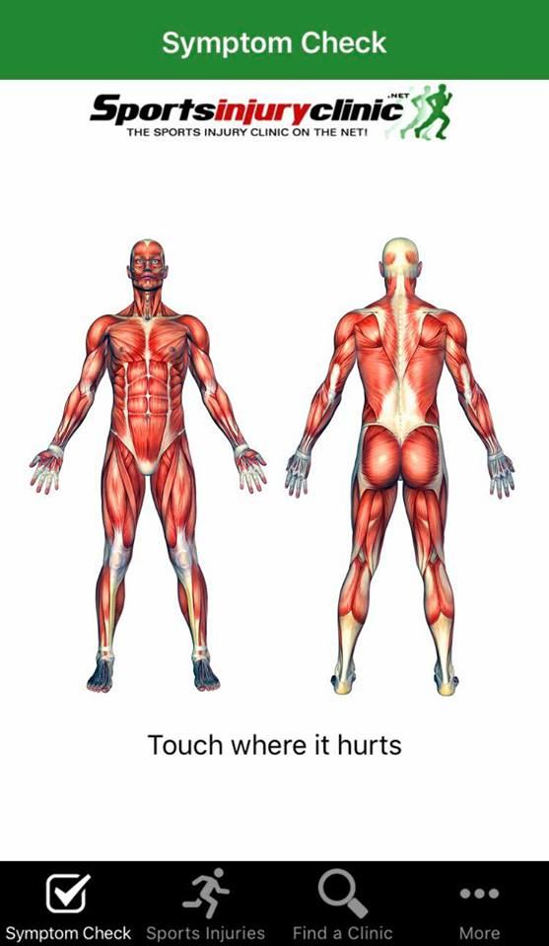

Figure 2 - Example of symptom selection on ‘Symptom Check’ function.

