Supporting information

**Optimising platelet secretomes to deliver robust tissue-specific regeneration**

David Scully1, Peggy Sfyri1, Holly N. Wilkinson1, Andrea Acebes-Huerta2, Sandrine Verpoorten1, María Carmen Muñoz-Turrillas3,2, Andrew Parnell4, Ketan Patel4, Matthew J. Hardman1, Laura Gutierrez2,5, Antonios Matsakas1

1Molecular Physiology Laboratory, Centre for Atherothrombosis & Metabolic Disease, Hull York Medical School, University of Hull; 2Platelet Research Lab, 3Centro Comunitario de Sangre y Tejidos, Instituto de Investigación Sanitaria del Principado de Asturias (ISPA), Oviedo, Spain; 4School of Biological Sciences, University of Reading, UK; 5Dept. of Medicine, University of Oviedo, Spain.

**Table 1.** qPCR primers sequence

|  |  |  |
| --- | --- | --- |
| Primer | Forward | Reverse |
| *Acta2* | GCAAACAGGAATACGATGAAGCC | AACACATAGGTAACGAGTCAGAGC |
| *Cdh11* | CCCAGTACACGTTGATGCCT | GACGTTCCCACATTGGACCT |
| *Col1a1* | CACACGTCTCGGTCATGGTA | CGGCTCCTGCTCCTCTTAG |
| *Col3a1* | ATATTTGGCATGGTTCTGGC | TGGCTACTTCTCGCTCTGCT |
| *Cyclind1* | TTGTGCATCTACACTGACAACTC | AGGGTGGGTTGGAAATGAACT |
| *Filaggrin* | GTGTCCCTCACTGTCCCTGT | CCAGGTACCATTGCAGGAGT |
| *GAPDH* | TGCACCACCAACTGCTTAGC | GGCATGGACTGTGGTCATGAG |
| *Hprt* | GCTCGAGATGTCATGAAGGAGAT | AAAGAACTTATAGCCCCCCTTGA |
| *Igf1* | GTGAGCCAAAGACACACCCA | ACCTCTGATTTTCCGAGTTGC |
| *Involucrin* | CTGCCTCAGCCTTACTGTGA | GGAGGAGGAACAGTCTTGAGG |
| *Krt1* | TTATGGTCCTGTCTGCCCTC | CCTTTTGGATCTCAGGGTCA |
| *Krt14* | GGCCTGCTGAGATCAAAGAC | GTCCACTGTGGCTGTGAGAA |
| Transglutaminase 1 | CCCAAGAGACTAGCAGTGGC | GCTGCCAGTACACCTTGTCA |
| *Vegfa165* | TGCAGGCTGCTGTAACGATG | GAACAAGGCTCACAGTGATTTTCT |
| *Vegfr1* | CACTGACATACCCAAACTTGTGC | GTCCCATGTTATTCTTTGCCCAT |
| *YWHAZ* | ACTTTTGGTACATTGTGGCTTCAA | CCGCCAGGACAAACCAGTAT |

**Table 2.** An outline of current experimental evidence of platelet-based applications on keratinocytes, fibroblasts and chondrocytes.

|  |  |  |  |
| --- | --- | --- | --- |
| **Reference** | **Cell Type** | **Platelet Intervention** | **Finding** |
| (Bayer et al., 2017);(Bayer et al., 2018) | Primary Keratinocytes | Supernatants of human thrombocyte concentrates | Platelet-derived growth factors inhibit proliferation and induce differentiation. |
| (Baik et al., 2014) | HaCaT keratinocytes | Platelet lysates | Maintains culture (proliferation (1x106 platelets/μl) similar to serum conditions. |
| (Ranzato, Martinotti, Volante, Mazzucco, & Burlando, 2011) | HaCaT keratinocytes and fibroblasts | Platelet lysates | Promotes keratinocyte epithelialisation and regulates fibroblast matrix deposition |
| (Law, Chowdhury, Saim, & Idrus, 2017) | Primary Keratinocytes and ﬁbroblasts | Platelet-rich plasma | Increased healing and wound closure. |
| (Rothan et al., 2014) | Dermal fibroblast cells | Platelet-rich plasma Releasate | Increased proliferation and differentiation. |
| (Cho et al., 2018) | Human dermal fibroblasts | Platelet‐rich plasma | Increased proliferation and migration. |
| (Kreuz et al., 2015) | Human subchondral mesenchymal progenitor cells | Platelet-rich plasma | Increased chondrogenic differentiation, migration and proliferation. |
| (Bendinelli et al., 2010) | Human articular chondrocytes (Ibpva55) | Platelet-rich plasma | Increased proliferation, differentiation with anti-inflammatory effects. |

**Table 3.** An outline of current evidence on skeletal and cardiac muscle tissues and myoblasts.

|  |  |  |
| --- | --- | --- |
| **Reference** | **Factor** | **Findings** |
| (Choo, Canner, Vest, Thompson, & Pavlath, 2017)(Iwamiya, Matsuura, Masuda, Shimizu, & Okano, 2016) | VCAM-1 | Important for satellite cell fusion and lineage progression, anti-apoptotic in skeletal muscle, and enhances cardiomyocyte proliferation. |
| (Sonnet et al., 2006)  (Salvador et al., 2016) | ICAM-1 | Anti-apoptotic in skeletal muscle and may drive cardiac inflammation, fibrosis and dysfunction. |
| (Sonnet et al., 2006)  (DeLisser et al., 1997) | PECAM-1 | Anti-apoptotic in skeletal muscle, pro-angiogenic in cardiomyocytes. |
| (W. Baker et al., 2004; Blann, Nadar, & Lip, 2003) | P-Selectin | Essential for skeletal muscle fibre-regeneration *in vivo*, Increased levels of soluble P-selectin in the plasma have been demonstrated in a variety of cardiovascular disorders. |
| (Masuda et al., 2018; Sonnet et al., 2006; Wang et al., 2018) | CXCL1 (Gro-α) | Important for skeletal myoblast proliferation and differentiation, anti-apoptotic.  May be involved in cardiac dysfunction, hypertrophy and fibrosis. |
| (Fernando, Kelly, Balazsi, Slack, & Megeney, 2002; Putinski et al., 2013) | Caspase-3 | Caspase 3 activity is required for skeletal muscle differentiation and apoptosis. May induce cardiomyocyte hypertrophy. |
| - | CD40L | - |
| (Leroy, Perroud, Darbellay, Bernheim, & Konig, 2013) (Hammoud, Burger, Lu, & Feng, 2009) | EGF | EGF stimulates skeletal myoblast proliferation and down-regulates differentiation. EGF does not induce cardiomyocyte proliferation. |
| (Milasincic, Calera, Farmer, & Pilch, 1996) (Rosenblatt-Velin, Lepore, Cartoni, Beermann, & Pedrazzini, 2005) | FGF-2 | A potent mitogen and inhibitor of myogenic differentiation in skeletal muscle.  Upregulates cardiomyocyte differentiation. |
| (Avin et al., 2018; Faul, 2017) | FGF-23 | No effect on skeletal myoblast proliferation or differentiation.  FGF23 can directly tackle cardiac myocytes via FGFR4 thereby contributing to cardiac hypertrophy. |
| i) (Hara et al., 2011)  ii) (Chung et al., 2012; Wright et al., 2014) | i) G-CSF  ii) G-CSF | i) G-CSF stimulates skeletal myoblast proliferation.  ii) G-CSF does not affect skeletal myoblast proliferation or differentiation.  Anti-apoptotic effects on H9C2s. |
|  | GITRL | - |
| (Georgantas et al., 2014) | GM-CSF | GM-CSF has no effect on skeletal myoblast differentiation. |
| (Cherin et al., 1996) | Granzyme B | A serine protease that mediates apoptosis in target cells. |
| (Walker, Kahamba, Woudberg, Goetsch, & Niesler, 2015)  (Liu et al., 2016) | HGF | 2 ng/ ml promoted cell division but reduced fusion; 10 ng/ml HGF reduced proliferation but increased differentiation of skeletal myoblasts. HGF promotes cell survival in hypoxic conditions. |
| (Grzelkowska-Kowalczyk & Wieteska-Skrzeczynska, 2010) | IFN-γ | Inhibits differentiation but is necessary for normal cell division in skeletal myoblasts. |
| (Dagdeviren et al., 2017; Deng, Wehling-Henricks, Villalta, Wang, & Tidball, 2012; Verma et al., 2012) | IL-10 | Indirectly beneficial for skeletal muscle regeneration through macrophage switch in phenotype.  Inhibits H9C2 hypertrophy and may improve heart function. |
| (Li, Moylan, Chambers, Smith, & Reid, 2009)  (Madonna et al., 2005) | IL-1α | Stimulates catabolism and atrophy in skeletal myotubes.  Increases inflammation in the heart and nitric oxide synthase in H9C2s. |
| (Li et al., 2009).  (Xu et al., 2015) | IL-1β | Stimulates catabolism and atrophy in skeletal myotubes.  Upregulates reactive oxygen species, apoptosis and cytotoxicity in cardiomyocytes. |
| (Al-Shanti, Durcan, Al-Dabbagh, Dimchev, & Stewart, 2014; Zeng et al., 2016) | IL-2 | Lymphocytes activated with IL-2 inhibit skeletal myoblast differentiation and induces proliferation.  Anti-inflammatory in cardiomyocytes. |
| (Serrano, Baeza-Raja, Perdiguero, Jardi, & Munoz-Canoves, 2008; Xu et al., 2015) | IL-6 | IL-6 regulates skeletal myoblast proliferation and migration.  Upregulates reactive oxygen species, apoptosis and cytotoxicity in cardiomyocytes. |
| (Haneef et al., 2018; Haugen et al., 2010) | IL-7 | Increased satellite cell migration and potent inhibition of differentiation with no effect on proliferation in skeletal muscle.  Increased cell proliferation, survival and fusion of cardiomyocytes. |
| (Pedersen & Febbraio, 2008)  (Kocher et al., 2006) | IL-8 | Increases angiogenesis.  Potentially induces myocardial neovascularization and protection against cardiomyocyte apoptosis. |
| (Shireman et al., 2007; Tarzami et al., 2005; Yahiaoui, Gvozdic, Danialou, Mack, & Petrof, 2008) | MCP-1 (CCL2) | Important for skeletal muscle regeneration. Directly increases skeletal myoblast proliferation and inhibits differentiation.  Protects cardiomyocytes from apoptosis. |
| (Xiao et al., 2016) | MCP-2 (CCL8) | May potentially play a role in skeletal myoblast differentiation. |
|  | MCP-3 (CCL7) | - |
| (Yahiaoui et al., 2008)  (Weinreuter et al., 2014) | MIP-1α (CCL3) | Directly increases skeletal myoblast proliferation.  Pro-inflammatory after hypoxic conditions. |
| (Yahiaoui et al., 2008) | MIP-1β (CCL4) | Directly increases skeletal myoblast proliferation. |
| (Yahiaoui et al., 2008)  (Medeiros et al., 2009) | RANTES (CCL5) | Directly increases skeletal myoblast proliferation.  Increases cardiomyocyte migration and reduced heart tissue damage. |
| (Barbosa-Souza et al., 2011) (Duerr et al., 2014) | Osteopontin | A pro-fibrotic factor in skeletal muscle and myoblasts.  Cardio-protective effects with reduced fibrosis. |
| (Jin, Sejersen, & Ringertz, 1991)  (Vantler et al., 2010) | PDGF-BB | Platelet-derived growth factor-BB stimulates growth and inhibits differentiation of skeletal myoblasts.  PDGF-BB does not stimulate proliferation or hypertrophy of cardiomyocytes and is anti-apoptotic. |
| (Brzoska et al., 2015; Liehn et al., 2011) | SDF-1α (CXCL12) | Increased skeletal muscle regeneration through upregulation of CD9-mediated myoblast fusion. Involved in cardiac-homeostasis after injury. |
| (Bajaj & Sharma, 2006; Zhao et al., 2015) | TNF-α | TNF-α inhibits myogenic differentiation of C2C12 cells through NF-kB.  Apoptosis and hypertrophy in cardiomyocytes. |
| (J. E. Baker et al., 2008; Chan et al., 2015) | TPO | TPO administration upregulates myocardio-protection *in vitro* and *in vivo.*  Cardiomyocyte survival. |
| (Sassoli et al., 2012) | VEGF-A | VEGF induces skeletal myoblast proliferation.  VEGF promotes cardiomyocyte migration. |
| (Rissanen et al., 2003; Wong, Wong, Luo, & McManus, 2011) | VEGF-D | A potent angiogenic factor.  Induces endothelial permeability and is overexpressed in cardiac adipogenic problems. |

|  |  |
| --- | --- |
| **Analytes** | **RATIO SR vs PR** |
| ICAM-1 | 8.911 |
| IL-1β | 6.722 |
| IL-1α | 6.214 |
| MCP-2 | 5.241 |
| VCAM-1 | 5.117 |
| VEGF-A | 4.863 |
| Granzyme B | 4.500 |
| GM-CSF | 4.217 |
| FGF-2 | 3.932 |
| MIP-1β | 3.739 |
| IL-8 | 3.564 |
| VEGF-D | 3.505 |
| MIP-1α | 3.391  **Fold ratio changes SR vs. PR** |
| IL-6 | 3.179 |
| Gro-α | 2.941 |
| FGF-23 | 2.802 |
| MCP-1 | 2.615 |
| SDF-1α | 2.598 |
| HGF | 2.561 |
| G-CSF/CSF-3 | 2.271 |
| IL-10 | 2.243 |
| TNF-α | 2.196 |
| IL-7 | 1.915 |
| GITRL | 1.912 |
| EGF | 1.834 |
| CD40L | 1.732 |
| IL-2 | 1.719 |
| P-Selectin | 1.678 |
| PDGF-BB | 1.595 |
| PECAM | 1.568 |
| Caspase-3 | 1.532 |
| MCP-3 | 1.493 |
| TPO | 1.337 |
| IFN-γ | 1.295 |
| RANTES | 1.157 |
| TGF-β | 0.293 |



**S. Figure 1.** Fold ratio changes of individual analytes for SR vs PR considering the average of two agonists (i.e. PAR1 and thrombin) shown as raw data and a whisker figure.

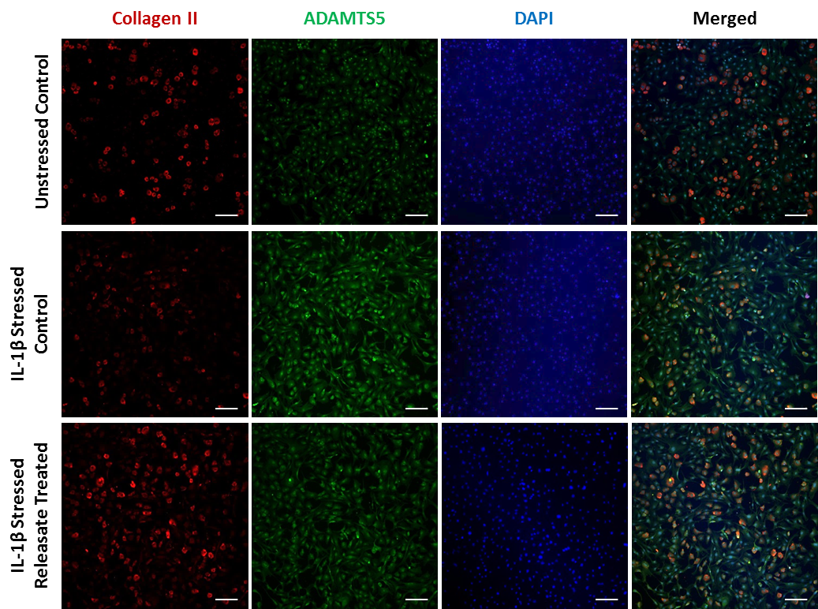

**GM**

**GM**

**GM+R**

**GM + R**

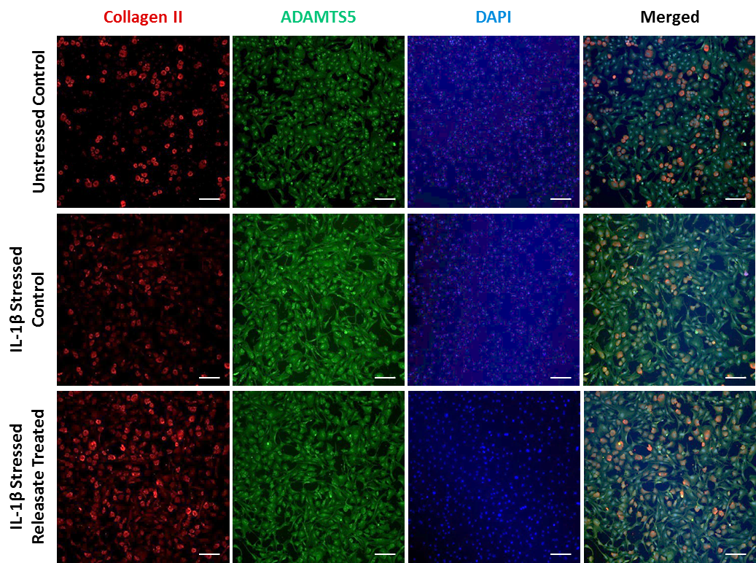

**IL-1β-treated**

**S. Figure 2.** Chondrocytes were stained with Collagen II, ADAMTS5 and DAPI and treated with GM, IL-1β+GM and IL-1β+GM+R. All releasate was made with 2.5x108 platelets/mL. Representative images showing merged and unmerged channels for Collagen II (Red), ADAMTS5 (Green) and DAPI (Blue). Scale bar 60 μm.

**\***

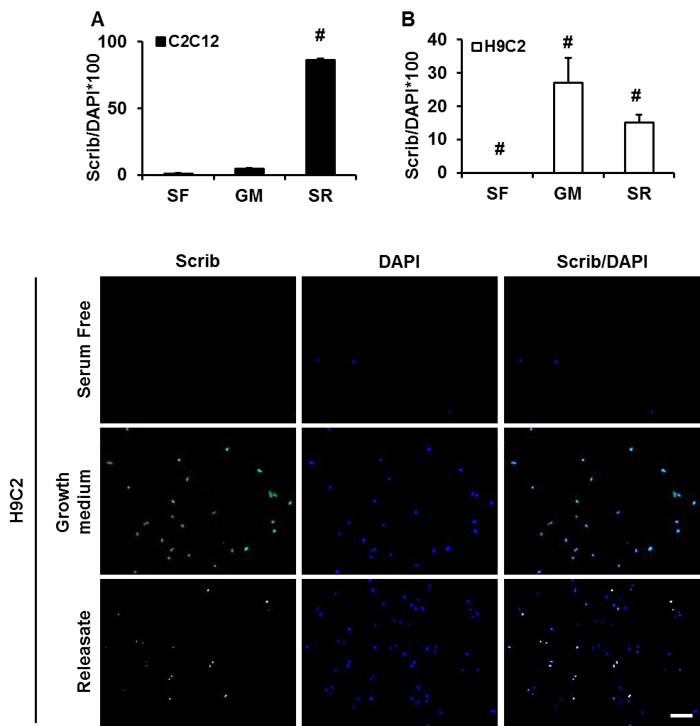

**S. Figure 3. Scrib expression in cardiomyocytes exposed to platelet releasate.** (**A**) Scrib expression of C2C12 skeletal myoblasts and H9C2 cardiomyocytes in serum-free, growth medium and 10% releasate conditions (x5 magnification, scale bar 200 μm). Statistical analysis was performed by one-way ANOVA followed by Tukey’s post-hoc test. Differences are *p<0.05, #p<0.05 vs. every other group.

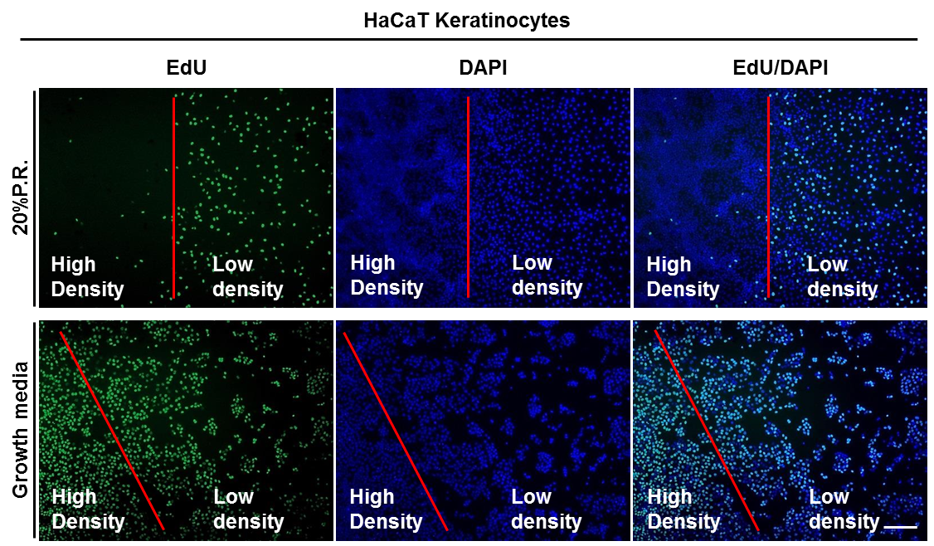

**S. Figure 4.** Morphological differences in HaCaT culture with platelet releasate. HaCaTs were seeded with or without 20% physiological levels of platelet releasate (20% P.R.) for 24 hours to analyse proliferation rates. Low and dense areas of keratinocytes were noted with a single red line, where clear proliferative differences are between the culture conditions and platelet releasate conditions.

**S. Figure 5. Cumulative population growth rates for C2C12 and H9C2 cells.** The population growth rate of C2C12 cells and H9C2 cells as calculated by the yield divided by the seeding level per day of growth. Measurements were taken over 38 days for 15-16 passages of cells.

**S. Figure 6. Physiological platelet releasate does not contribute to increased H9C2 or HaCaT cell proliferation in serum-rich conditions.** H9C2 and HaCaT cellular proliferation assessed after a 3-hour EdUincubation as normalised to number of DAPI positive nuclei as a percentage. Statistical analysis was performed by one-way ANOVA followed by Tukey’s post-hoc test. Differences are #p<0.05 vs. every other group.

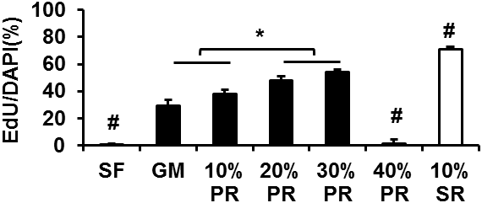

**SF**

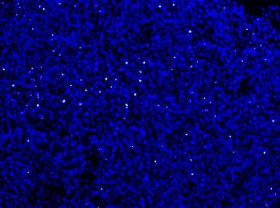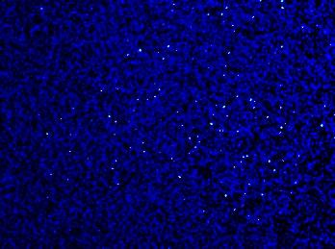

**GM**

**10% PR**

**20% PR**

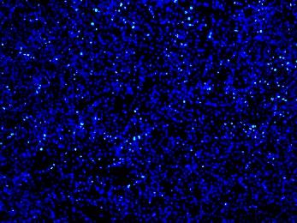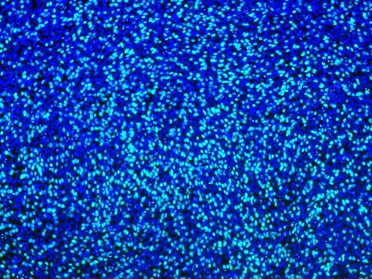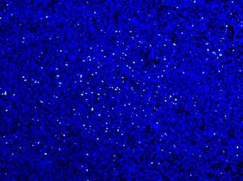

**30% PR**

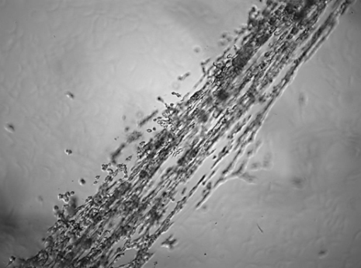

**40% PR**

**400% PR**

**10% SR**

**400% PR**

**S. Figure 7. C2C12 dose response of PR platelet releasate versus 10% SR.** 10-40% physiological (PR) and 10% supra-physiological (SR) platelet releasate was added to C2C12 cells for 48 hours with an incubation of EdU for 3 hours before fixing and staining. 40% platelet releasate was not analysable due to a fibrin clot forming with high volume/volume levels of platelet releasate in culture as imaged *via* bright field microscopy. Statistical analysis was performed by one-way ANOVA followed by Tukey’s post-hoc test. Differences are *p<0.05 and #p<0.05 vs. every other group.

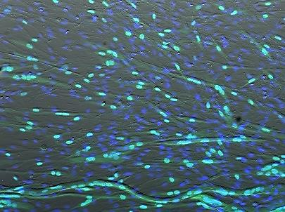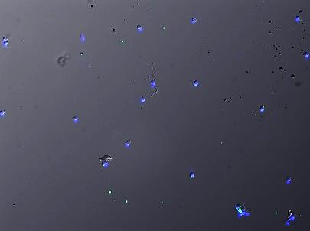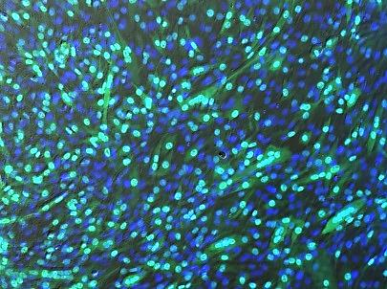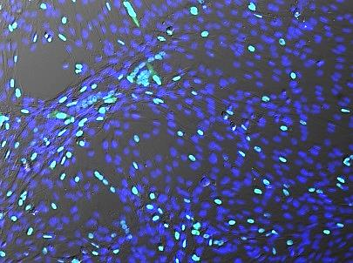

**SF**

**GM**

**SF+SR**

**GM+SR**

**Myogenin**

**DAPI**

**S. Figure 8. Supra-physiological releasate increases total C2C12 myotube number**. C2C12 myoblasts were proliferated in serum-free, growth medium conditions with or without 10% platelet releasate (SR; supra-physiological concentrations 10x108 platelets/mL). Differentiation was measured after 4 days in differentiation medium (2% horse serum). Representative images for Myogenin and DAPI (x10 magnification). Statistical analysis was performed by one-way ANOVA followed by Tukey’s post-hoc test. Differences are #p<0.05 vs. every other group.

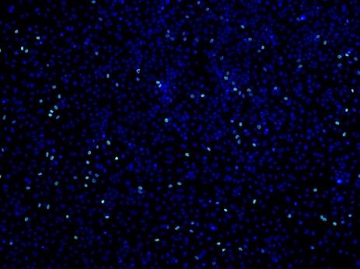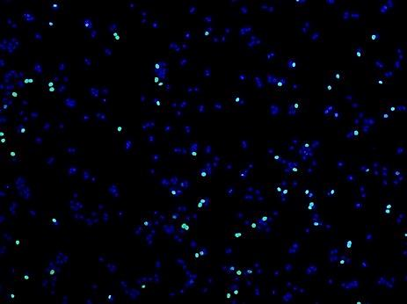

**SF**

**SR**

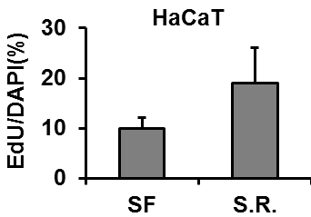

**\***

**SR**

**S. Figure 9. SF versus SR supra-physiological platelet releasate on HaCaT cell proliferation in culture.** HaCaT cells were cultured in serum-free media with or without 10% supra-physiological (SR) platelet releasate for 24 hours. Cells were incubated with EdU for 3 hours before fixing and staining. Representative images and quantitative data for EdU/DAPI (%). Statistical analysis was performed by Student’s *t*-test. Differences are *p<0.05.

**References**

Al-Shanti, N., Durcan, P., Al-Dabbagh, S., Dimchev, G. A., & Stewart, C. E. (2014). Activated lymphocytes secretome inhibits differentiation and induces proliferation of C2C12 myoblasts. *Cell Physiol Biochem, 33*(1), 117-128. doi:10.1159/000356655

Avin, K. G., Vallejo, J. A., Chen, N. X., Wang, K., Touchberry, C. D., Brotto, M., . . . Wacker, M. J. (2018). Fibroblast growth factor 23 does not directly influence skeletal muscle cell proliferation and differentiation or ex vivo muscle contractility. *Am J Physiol Endocrinol Metab, 315*(4), E594-E604. doi:10.1152/ajpendo.00343.2017

Baik, S. Y., Lim, Y. A., Kang, S. J., Ahn, S. H., Lee, W. G., & Kim, C. H. (2014). Effects of platelet lysate preparations on the proliferation of HaCaT cells. *Ann Lab Med, 34*(1), 43-50. doi:10.3343/alm.2014.34.1.43

Bajaj, G., & Sharma, R. K. (2006). TNF-alpha-mediated cardiomyocyte apoptosis involves caspase-12 and calpain. *Biochem Biophys Res Commun, 345*(4), 1558-1564. doi:10.1016/j.bbrc.2006.05.059

Baker, J. E., Su, J., Hsu, A., Shi, Y., Zhao, M., Strande, J. L., . . . Gross, G. J. (2008). Human thrombopoietin reduces myocardial infarct size, apoptosis, and stunning following ischaemia/reperfusion in rats. *Cardiovasc Res, 77*(1), 44-53. doi:10.1093/cvr/cvm026

Baker, W., Schneider, B. A., Kulkarni, A., Sloan, G., Schaub, R., Sypek, J., & Cannon, J. G. (2004). P-selectin inhibition suppresses muscle regeneration following injury. *J Leukoc Biol, 76*(2), 352-358. doi:10.1189/jlb.1102528

Barbosa-Souza, V., Contin, D. K., Filho, W. B., de Araujo, A. L., Irazusta, S. P., & da Cruz-Hofling, M. A. (2011). Osteopontin, a chemotactic protein with cytokine-like properties, is up-regulated in muscle injury caused by Bothrops lanceolatus (fer-de-lance) snake venom. *Toxicon, 58*(5), 398-409. doi:10.1016/j.toxicon.2011.07.011

Bayer, A., Tohidnezhad, M., Berndt, R., Lippross, S., Behrendt, P., Kluter, T., . . . Harder, J. (2018). Platelet-released growth factors inhibit proliferation of primary keratinocytes in vitro. *Ann Anat, 215*, 1-7. doi:10.1016/j.aanat.2017.09.002

Bayer, A., Tohidnezhad, M., Lammel, J., Lippross, S., Behrendt, P., Kluter, T., . . . Harder, J. (2017). Platelet-Released Growth Factors Induce Differentiation of Primary Keratinocytes. *Mediators Inflamm, 2017*, 5671615. doi:10.1155/2017/5671615

Bendinelli, P., Matteucci, E., Dogliotti, G., Corsi, M. M., Banfi, G., Maroni, P., & Desiderio, M. A. (2010). Molecular basis of anti-inflammatory action of platelet-rich plasma on human chondrocytes: mechanisms of NF-kappaB inhibition via HGF. *J Cell Physiol, 225*(3), 757-766. doi:10.1002/jcp.22274

Blann, A. D., Nadar, S. K., & Lip, G. Y. (2003). The adhesion molecule P-selectin and cardiovascular disease. *Eur Heart J, 24*(24), 2166-2179.

Brzoska, E., Kowalski, K., Markowska-Zagrajek, A., Kowalewska, M., Archacki, R., Plaskota, I., . . . Ciemerych, M. A. (2015). Sdf-1 (CXCL12) induces CD9 expression in stem cells engaged in muscle regeneration. *Stem Cell Res Ther, 6*, 46. doi:10.1186/s13287-015-0041-1

Chan, S., Chan, G. C., Ye, J., Lian, Q., Chen, J., & Yang, M. (2015). Thrombopoietin Protects Cardiomyocytes from Iron-Overload Induced Oxidative Stress and Mitochondrial Injury. *Cell Physiol Biochem, 36*(5), 2063-2071. doi:10.1159/000430173

Cherin, P., Herson, S., Crevon, M. C., Hauw, J. J., Cervera, P., Galanaud, P., & Emilie, D. (1996). Mechanisms of lysis by activated cytotoxic cells expressing perforin and granzyme-B genes and the protein TIA-1 in muscle biopsies of myositis. *J Rheumatol, 23*(7), 1135-1142.

Cho, E. B., Park, G. S., Park, S. S., Jang, Y. J., Kim, K. H., Kim, K. J., & Park, E. J. (2018). Effect of platelet-rich plasma on proliferation and migration in human dermal fibroblasts. *J Cosmet Dermatol*. doi:10.1111/jocd.12780

Choo, H. J., Canner, J. P., Vest, K. E., Thompson, Z., & Pavlath, G. K. (2017). A tale of two niches: differential functions for VCAM-1 in satellite cells under basal and injured conditions. *Am J Physiol Cell Physiol, 313*(4), C392-C404. doi:10.1152/ajpcell.00119.2017

Chung, H. K., Ko, E. M., Kim, S. W., Byun, S. J., Chung, H. J., Kwon, M., . . . Kim, K. W. (2012). Antiapoptotic effects of Phe140Asn, a novel human granulocyte colony-stimulating factor mutant in H9c2 rat cardiomyocytes. *BMB Rep, 45*(12), 742-747.

Dagdeviren, S., Jung, D. Y., Friedline, R. H., Noh, H. L., Kim, J. H., Patel, P. R., . . . Kim, J. K. (2017). IL-10 prevents aging-associated inflammation and insulin resistance in skeletal muscle. *FASEB J, 31*(2), 701-710. doi:10.1096/fj.201600832R

DeLisser, H. M., Christofidou-Solomidou, M., Strieter, R. M., Burdick, M. D., Robinson, C. S., Wexler, R. S., . . . Albelda, S. M. (1997). Involvement of endothelial PECAM-1/CD31 in angiogenesis. *Am J Pathol, 151*(3), 671-677.

Deng, B., Wehling-Henricks, M., Villalta, S. A., Wang, Y., & Tidball, J. G. (2012). IL-10 triggers changes in macrophage phenotype that promote muscle growth and regeneration. *J Immunol, 189*(7), 3669-3680. doi:10.4049/jimmunol.1103180

Duerr, G. D., Mesenholl, B., Heinemann, J. C., Zoerlein, M., Huebener, P., Schneider, P., . . . Dewald, O. (2014). Cardioprotective effects of osteopontin-1 during development of murine ischemic cardiomyopathy. *Biomed Res Int, 2014*, 124063. doi:10.1155/2014/124063

Faul, C. (2017). Cardiac actions of fibroblast growth factor 23. *Bone, 100*, 69-79. doi:10.1016/j.bone.2016.10.001

Fernando, P., Kelly, J. F., Balazsi, K., Slack, R. S., & Megeney, L. A. (2002). Caspase 3 activity is required for skeletal muscle differentiation. *Proc Natl Acad Sci U S A, 99*(17), 11025-11030. doi:10.1073/pnas.162172899

Georgantas, R. W., Streicher, K., Greenberg, S. A., Greenlees, L. M., Zhu, W., Brohawn, P. Z., . . . Ranade, K. (2014). Inhibition of myogenic microRNAs 1, 133, and 206 by inflammatory cytokines links inflammation and muscle degeneration in adult inflammatory myopathies. *Arthritis Rheumatol, 66*(4), 1022-1033. doi:10.1002/art.38292

Grzelkowska-Kowalczyk, K., & Wieteska-Skrzeczynska, W. (2010). Treatment with TNF-alpha and IFN-gamma alters the activation of SER/THR protein kinases and the metabolic response to IGF-I in mouse c2c12 myogenic cells. *Cell Mol Biol Lett, 15*(1), 13-31. doi:10.2478/s11658-009-0033-1

Hammoud, L., Burger, D. E., Lu, X., & Feng, Q. (2009). Tissue inhibitor of metalloproteinase-3 inhibits neonatal mouse cardiomyocyte proliferation via EGFR/JNK/SP-1 signaling. *Am J Physiol Cell Physiol, 296*(4), C735-745. doi:10.1152/ajpcell.00246.2008

Haneef, K., Ali, A., Khan, I., Naeem, N., Jamall, S., & Salim, A. (2018). Role of interleukin-7 in fusion of rat bone marrow mesenchymal stem cells with cardiomyocytes in vitro and improvement of cardiac function in vivo. *Cardiovasc Ther*, e12479. doi:10.1111/1755-5922.12479

Hara, M., Yuasa, S., Shimoji, K., Onizuka, T., Hayashiji, N., Ohno, Y., . . . Fukuda, K. (2011). G-CSF influences mouse skeletal muscle development and regeneration by stimulating myoblast proliferation. *J Exp Med, 208*(4), 715-727. doi:10.1084/jem.20101059

Haugen, F., Norheim, F., Lian, H., Wensaas, A. J., Dueland, S., Berg, O., . . . Drevon, C. A. (2010). IL-7 is expressed and secreted by human skeletal muscle cells. *Am J Physiol Cell Physiol, 298*(4), C807-816. doi:10.1152/ajpcell.00094.2009

Iwamiya, T., Matsuura, K., Masuda, S., Shimizu, T., & Okano, T. (2016). Cardiac fibroblast-derived VCAM-1 enhances cardiomyocyte proliferation for fabrication of bioengineered cardiac tissue. *Regenerative Therapy, 4*, 92-102.

Jin, P., Sejersen, T., & Ringertz, N. R. (1991). Recombinant platelet-derived growth factor-BB stimulates growth and inhibits differentiation of rat L6 myoblasts. *J Biol Chem, 266*(2), 1245-1249.

Kocher, A. A., Schuster, M. D., Bonaros, N., Lietz, K., Xiang, G., Martens, T. P., . . . Itescu, S. (2006). Myocardial homing and neovascularization by human bone marrow angioblasts is regulated by IL-8/Gro CXC chemokines. *J Mol Cell Cardiol, 40*(4), 455-464. doi:10.1016/j.yjmcc.2005.11.013

Kreuz, P. C., Kruger, J. P., Metzlaff, S., Freymann, U., Endres, M., Pruss, A., . . . Kaps, C. (2015). Platelet-Rich Plasma Preparation Types Show Impact on Chondrogenic Differentiation, Migration, and Proliferation of Human Subchondral Mesenchymal Progenitor Cells. *Arthroscopy, 31*(10), 1951-1961. doi:10.1016/j.arthro.2015.03.033

Law, J. X., Chowdhury, S. R., Saim, A. B., & Idrus, R. B. H. (2017). Platelet-rich plasma with keratinocytes and fibroblasts enhance healing of full-thickness wounds. *J Tissue Viability, 26*(3), 208-215. doi:10.1016/j.jtv.2017.05.003

Leroy, M. C., Perroud, J., Darbellay, B., Bernheim, L., & Konig, S. (2013). Epidermal growth factor receptor down-regulation triggers human myoblast differentiation. *PLoS One, 8*(8), e71770. doi:10.1371/journal.pone.0071770

Li, W., Moylan, J. S., Chambers, M. A., Smith, J., & Reid, M. B. (2009). Interleukin-1 stimulates catabolism in C2C12 myotubes. *Am J Physiol Cell Physiol, 297*(3), C706-714. doi:10.1152/ajpcell.00626.2008

Liehn, E. A., Tuchscheerer, N., Kanzler, I., Drechsler, M., Fraemohs, L., Schuh, A., . . . Weber, C. (2011). Double-edged role of the CXCL12/CXCR4 axis in experimental myocardial infarction. *J Am Coll Cardiol, 58*(23), 2415-2423. doi:10.1016/j.jacc.2011.08.033

Liu, J., Wu, P., Wang, Y., Du, Y., A, N., Liu, S., . . . Yang, Z. (2016). Ad-HGF improves the cardiac remodeling of rat following myocardial infarction by upregulating autophagy and necroptosis and inhibiting apoptosis. *Am J Transl Res, 8*(11), 4605-4627.

Madonna, R., Di Napoli, P., Massaro, M., Grilli, A., Felaco, M., De Caterina, A., . . . Geng, Y. J. (2005). Simvastatin attenuates expression of cytokine-inducible nitric-oxide synthase in embryonic cardiac myoblasts. *J Biol Chem, 280*(14), 13503-13511. doi:10.1074/jbc.M411859200

Masuda, S., Tanaka, M., Inoue, T., Ohue-Kitano, R., Yamakage, H., Muranaka, K., . . . Satoh-Asahara, N. (2018). Chemokine (C-X-C motif) ligand 1 is a myokine induced by palmitate and is required for myogenesis in mouse satellite cells. *Acta Physiol (Oxf), 222*(3). doi:10.1111/apha.12975

Medeiros, G. A., Silverio, J. C., Marino, A. P., Roffe, E., Vieira, V., Kroll-Palhares, K., . . . Lannes-Vieira, J. (2009). Treatment of chronically Trypanosoma cruzi-infected mice with a CCR1/CCR5 antagonist (Met-RANTES) results in amelioration of cardiac tissue damage. *Microbes Infect, 11*(2), 264-273. doi:10.1016/j.micinf.2008.11.012

Milasincic, D. J., Calera, M. R., Farmer, S. R., & Pilch, P. F. (1996). Stimulation of C2C12 myoblast growth by basic fibroblast growth factor and insulin-like growth factor 1 can occur via mitogen-activated protein kinase-dependent and -independent pathways. *Mol Cell Biol, 16*(11), 5964-5973.

Pedersen, B. K., & Febbraio, M. A. (2008). Muscle as an endocrine organ: focus on muscle-derived interleukin-6. *Physiol Rev, 88*(4), 1379-1406. doi:10.1152/physrev.90100.2007

Putinski, C., Abdul-Ghani, M., Stiles, R., Brunette, S., Dick, S. A., Fernando, P., & Megeney, L. A. (2013). Intrinsic-mediated caspase activation is essential for cardiomyocyte hypertrophy. *Proc Natl Acad Sci U S A, 110*(43), E4079-4087. doi:10.1073/pnas.1315587110

Ranzato, E., Martinotti, S., Volante, A., Mazzucco, L., & Burlando, B. (2011). Platelet lysate modulates MMP-2 and MMP-9 expression, matrix deposition and cell-to-matrix adhesion in keratinocytes and fibroblasts. *Exp Dermatol, 20*(4), 308-313. doi:10.1111/j.1600-0625.2010.01173.x

Rissanen, T. T., Markkanen, J. E., Gruchala, M., Heikura, T., Puranen, A., Kettunen, M. I., . . . Yla-Herttuala, S. (2003). VEGF-D is the strongest angiogenic and lymphangiogenic effector among VEGFs delivered into skeletal muscle via adenoviruses. *Circ Res, 92*(10), 1098-1106. doi:10.1161/01.RES.0000073584.46059.E3

Rosenblatt-Velin, N., Lepore, M. G., Cartoni, C., Beermann, F., & Pedrazzini, T. (2005). FGF-2 controls the differentiation of resident cardiac precursors into functional cardiomyocytes. *J Clin Invest, 115*(7), 1724-1733. doi:10.1172/JCI23418

Rothan, H. A., Djordjevic, I., Bahrani, H., Paydar, M., Ibrahim, F., Abd Rahmanh, N., & Yusof, R. (2014). Three-dimensional culture environment increases the efficacy of platelet rich plasma releasate in prompting skin fibroblast differentiation and extracellular matrix formation. *Int J Med Sci, 11*(10), 1029-1038. doi:10.7150/ijms.8895

Salvador, A. M., Nevers, T., Velazquez, F., Aronovitz, M., Wang, B., Abadia Molina, A., . . . Alcaide, P. (2016). Intercellular Adhesion Molecule 1 Regulates Left Ventricular Leukocyte Infiltration, Cardiac Remodeling, and Function in Pressure Overload-Induced Heart Failure. *J Am Heart Assoc, 5*(3), e003126. doi:10.1161/JAHA.115.003126

Sassoli, C., Pini, A., Chellini, F., Mazzanti, B., Nistri, S., Nosi, D., . . . Formigli, L. (2012). Bone marrow mesenchymal stromal cells stimulate skeletal myoblast proliferation through the paracrine release of VEGF. *PLoS One, 7*(7), e37512. doi:10.1371/journal.pone.0037512

Serrano, A. L., Baeza-Raja, B., Perdiguero, E., Jardi, M., & Munoz-Canoves, P. (2008). Interleukin-6 is an essential regulator of satellite cell-mediated skeletal muscle hypertrophy. *Cell Metab, 7*(1), 33-44. doi:10.1016/j.cmet.2007.11.011

Shireman, P. K., Contreras-Shannon, V., Ochoa, O., Karia, B. P., Michalek, J. E., & McManus, L. M. (2007). MCP-1 deficiency causes altered inflammation with impaired skeletal muscle regeneration. *J Leukoc Biol, 81*(3), 775-785. doi:10.1189/jlb.0506356

Sonnet, C., Lafuste, P., Arnold, L., Brigitte, M., Poron, F., Authier, F. J., . . . Chazaud, B. (2006). Human macrophages rescue myoblasts and myotubes from apoptosis through a set of adhesion molecular systems. *J Cell Sci, 119*(Pt 12), 2497-2507. doi:10.1242/jcs.02988

Tarzami, S. T., Calderon, T. M., Deguzman, A., Lopez, L., Kitsis, R. N., & Berman, J. W. (2005). MCP-1/CCL2 protects cardiac myocytes from hypoxia-induced apoptosis by a G(alphai)-independent pathway. *Biochem Biophys Res Commun, 335*(4), 1008-1016. doi:10.1016/j.bbrc.2005.07.168

Vantler, M., Karikkineth, B. C., Naito, H., Tiburcy, M., Didie, M., Nose, M., . . . Zimmermann, W. H. (2010). PDGF-BB protects cardiomyocytes from apoptosis and improves contractile function of engineered heart tissue. *J Mol Cell Cardiol, 48*(6), 1316-1323. doi:10.1016/j.yjmcc.2010.03.008

Verma, S. K., Krishnamurthy, P., Barefield, D., Singh, N., Gupta, R., Lambers, E., . . . Kishore, R. (2012). Interleukin-10 treatment attenuates pressure overload-induced hypertrophic remodeling and improves heart function via signal transducers and activators of transcription 3-dependent inhibition of nuclear factor-kappaB. *Circulation, 126*(4), 418-429. doi:10.1161/CIRCULATIONAHA.112.112185

Walker, N., Kahamba, T., Woudberg, N., Goetsch, K., & Niesler, C. (2015). Dose-dependent modulation of myogenesis by HGF: implications for c-Met expression and downstream signalling pathways. *Growth Factors, 33*(3), 229-241. doi:10.3109/08977194.2015.1058260

Wang, L., Zhang, Y. L., Lin, Q. Y., Liu, Y., Guan, X. M., Ma, X. L., . . . Li, H. H. (2018). CXCL1-CXCR2 axis mediates angiotensin II-induced cardiac hypertrophy and remodelling through regulation of monocyte infiltration. *Eur Heart J, 39*(20), 1818-1831. doi:10.1093/eurheartj/ehy085

Weinreuter, M., Kreusser, M. M., Beckendorf, J., Schreiter, F. C., Leuschner, F., Lehmann, L. H., . . . Backs, J. (2014). CaM Kinase II mediates maladaptive post-infarct remodeling and pro-inflammatory chemoattractant signaling but not acute myocardial ischemia/reperfusion injury. *EMBO Mol Med, 6*(10), 1231-1245. doi:10.15252/emmm.201403848

Wong, B. W., Wong, D., Luo, H., & McManus, B. M. (2011). Vascular endothelial growth factor-D is overexpressed in human cardiac allograft vasculopathy and diabetic atherosclerosis and induces endothelial permeability to low-density lipoproteins in vitro. *J Heart Lung Transplant, 30*(8), 955-962. doi:10.1016/j.healun.2011.04.007

Wright, C. R., Brown, E. L., Della-Gatta, P. A., Ward, A. C., Lynch, G. S., & Russell, A. P. (2014). G-CSF does not influence C2C12 myogenesis despite receptor expression in healthy and dystrophic skeletal muscle. *Front Physiol, 5*, 170. doi:10.3389/fphys.2014.00170

Xiao, W., Liu, Y., Luo, B., Zhao, L., Liu, X., Zeng, Z., & Chen, P. (2016). Time-dependent gene expression analysis after mouse skeletal muscle contusion. *J Sport Health Sci, 5*(1), 101-108. doi:10.1016/j.jshs.2016.01.017

Xu, W., Chen, J., Lin, J., Liu, D., Mo, L., Pan, W., . . . Zheng, D. (2015). Exogenous H2S protects H9c2 cardiac cells against high glucose-induced injury and inflammation by inhibiting the activation of the NF-kappaB and IL-1beta pathways. *Int J Mol Med, 35*(1), 177-186. doi:10.3892/ijmm.2014.2007

Yahiaoui, L., Gvozdic, D., Danialou, G., Mack, M., & Petrof, B. J. (2008). CC family chemokines directly regulate myoblast responses to skeletal muscle injury. *J Physiol, 586*(16), 3991-4004. doi:10.1113/jphysiol.2008.152090

Zeng, Z., Yu, K., Chen, L., Li, W., Xiao, H., & Huang, Z. (2016). Interleukin-2/Anti-Interleukin-2 Immune Complex Attenuates Cardiac Remodeling after Myocardial Infarction through Expansion of Regulatory T Cells. *J Immunol Res, 2016*, 8493767. doi:10.1155/2016/8493767

Zhao, Q., Yang, S. T., Wang, J. J., Zhou, J., Xing, S. S., Shen, C. C., . . . Song, Y. H. (2015). TNF alpha inhibits myogenic differentiation of C2C12 cells through NF-kappaB activation and impairment of IGF-1 signaling pathway. *Biochem Biophys Res Commun, 458*(4), 790-795. doi:10.1016/j.bbrc.2015.02.026