Principles underpinning innovative mobile learning: Stakeholders’ priorities

Abstract
This article discusses the results of a survey that measured school teachers’ and mobile learning (m-learning) experts’ perceptions of the relative importance and effectiveness of various pedagogical principles underpinning m-learning designs. A scan of relevant literature produced a set of articles describing effective innovative m-learning. Principles underpinning the learning activities in these articles were identified. These principles were then provided to respondents so that they could identify the most important ones relative to the others for designing effective and innovative m-learning tasks. A rigorous Best/Worst Scaling (BWS) survey was used to collect these data. This is the first time that a BWS has been conducted with regard to mobile pedagogical principles. Findings showed that principles related to authenticity were rated most important relative to other principles by the m-learning experts and principles related to personalisation and customisation were rated most important by practising teachers. Other principles that have been used in innovative m-learning designs, such as gamification and intergenerational learning, were seen as least important by all respondents. The findings will inform design of professional development activities, in particular, those pertaining to an app being developed in an Erasmus + project, Developing and Evaluating Innovative Mobile Pedagogies (DEIMP).

Keywords: Effective mobile learning; pedagogical principles; Best/Worse Scaling; innovative mobile practice; teacher beliefs; m-Learning activities; mobile technologies; school-aged learners; practitioner teachers, Delphi panel, DEIMP.

1. Introduction
This article concerns the use of mobile pedagogies for innovative teaching and learning. The study is part of a larger study which has the aim of assisting teachers to be designers of innovative mobile pedagogies. A mobile pedagogy is a pedagogy which employs the characteristics and affordances of mobile devices to enhance learning. This study identifies and investigates the underlying principles that have been used in innovative mobile pedagogies and considers the perceptions of stakeholders regarding the importance of those principles.

Apple did not invent the first mobile phone, indeed they were noticeably absent from the market when the first generation of personal mobile devices began to appear in the mid 1990s. And yet by 2007 it was Apple’s CEO, Steve Jobs, who would claim that ‘Today Apple is going to reinvent the phone’, introducing the first widescreen phone that combined all the existing functionality of mobile phones with the iPod music player, a high quality onboard camera and internet connectivity. Today, barely a decade on from the launch of this iconic device, mobile technologies and the infrastructure that supports them have evolved so rapidly that they are hardly recognisable as telephones anymore. They have become pervasive and ubiquitous multifunctional technologies we take for granted in much the same way that electricity, which once drew attention for its novelty and unfamiliarity, quickly faded into an essential but ‘invisible’ technology, a certain sign of its universal acceptance and adoption in the early part of the twentieth century. These so-called second generation mobile phones combine highly sophisticated technical features such as context awareness and learning analytics with infrastructure developments that include exponential increases in bandwidth and connectivity, allowing them to be used anytime, anywhere in the world.

But whilst technical and infrastructure developments associated with these second generation smartphones render them almost unrecognisable from their predecessors, their use and application as learning tools in classrooms is not strikingly different to how first generation mobile phones were used, or indeed the tethered computers that pre-dated them (Royle, Stager & Traxler, 2014). There has been considerable discussion and speculation around the game-changing potential of mobile technologies in terms of teaching, learning and even school reform (Joan, 2013; Kee & Samsudin, 2014; authors, 2017), and mobile learning (or m-learning), has been described by some as a paradigmatic shift, contrasting the opportunities for flexible, seamless and personal learning with the tethered and static paradigm of learning, referred to as e-learning (authors, 2017). In practice, however, the differences between these paradigmatic positions may not be that dramatic and a growing number of research studies in this field suggests that educators are only exploiting a small fraction of the educational affordances that are available when students have access to a mobile device, particularly if it is a personal device (authors, 2016; authors, 2015). On a technological level, as Jobs predicted in 2007, the mobile phone has been reinvented but at a pedagogical level it is difficult to detect the same kind of paradigmatic shift.

This disjunct between the potential and reality of m-learning practices in classrooms has inspired a number of teaching and research projects and practical initiatives to support educators in making more informed and principled judgements about when and how to use digital technologies, and in this case mobile technologies, to support, enhance and transform learning in classrooms (see for example, www.mttep.eu/ ). This article is rooted in one of these initiatives, the Designing and Evaluating Innovative Mobile Pedagogies (DEIMP) project, an international partnership of five universities in the UK, Belgium, The Netherlands, Australia and Ireland, an NGO in Cyprus and a network of over thirty schools across Europe and Australia (see www.deimpeu.com). It is funded by the European Commission (EU) under the Erasmus+ platform and led by the University of X [name withdrawn for blind review]. Projects funded by this initiative are transnational, multi-institution strategic partnerships designed to develop and share innovative practices that will impact positively on learners. In this instance the principal focus of the project has been to support educators in schools in designing and then evaluating m-learning activities that are genuinely innovative and transformational rather than those that simply replicate and repeat existing pedagogical practices, many of which could be undertaken without the mediation of mobile devices. The aim is to design and develop a mobile app and accompanying online course that will inspire and guide teachers and teacher educators to design and evaluate their own innovative m-learning activities and to share these as part of a growing network of innovators. As a starting point for the design and construction of the app and online course, the project partners have undertaken an extensive scoping study which includes a systematic literature review of the published research on innovative m-learning in schools (Authors, in press) and a Delphi study to verify and validate its outcomes.

A systematic literature review (SLR) was purposefully implemented for the scoping study in order to ensure the project was rigorous, focused, and driven by a clear set of criteria and protocols. This SLR highlighted the most relevant evidence for how mobile technologies are used innovatively in schools. The initial search strategy yielded 208 academic papers which were further refined to 72 and finally to 57 (see authors, 2019, for full details of this SLR process). Subsequently, we investigated the pedagogical principles underpinning each of the activities described in these 57 articles. After a prolonged period of analysis and codification we identified 42 principles used to design innovative m-learning scenarios or activities. Similar principles were combined and the final outcome was a set of 21 distinct principles (see Table 1 below).
Table 1: 21 principles underpinning innovative m-learning activities for 5-18 year olds (DEIMP project)

Seamless learning
Activity occurs across a variety of physical and/or virtual settings
Digital play
Activity involves explorations without an explicit curriculum goal
Student agency
Students have choice of how to do activity
Student autonomy
Students determine the activity
Gamification
Applies elements of games such as competitions, random events, scoring
Customisation
Learning pathways are adapted to individual input
Authentic environment
Activity occurs in situ
Simulation
Conducting realistic virtual task e.g. Google expedition
Context-awareness
Activity adapts to environmental stimuli, for example new vocabulary is determined by external items
Data sharing
Learners share digital artefacts with peers
Artefact construction
Learners make digital object e.g. video, music, game
Co-construction
Learners use collaborative authoring tools e.g. Google docs
Reflection
Learners reflect in multimodal ways e.g. with vlogs, colours, sound
Real-world processes
Learners engage in activities similar to those done by practitioners e.g. testing aero-dynamics of object with app
Real-world tools
Activity uses app as tool e.g. to compose music or paint a picture
Role-play
Learners assemble tools and methods and enact roles e.g. citizen journalist
Peer review
Learners review each other’s contributions e.g. via blogs
Co-design for mobile learning
Students and teachers ‘mobilise activities’ i.e. transform them into ones with mobile features
Intergenerational learning
Learners across different generations work together e.g. capturing an oral history
Bridging
Learners work across formal and informal contexts
Community-based
Learners conduct a community activity or project e.g. monitoring litter

--------------------------------------------------------------------
Insert Table 1 here
--------------------------------------------------------------------
The 21 principles are firmly grounded in, and extracted from, the research studies identified by the SLR, but we wished to explore their importance and relevance to both educational practitioners in schools and m-learning experts. This article examines the views of these stakeholders regarding the effectiveness of these principles for pedagogical design. Our research question for this part of the DEIMP study was:
What pedagogical principles underpinning innovation in m-learning do teachers and other experts perceive as most important for effective teaching and learning?
There were a number of sub-questions that we sought to answer:
- What principles were perceived as most important for designing effective mobile learning activities?
- What principles were perceived as least important for designing effective mobile learning activities?
- How did the different cohorts surveyed differ in their perceptions?

2. Methodology
This study aims to elicit the perceptions of certain cohorts of educators regarding the relevance and importance of each of the 21 identified principles identified in the previous section. We set up a survey, called a Best/Worst Scaling (BWS) survey (Finn & Louviere, 1992), and disseminated it amongst two cohorts of educators. Details of these cohorts and the BWS survey follow.

2.1 Participants
One cohort of respondents in this study was comprised of experts in the field of education and educational technology. At the start of the project, all project members from the five participating countries were asked to nominate four to five experts for a Delphi panel. Criteria for nominations were that the person was both a pedagogical expert and an expert in the use of mobile technologies for learning. Team members nominated people whose publications were influential in m-learning, others who had worked with them on m-learning projects and those who had been keynote speakers at relevant m-learning conferences. The leader of the DEIMP project and two other team members (first three authors ), formed a panel which then considered each of the nominations and rejected anyone who did not have a background related to teaching in Years K-12 (that is, 5 to 18 year olds) or did not have sufficient expertise in m-learning. As the project progressed, other educators with international reputations in technology-enhanced learning were invited to complete the survey using the Delphi panel pathway offered in the survey.

The second cohort of respondents was formed from the participating schools in the DEIMP project. The project team members from each participating country were encouraged to disseminate the survey link to teachers at their national project meetings and through emails to their partner schools. The responding teachers were all experienced and interested in m-learning as indicated by their participation in the project. They were asked to complete the survey using the teacher pathway offered in the survey.

The final tally of respondents to the survey were: 139 completed the survey. Of the total number, 70 identified as members of the Delphi panel. The remaining 69 respondents identified as teachers who had been given the link at their school. In most cases the school was one of the partner schools in the project. A filter question was added to the survey pathway for teachers that asked about their level of usage of mobile technologies in their teaching. Only the 69 teachers who responded with ‘often used’ (48% of final cohort of teacher respondents) or ‘frequently used’ (52%) were able to continue with the survey.

2.2 Profiles of participants
As noted above, the respondents comprised two groups. One group were teachers from DEIMP partner schools who received the link to the survey from the contact teacher at the school. If a respondent indicated that they had received the survey in this way, they were directed to a few demographic questions, including: age of students taught, educational setting and subjects taught (if secondary), and number of years in teaching. Table 2 provides these demographic details for the 69 teacher participants.
Table 2. Background information on teachers (n=69)
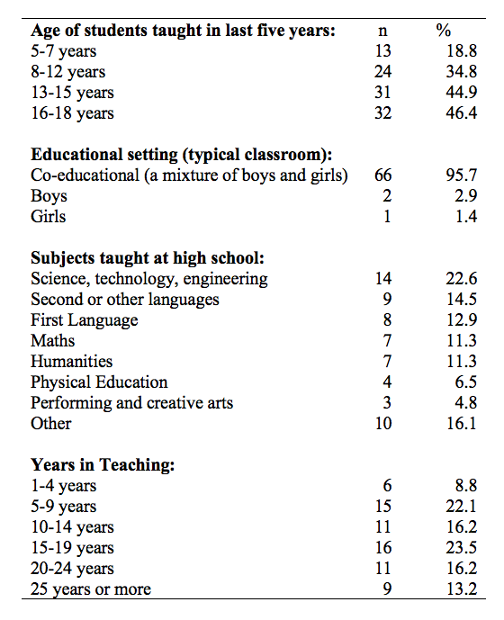

--------------------------------------------------------------------
Insert Table 2 here
--------------------------------------------------------------------

The 69 teachers taught for a range of years from 5 to 35 years. The students that this cohort of respondents had taught over the last five years were predominantly in the secondary school years (that is, students aged 13-18), although 34.8% of the cohort had taught students aged 8-12 years of age, that is, in their upper primary (upper elementary) years. A few had taught lower primary years (18.8%) that is, students aged 5-7 years. Teachers were able to select more than one age grouping to reflect all their teaching over the last five years.

The respondents from the Delphi Panel took a different pathway in the survey. If respondents indicated that they were answering in their capacity as an expert on the Delhi Panel, they were not asked the specific questions about teaching and students but were directed to the common questions for all participants. These included country of origin, gender and age. Table 3 contains these common questions on country, gender and age.

Table 3. Characteristics of Delphi and Teacher samples
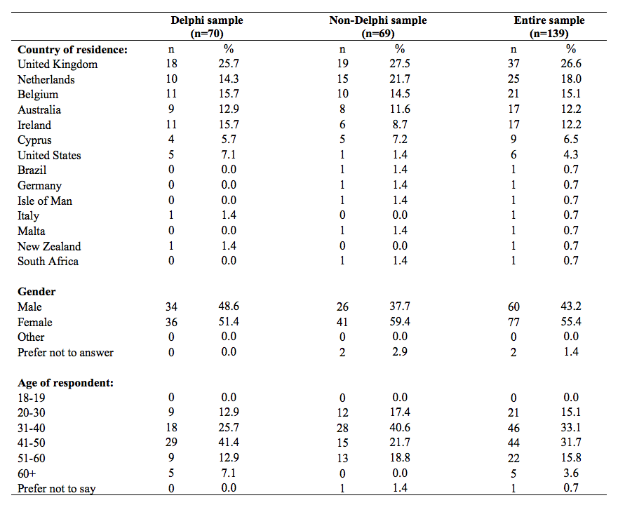

--------------------------------------------------------------------
Insert Table 3 here
--------------------------------------------------------------------

It can be seen that the respondents came from numerous countries across the world. Unsurprisingly, most respondents were located in the six countries participating in the DEIMP study, that is, the UK, The Netherlands, Belgium, Australia, Ireland and Cyprus. Some of the Delphi panelists were located in other countries (particularly the USA) and there were single teacher respondents from a handful of countries in which neither Delphi panelists were located nor were participating in the DEIMP project. These few respondents would have responded to online invitations on the DEIMP website.

2.3 The Best-Worst Scaling survey
The survey disseminated to the respondents was a Best-Worst Scaling (BWS) survey (Finn & Louviere, 1992). BWS provides a way of quantifying the relative importance of an issue or principle compared to other related issues or principles. Respondents complete a BWS survey to indicate the most important/least important of the set of issues in their view. BWS was first developed by Finn and Louviere (1992) and has been applied in a range of circumstances.
Previous studies using BWS in education have considered reasons for staying in the teaching profession, choices of educational technologies, and decisions about science teaching in primary schools (authors, 2013; authors 2016, authors 2018). It is a useful methodology for assessing decisions.

Unlike a Likert scale where respondents can choose each item as being extremely important or unimportant, in a BWS respondents have to nominate which item is most important relative to other items being considered (Marley & Louviere, 2005). As such, respondents are forced to trade off items against each other rather than potentially nominate all items as being equally (un)important.

The 21 principles identified in our earlier discussion as underpinning innovative m-learning practice (see Background) were the subject of the BWS survey. We wished to ascertain which of these principles were perceived to be most important relative to the others for effective m-learning. The BWS survey comprised 7 tasks. In each of those tasks, participants were offered different sets of five principles to work with in their selection of most important principles. In each task, they selected the most important from the five. Then they selected the second most important from the four remaining. They continued in this way until they had nominated in order the four most important principles of the five, thus also indicating their perceptions about which was least important.

Thus participants had different combinations of principles offered in each set so that they could select the importance of one principle relative to other principles. Each item appeared with each other once only. The underlying design used was a Balance Incomplete Block Design (BIBD) for 21 treatments (Bose 1939; authors, 2013). Using BIBD, the 21 items were displayed in 21 sets of five items. Each respondent was assigned to undertake 7 treatments or tasks.

2.4 Analysis
The scores for each principle were derived from an ordinal probit model that considered the likelihood that a principle would receive a particular ranking of best to worst relative to the presence of other principles evaluated by the respondent (McKelvey & Zavoina, 1975). To aid interpretation, the parameter estimates were standardized with respect to the principles being least and most likely to be selected. That is, the scores reported in the next section assume that a score of 100 represents the principle most likely to be selected as effective and a score of 0 represents the principle least likely to be selected as effective.

In summary, use of BWS and the underlying BIBD design allowed the researchers to ascertain the relative value of the 21 principles when compared to each other. The results informed us of what teachers and Delphi panelists (or m-learning experts) perceived as the most essential principles for effective m-learning and what they perceived as the least essential principles.

3. Limitations
One limitation of the BWS concerned the understandings of the descriptions of the principles. Of the six partner countries participating in the study, three had a first language other than English (Cyprus, Belgium and The Netherlands). Project team members from those countries, particularly members from Belgium, reported that their participating teachers sometimes were not sure of the meaning of a particular principle. Further, although the meaning of each principle was clearly explained under the principle name, if respondents looked only at the names, they could have been confused by these, for example, student agency and student autonomy are generally considered to be similar concepts. It was the descriptions in this case that differentiated between these concepts.

4. Results

4.1 Delphi results
Four of the top five principles emphasised by the Delphi panel were related to authentic learning (see Figure 1 below). The 70 Delphi experts perceived situated learning in realistic settings (ie. suitable to the topic) as the most important aspect of designing effective m-learning tasks for school-aged learners. They also highlighted the consideration of ‘real-world processes’ (ranked 2) and ‘real-world tools’ (4). These results revealed a high priority for realistic m-learning activities like those enacted by practitioners (e.g. scientists, authors, musicians etc.), as well as an emphasis on real-world, discipline-based use of tools (e.g., camera as a microscope, music app as a keyboard etc.). ‘Seamless learning’ (6) across a variety of physical and virtual contexts was also perceived by Delphi panelists as important, as was the principle of ‘bridging’ (8) of learning across formal and informal contexts. Note that the error bars in Figures 1 and 2 represent a 95% confidence interval for the mean BWS score associated with each principle.
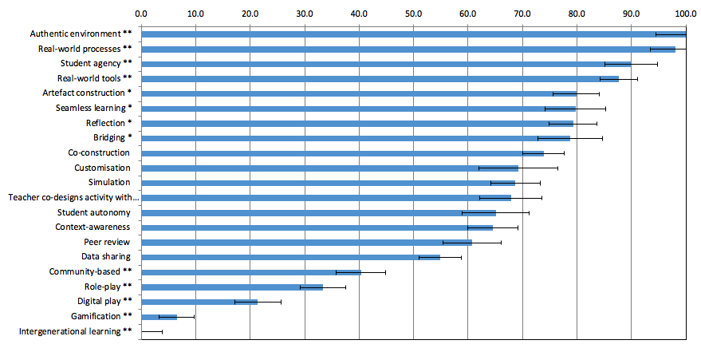

Figure 1. Most important principles in designing effective m-learning activities as perceived by Delphi Experts (n=70). Note: ** Sig. ≤ .01 (two-tailed); * Sig. ≤ .05

--------------------------------------------------------------------
Insert Figure 1 here
--------------------------------------------------------------------

‘Intergenerational learning’ (21) between school-aged learners and younger or older learners was the least important principle perceived by the Delphi experts when designing m-learning activities. Similarly, principles broadly linked to games-based learning (‘role-play’ (18), ‘digital play’ (19) and ‘gamification’ (20)) were perceived as less important compared to most other principles shown in Figure 1. ‘Community-based learning’ (17) and ‘data sharing’ (16) were two other principles that were not highly prioritised by the panel. Given the panel’s propensity towards prioritising authentic learning principles, it was particularly surprising that community projects, a form of project-based learning with goals and processes typically embedded in real-world problems, were not emphasised by the Delphi panel as overly important when designing m-learning tasks for school-aged learners.

4.2 Teacher results
The teachers’ most highly ranked principles were primarily linked to aspects of personalised learning (see Figure 2 below). Their top two ranked principles, ‘customisation’ (ranked 1) and ‘student agency’ (2), indicated a high priority for activities that leveraged individualised learning pathways and tasks that catered for student choice. Teachers also perceived ‘real-world processes’ (4), ‘seamless learning’ (5) and ‘bridging’ of informal and formal contexts (7) as important principles underpinning effective m-learning for school-aged learners.
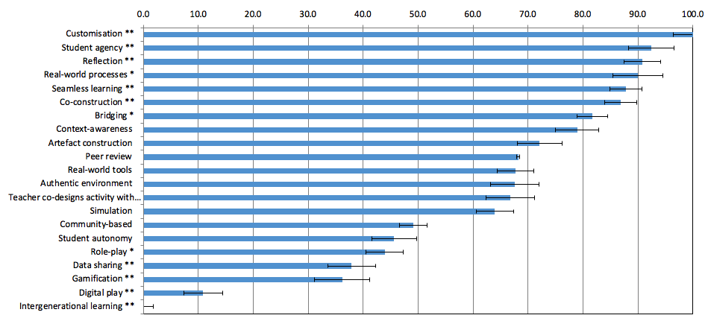

Figure 2. Most important principles in designing effective m-learning activities as perceived by Teachers (n=69). Note: ** Sig. ≤ .01 (two-tailed); * Sig. ≤ .05

--------------------------------------------------------------------
Insert Figure 2 here
--------------------------------------------------------------------

Like the Delphi panel, ‘intergenerational learning’ (21) was perceived by the teachers as the least important principle when designing m-learning activities. Similarly, principles linked to games-based learning (‘role-play’ (17), ‘digital play’ (20) and ‘gamification’ (19) were again perceived as less important, as were ‘community-based learning’ (15) and ‘data sharing’ (18) principles. Given the teachers’ emphasis on personalised learning principles, it was surprising that ‘student autonomy’ (16) was not perceived as more important when designing m-learning tasks for school-aged learners.

4.3 Overall
The most important and least important principles for designing effective m-learning activities for school-aged learners are shown below for both cohorts (Delphi experts and teachers), as well as an overall aggregate score combining both cohorts (see Table 4). ‘Real world processes’ (ranked 2 by Delphi panel, and 4 by teachers) was the strongest principle overall, followed by ‘student agency’ (3 and 2). The next three most important principles overall were ‘authentic environment’ (1 and 12), ‘customisation’ (10 and 1) and multi-modal ‘reflection’ (7 and 3). Intergenerational learning (21 and 21) was perceived by both groups as the least important principle, with ‘digital play’ (19 and 20) ranked as the 2nd least important principle overall.

Comparisons between cohort rankings also can be seen in Table 4 below. In comparing the perceptions of the Delphi experts and the participating teachers, we found that overall the correlation in mean scores was extremely high (r=.83) with some significant differences noted.
Table 4: Comparison of non-normalised scores.
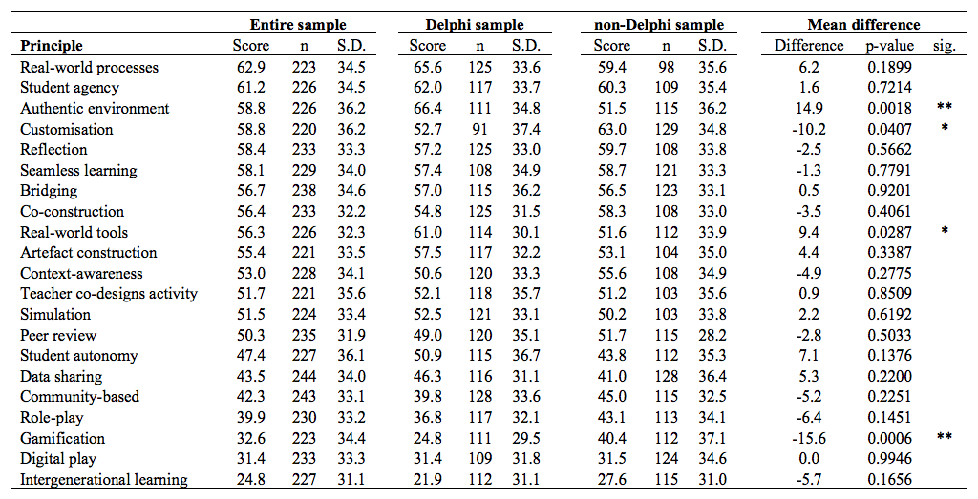
Note: ** Sig. ≤ .01 (two-tailed); * Sig. ≤ .05

--------------------------------------------------------------------
Insert Table 4 here
--------------------------------------------------------------------

In particular, the analysis shows that there are only two principles that receive a slightly different rank at the .01 level and one principle is ranked significantly different at the .05 level. In particular, the Delphi-panel placed significantly more relevance on the ‘authentic environment’ principle relative to the teacher sample (p<.01) and ‘real-world tools’ (p<.05) but significantly less emphasis on the principle of ‘customisation’ (p<.05) and ‘gamification’ (p<.01) than the teacher cohort.

5. Discussion
The 21 principles under scrutiny in this BWS survey were identified as underpinning innovative m-learning with school-aged learners in a previous systematic literature review (authors, 2019). The results of this survey have identified a subset of these 21 principles that was clearly perceived by m-learning experts and teachers as more important in terms of potential to support m-learning for school-aged learners. Participants particularly highlighted aspects of authentic learning (Delphi panel) and personalised learning (teachers) as high priorities for effective m-learning design. We speculate that the principles resonating with teacher participants in particular were probably the principles that teachers felt could be more easily adopted in the design of innovative m-learning practices. In this way, these principles highlighted by teachers as ‘more important’ relative to other principles may act as a catalyst to feasible innovation ( authors, 2019b) in their m-learning practices.

This study also highlighted principles that were perceived by participants as relatively less important for effective m-learning design. Aspects of games-based learning (e.g., digital play, gamification) and to a lesser extent, aspects of collaboration (e.g., data sharing, co-construction), were not prioritised by participants in relation to other principles. Intergenerational learning was the principle perceived as the least important by both groups relative to the other principles. Interestingly, in the SLR the three articles identified as most innovative were all underpinned by this principle (authors, 2019). Given all 21 principles emerged from a substantial literature base on innovative mobile pedagogies (authors, 2019), these results reveal an apparent gap between examples of innovative practices in the literature and the practicalities of designing m-learning in school teaching contexts that is underpinned by particular principles. These ‘less-favoured’ principles provide a future focus for teachers’ professional learning. Indeed, in the last phase of our DEIMP project aiming at scaling up innovative m-learning practices amongst participating schools, these principles will be emphasised. Further research could test our hypothesis as to why these principles are perceived as less important, using additional methods such as interviews and focus groups.

Another point of interest emerging from this study is the different emphases of teacher participants (n=69) from the Delphi panel (n=70). When considering the 21 principles in the BWS survey, the Delphi experts’ most favoured principles were linked to authentic learning (e.g., ‘authentic environment’, ‘real-world processes’), while the teachers most prioritised principles were more closely aligned to personalised learning (e.g., customisation, student agency). Given the emphasis on differentiated learning in contemporary school curricula, the teachers’ emphasis on aspects of personalised learning was unsurprising. However, further research needs to further interrogate these discrepancies between teachers and other education experts. For example, given that most of the teachers were in secondary education, what are the effects of factors inherent in the 7-12 education landscape (e.g., prescriptive, formal curriculum requirements and external, high-stakes testing) on their perceptions of effective m-learning? To what extent are teachers’ perceptions of authentic learning principles (rated more highly by the Delphi panel) constrained by these parameters of formal schooling? How do these factors influence teachers’ consideration of m-learning principles and possibilities (such as community-based projects, intergenerational learning opportunities and aspects of collaboration) more closely aligned with mobile pedagogies in less formal, hybrid and untethered contexts?

6. Conclusions
The contribution of the BWS survey is significant in two ways. Firstly, this is the first time that this particular methodology has been used to interrogate stakeholders’ perceptions of the relative importance of mobile pedagogical principles. Secondly, the results unpack what effective innovation might look like in terms of underpinning pedagogical principles from the perspective of teachers and m-learning experts. Given that we and others (authors, 2019; Law, Chow & Yuen, 2005) have argued that feasible innovation is more likely to be adopted than radical innovation, understanding which principles are seen as more effective relative to others, indicates what feasible innovation might look like. Professional learning courses and apps such as those developed in this DEIMP project could emphasise ways to underpin m-learning designs for school-aged learners that include some of the more innovative principles identified in the literature.

This article helps to apprise us of how innovative m-learning principles underpinning pockets of innovation for school-aged learners (authors, 2019b) are viewed relative to each other by teacher practitioners and m-learning experts. Understanding teachers’ and m-learning experts’ views should inform professional development initiatives for supporting all teachers’ adoption of cutting-edge and effective learning design principles for their mobile pedagogies.

Ethics Approval [ university name removed for blind review]
All procedures performed in studies involving human participants were in accordance with the ethical standards of the University of X (approval no. No. 20162017009) and with the 1964 Helsinki declaration and its later amendments or comparable ethical standards

References [author references removed for blind review]
Bose, R. C. (1939). On the construction of balanced incomplete block designs. Annals of Eugenics, 9(4), 353-399.
Finn, A., & Louviere, J. J. (1992). Determining the appropriate response to evidence of public concern: the case of food safety. Journal of Public Policy & Marketing, 11(2), 12-25.
Joan, R. (2013). A study on mobile learning as a learning style in modern research practice. Journal on School Educational Technology, 8(4), 29-37.
Kee, C.L. & Samsudin, Z. (2014). Mobile devices: Toys or learning tools for 21st century teenagers? Turkish Online Journal of Educational Technology, 13(3), 107-122.
Law, N., Chow, Y., & Yuen, H. K. (2005). Methodological approaches to comparing pedagogical innovations using technology. Education and Information Technologies, 38, 7–20.
Marley, A.A., & Louviere, J.J. (2005). Some probabilistic models of best, worst, and best/worst choices. Journal of Mathematical Psychology, 49 (6), 464-80.
McKelvey, R. D., & Zavoina, W. (1975). A statistical model for the analysis of ordinal level dependent variables. Journal of Mathematical Sociology, 4(1), 103-120.
Royle, K., Stager, S. & Traxler, J. (2014). Teacher development with mobiles: Comparative critical factors. Prospects, 44(29) https://doi.org/10.1007/s11125-013-9292-8

