Supramolecular Assemblies Controlled by Cucurbit[n]uril Size (n = 6, 7, 8 and 10)

Weitao Xu,ª Xinyu Deng,ª Xin Xiao,^{a*} Bing Bian,^{c} Qing Chen,^{a*} Scott J. Dalgarno,^{d} Zhu Tao,ª and Carl Redshaw ^{b*}

ª Key Laboratory of Macrocyclic and Supramolecular Chemistry of Guizhou Province, Guizhou University, Guiyang 550025, China
^{b} Department of Chemistry and Biochemistry, University of Hull, Hull HU6 7RX, U.K.
^{c} College of Chemical and Environmental Engineering, Shandong University of Science and Technology, Qingdao 266590, P. R. China.
^{d} Institute of Chemical Sciences, School of Engineering and Physical Sciences, Heriot-Watt University, Edinburgh EH14 4AS, U.K.

*Corresponding author. Tel./fax: +86 15519089928
E-mail addresses: gyhxxiaoxin@163.com (X. Xiao), c.redshaw@hull.ac.uk (C. Redshaw)

Abstract: A benzyl substituted 4-pyrrolidinopyridinium salt (G) with multiple active sites including benzyl, pyridinium and pyrrole groups has been synthesized. The interaction between G and a series of cucurbit[n]urils (TMeQ[6], Q[7], Q[8], Q[10]), has been studied both in aqueous solution and in the solid state. The binding interaction site between G and the Q[n] can be controlled by the different size of the cavity of the Q[n]s. In the case of TMeQ[6], the benzyl is accommodated within the cavity, whilst for Q[7] and Q[8], the pyrrole ring and the benzyl are accommodated within the cavity of the Q[7/8], and the latter can shuttle on the guest G in a state of dynamic equilibrium. For the larger cavity of Q[10], the entire G molecule is located within the cavity of the Q[10].

Keywords: 4-pyrrolidinopyridinium salt; cucurbit[n]urils; binding interaction site.
- Introduction
Host–guest complexation or molecular recognition has gained increasing attention in recent years.^{[1–13]} Cucurbit[n]urils (Q[n]),^{[14–19]} are an intriguing class of macrocyclic host, and exhibit exceptional molecular recognition properties due to their high binding affinities and tuneable association and dissociation properties. Indeed, different cucurbit[n]uril-based supramolecular switches, polymers and nanoparticles, as well as other supramolecular systems with fascinating properties and applications have been developed.^{[20–26]} In our group, we have been studying the host-guest behaviour of Q[n]s towards a variety of pyridinium salts, and high binding constants have been observed.^{[27, 28]} In particular, we have investigated the nature of the host-guest complex between Q[6] and N-butyl-4-pyrrolidinopyridine (BuPC4),^{[29]} Q[8] and alkyl substituted 4-pyrrolidinopyridinium salts,^{[30]} and Q[10] and alkyl substituted 4-pyrrolidinopyridinium salts.^{[31]} Interestingly, the differing length of the alkyl determines the binding interactions between the Q[8] or Q[10] and the alkyl substituted 4-pyrrolidinopyridinium salts.
We now design a new guest, namely the benzyl substituted 4-pyrrolidinopyridinium salt (G) (see chart 1 below). The potential guest molecule G has multiple active sites which may interact with the different size of the Q[n] cavity. This prompted us to wonder which active site would preferentially reside within each of the Q[n]s, and if the binding interaction site between G and the Q[n] can be controlled by the differing cavity sizes. Given this, a series of host–guest supramolecular structure were constructed between G and a series of Q[n]s, specifically TMeQ[6], Q[7], Q[8] and Q[10]. The host-guest structures were investigated using NMR and UV spectroscopy, MALDI-TOF mass spectrometry, isothermal titration calorimetry (ITC) and by single crystal X-ray crystallography.

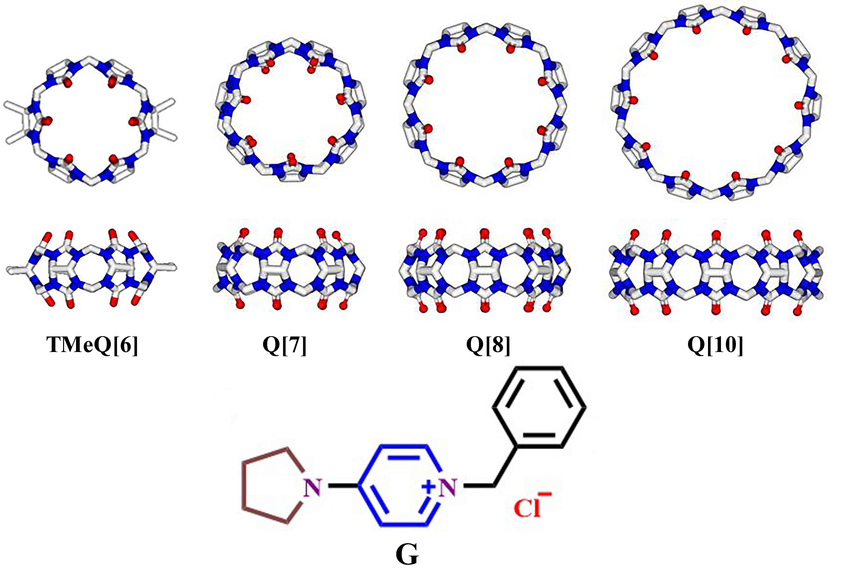
Chart 1. The Q[n]s and G used in this study.³²

- Results and Discussion
2.1 NMR spectroscopy
The binding interaction between each of the benzyl substituted 4-pyrrolidinopyridinium salt and the Q[n]s (TMeQ[6], Q[7], Q[8] or Q[10]) can be conveniently monitored using ¹H NMR spectroscopic data recorded in neutral D₂O solution.

In the case of TMeQ[6]:
Figure 1 shows the changes observed in the ¹H NMR spectrum of G as progressively larger amounts of TMeQ[6] are added to the solution. A slight up-field shift of the signals of the protons of the benzyl group and a clear down-field shift of the signals of the protons of the pyridine and pyrrole rings were observed as increasing amounts of TMeQ[6] were added. In particular, on adding TMeQ[6], the resonances of protons H_{d}, H_{c}, H_{b} and H_{a} of G, exhibited a down-field shift of 0.73 ppm (from 7.92 ppm to 8.65 ppm), 0.07 ppm (from 6.64 ppm to 6.71 ppm), 0.09 ppm (from 3.40 ppm to 3.49 ppm) and 0.04 ppm (from 1.97 ppm to 2.01 ppm). By contrast, the protons H_{f} and H_{e} of the benzyl experienced an up-field shift of 0.88 (from 7.27 ppm to 6.39 ppm) ppm and 0.47 ppm (from 5.21 ppm to 4.74 ppm), respectively, and the proton H_{gh} of the benzyl exhibited two kinds of protons, viz H_{g’} (from 7.37 ppm to 6.52 ppm) and H_{h’} (from 7.37 ppm to 6.46 ppm). Lastly, the COSY spectrum (Figure S1) of G with 2.22 equiv. of TMeQ[6] in D₂O was studied. These shifts indicated that the pyridine and pyrrole rings were out the portal of the TMeQ[6] and that only the benzyl motif was accommodated within the cavity of the TMeQ[6] as represented by the cartoon representation top right of Figure 1.

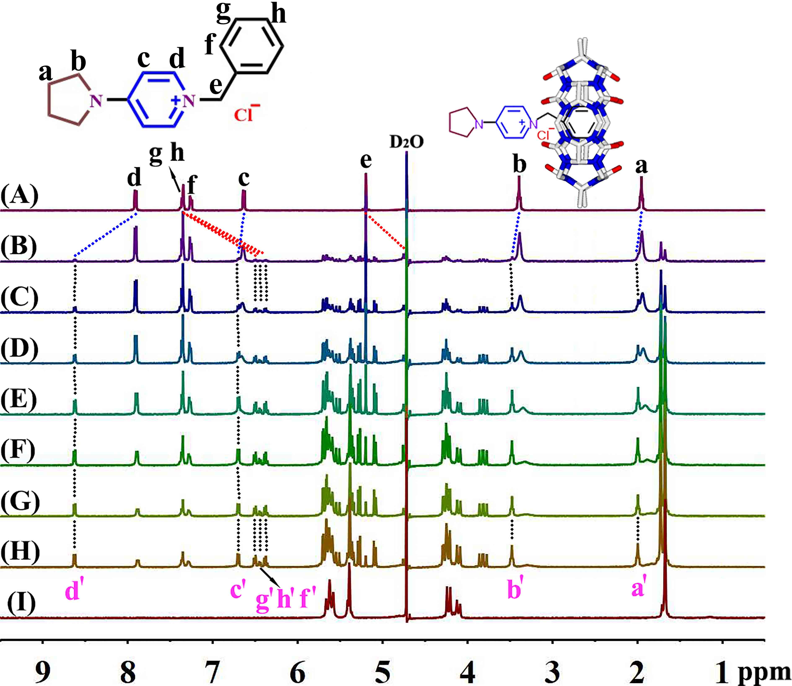
Figure 1. Interaction of G and TMeQ[6] (20 ℃): (A) ¹H NMR spectra (400 MHz, D₂O) of G (ca. 1 mM) in the absence; (B) in the presence of 0.13 equiv.; (C) 0.25 equiv.; (D) 0.38 equiv.; (E) 0.60 equiv.; (F) 0.95 equiv.; (G) 1.49 equiv.; (H) 2.22 equiv.; (I), and neat TMeQ[6].

In the case of Q[7]:
Figure 2 shows the ¹H NMR titration spectra of G in D₂O recorded (A) in the absence of Q[7], and with increasing proportions of Q[7] at (B) 0.13, (C) 0.28 equiv., (D) 0.41 equiv., (E) 0.68 equiv., (F) 0.90 equiv., (G) 1.19 equiv., (H) 1.71 equiv., and (I) neat Q[7] in D₂O at 20 ℃. Noticeably up-field shifts were observed for all the protons of the pyridine ring, pyrrole ring and the benzyl group as more Q[7] was added. On addition of one equivalent of Q[7], all peaks were shifted by > 0.12 ppm compared to their positions in free G, with the largest shift observed for Hc at 0.48 ppm (from 6.64 to 6.16 ppm); the shifts for the other protons of G are available in Table S1 in the SI. This indicates that the pyridine ring, the pyrrole ring and the benzyl group are all accommodated within the cavity of the Q[7]. As for G with TMeQ[6], the COSY spectrum (Figure S2) of G with 1.71 equiv. of Q[7] in D₂O was studied. However, given that the cavity of the Q[7] is larger than the size of G, Q[7] could shuttle on the guest G in a state of dynamic equilibrium, and the exchange process involving the G thread through the cavity of Q[7] seems to be fast relative to the NMR timescale.

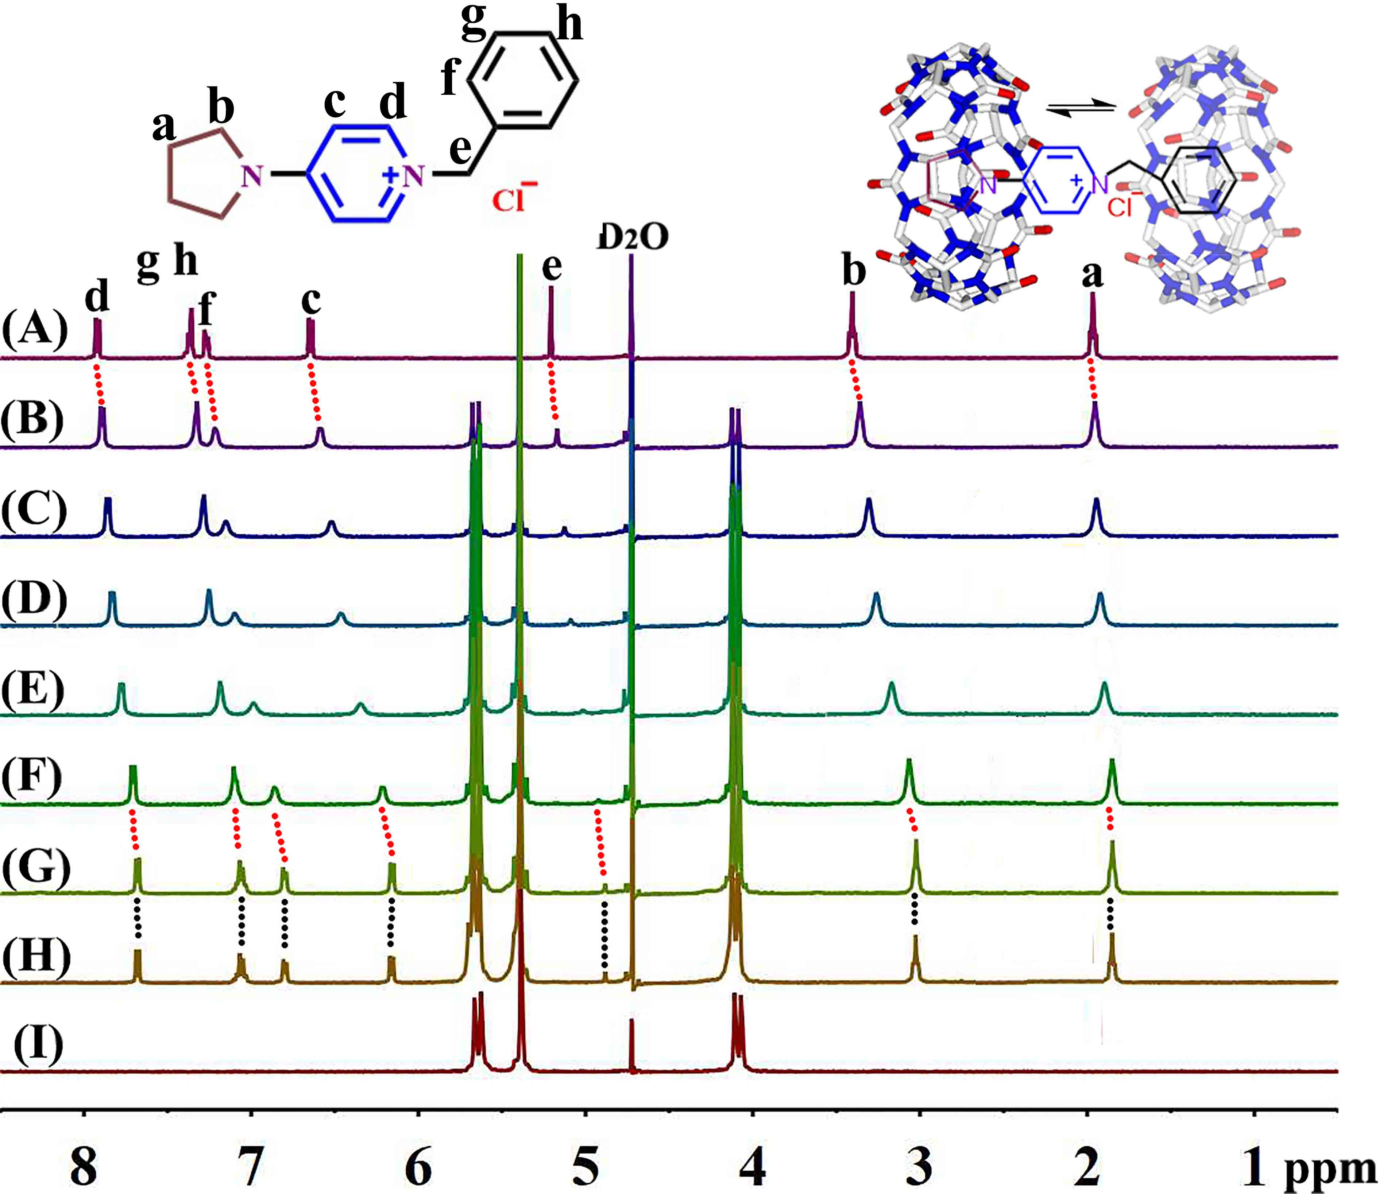
Figure 2. Interaction of G and Q[7] (20 ℃): ¹H NMR spectra (400 MHz, D₂O) of G (ca. 1 mM) (A) in the absence of Q[7], in the presence of (B) 0.13 equiv., (C) 0.28 equiv., (D) 0.41 equiv., (E) 0.68 equiv., (F) 0.90 equiv., (G) 1.19 equiv., (H) 1.71 equiv., and (I) neat of Q[7].

In the case of Q[8]:
Figure 3 shows the ¹H NMR titration spectra of G in D₂O recorded (A) in the absence of Q[8] and with increasing proportions of Q[8] at (B) 0.51, (C) 1.15 equiv., (D) 1.26 equiv., and (E) neat Q[8] in D₂O at 20 ℃. Noticeably up-field shifts were observed for all the protons of the pyridine ring, pyrrole ring and benzyl group as more Q[8] was added. In particular, as Q[8] was added, H_{d}, H_{gh}, H_{f}, H_{c} and H_{e} of G move up-field slowly until about one equivalent of Q[8] was added, exhibiting up-field shifts of 0.19 ppm, 0.47 ppm, 0.37 ppm, 0.31 ppm and 0.48 ppm, respectively compared to their positions in free G; H_{gh} merges with H_{f}. However, H_{b} and H_{a} of the pyrrole ring are different from the above, and they move up-field at first, and then move down-field slowly. Thus, at 1.26 equivalents of Q[8], the protons H_{b} and H_{a} of the pyrrole ring of G experienced a down-field shift of 0.12 ppm, 0.16 ppm, respectively compared to their positions observed for 0.51 equiv. of Q[8]. Also at this concentration of Q[8], H_{b} and H_{a} of the pyrrole of G, underwent up-field shifts of 0.45 ppm and 0.54 ppm respectively compared to their positions in free G. This indicates that the pyridine ring, the pyrrole ring and the benzyl group are all accommodated within the cavity of the Q[8], and that the Q[8] can shuttle on the guest G in a state of dynamic equilibrium (see Figure 3). This is illustrated by the broad resonances observed upon the gradual addition of Q[8] to the guest G.

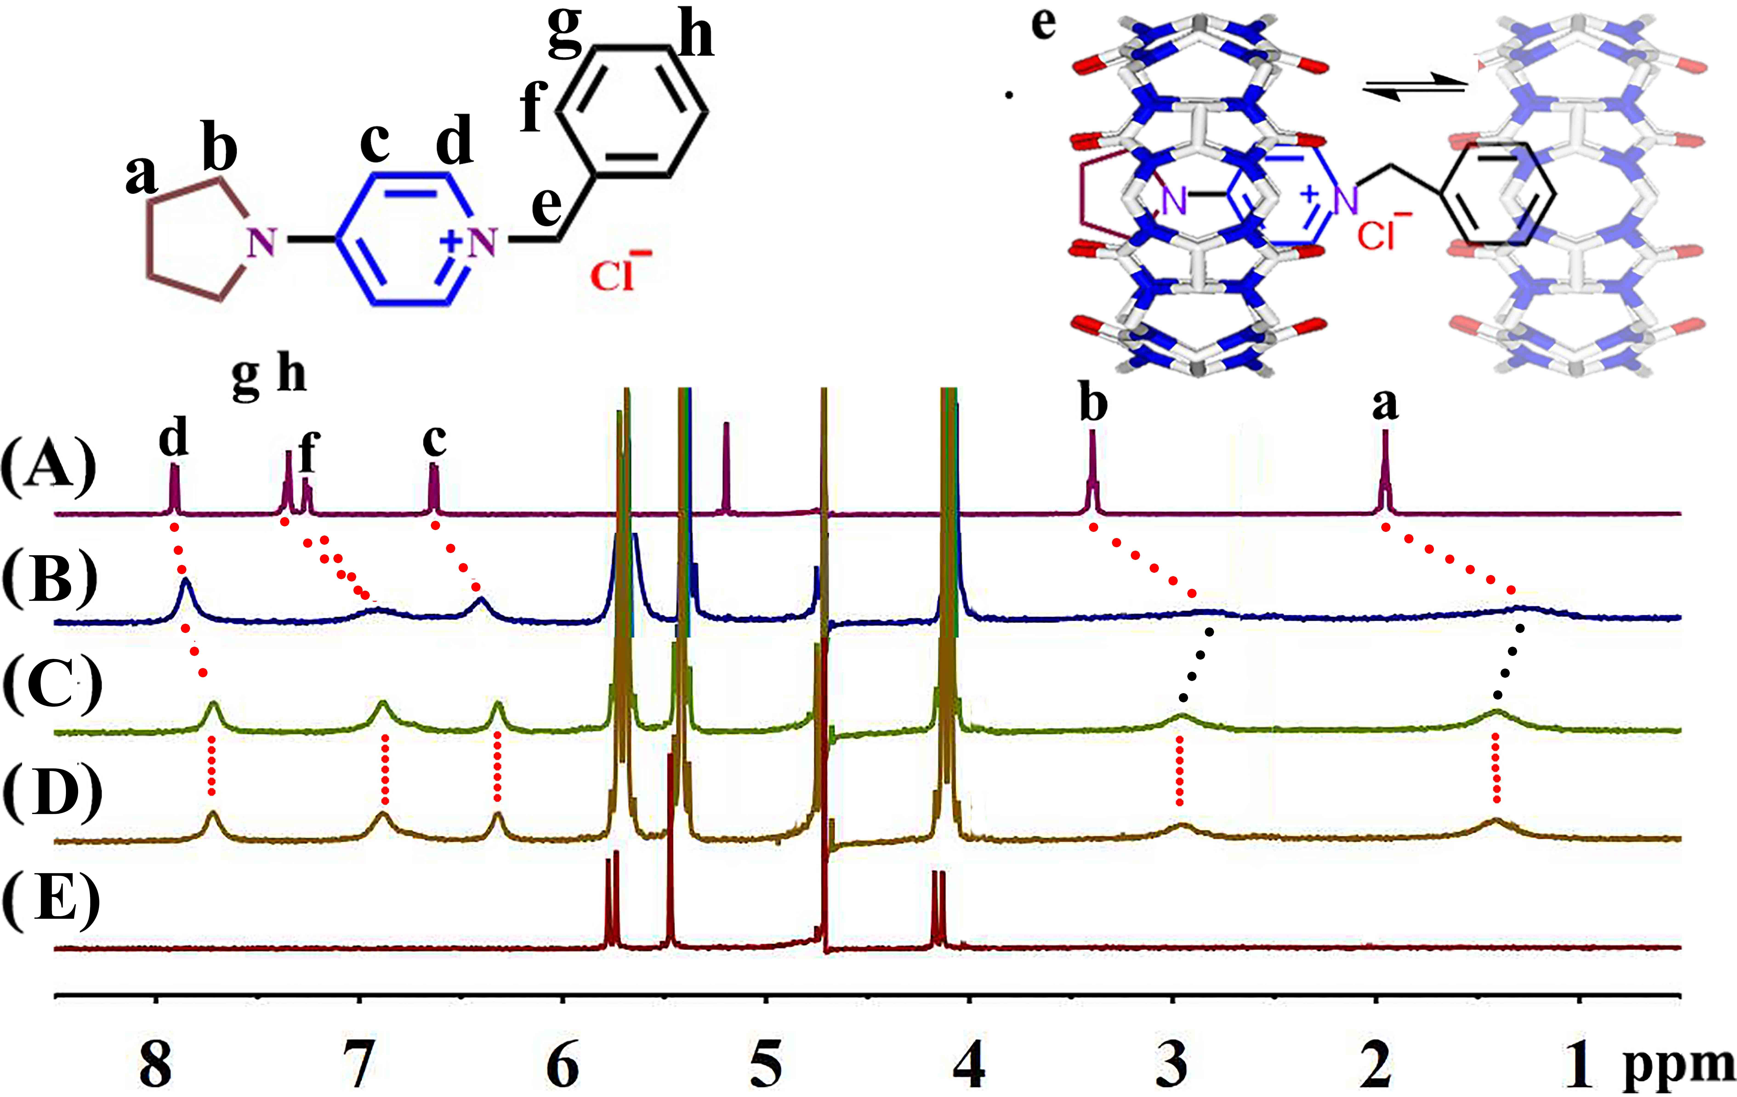
Figure 3. Interaction of G and Q[8] (20 ℃): ¹H NMR spectra (400 MHz, D₂O) of G (ca. 1 mM) (A) in the absence of Q[8], in the presence of (B) 0.51 equiv., (C) 1.15 equiv., (D) 1.26 equiv., and (E) neat of Q[8].

In the case of Q[10]:
Figure 4 shows the ¹H NMR titration spectra of G in D₂O recorded (A) in the absence of Q[10] and with increasing proportions of Q[10] at (B) 0.04, etc...... (I) 0.76 equiv., etc...... (O) 2.05 equiv., and (P) neat Q[10] in D₂O at 20 ℃. Noticeably up-field shifts were observed for all the protons of the pyridine ring, pyrrole ring and benzyl group as more Q[10] was added. In fact, as Q[10] was added, H_{gh}, H_{f}, H_{e} and H_{a} of G move slowly up-field, exhibiting up-field shifts of 0.42 ppm, 0.41 ppm, 0.42 ppm and 0.46 ppm, respectively compared to their positions in free G, whilst H_{gh} combine with H_{f}. However, H_{d}, H_{c} of the pyridine ring and H_{b} of the pyridine ring are different from the above, firstly, they move up-field, then slowly move down-field, and at 2.05 equiv. of Q[10], the protons H_{d}, H_{c} of the pyridine ring and H_{b} of the pyridine ring of G experienced a down-field shift of 0.20 ppm, 0.31 ppm, 0.17 ppm, respectively compared to their positions observed for 0.758 equiv. of Q[10]. Also at this concentration of Q[10], H_{d}, H_{c} of the pyridine ring and H_{b} of the pyridine ring of G, underwent up-field shifts of 0.48 ppm, 0.62 ppm and 0.58 ppm respectively compared to their positions in free G. This indicates that the pyridine ring, the pyrrole ring and the benzyl group are all located within the cavity of Q[10], due to the large cavity of Q[10]. Also, the Q[10] can shuttle on the guest in a state of dynamic equilibrium. The likely reason for this is that Q[10] has a large cavity, and there are multiple binding models possible between the guest and Q[10].

Figure 4. Interaction of G and Q[10] (20 ℃): ¹H NMR spectra (400 MHz, D₂O) of G (ca. 1 mM) (A) in the absence of Q[10], in the presence of (B) 0.04 equiv., (C) 0.21 equiv., (D) 0.30 equiv., (E) 0.39 equiv., (F) 0.45 equiv., (G) 0.55 equiv., (H) 0.69 equiv., (I) 0.76 equiv., (J) 0.88 equiv., (K) 1.02 equiv., (L) 1.15 equiv., (M) 1.28 equiv., (N) 1.58 equiv., (O) 2.05 equiv., and (P) neat Q[10].

2.2 UV spectroscopy
To further understand the binding of the benzyl substituted 4-pyrrolidinopyridinium salt to these Q[n]s, we have also employed UV-vis spectroscopy. The UV spectra were obtained using aqueous solutions containing a fixed concentration of G and variable concentrations of Q[n]s. Figure S3 shows that TMeQ[6] does not affect the UV-vis of G. As shown in Figure 5 and Figures S4-S5 in the SI, the other three systems exhibit similar phenomena except for the system TMeQ[6]@G, and here only the interactions between Q[7] and guest G are described as an example. On gradually increasing the Q[7] concentration in the G solution, the absorption band of the guest exhibits progressively higher absorbance due to the formation of the host-guest complex Q[7]@G. The absorbance vs. ratio of n(Q[7])/n(G) data can be fitted to a 1:1 binding model. The pyrrolidinopyridinium motif and the benzyl group of the guest are both encapsulated into the cavity of the Q[7] host. Furthermore, the binding constants (Ka) of the inclusion complex was calculated from UV-vis spectrophotometry data according to the modified Benesi-Hildebrand (B-H) equation.^{[33]} The Ka values are 2.25 × 10⁶ M ⁻¹ (for Q[7]@G), 8.71 × 10⁵ M ⁻¹ (for Q[8]@G) and 5.98 × 10⁶ M ⁻¹ (for Q[10]@G), respectively. The Ka value for Q[7]@G system is of the same order of magnitude as obtained by ITC, while the Ka value for Q[8]@G system is lower than the results obtained by ITC. The Ka value for Q[10]@G system is greater than the results obtained by ITC.

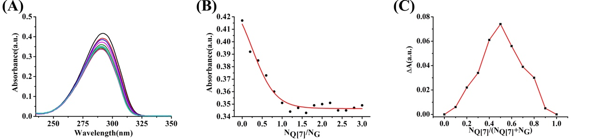
Figure 5. (Colour online) (A) Electronic absorption of G (2×10⁻⁵ mol L⁻¹) upon addition of increasing amounts (0, 0.2, 0.4······2.6, 2.8, 3.0 equiv.) of Q[7]; (B) the concentrations and absorbance vs. N_{Q[7]}/N_{G} plots; (C) the corresponding ΔA–N_{Q[7]}/(N_{Q[7]} + N_{G}) curves.

2.3 Mass spectrometry
The nature of the inclusion complexes formed between the Q[n]s and the benzyl substituted 4-pyrrolidinopyridinium salt was also established by the use of MALDI-TOF mass spectra, as shown in Figure S6. Intense signals were observed at 1292, 1402, 1568 and 1901, which correspond to [(TMeQ[6]@G)-Cl－]⁺, [(Q[7]@G)-Cl－]⁺, [(Q[8]@G)-Cl－]⁺ and [(Q[10]@G)-Cl－]⁺ respectively, thereby providing support for the formation of the 1:1 host-guest inclusion complexes.

2.4 Isothermal Titration Calorimetry
A solution of the guest G was injected into separate solutions of Q[n] at 25 ℃ to record the respective exothermic binding isotherms, see Figure S7. The association constants Ka for the Q[n]s were then derived from this experimental data (see table 1). Particularly high values of Ka were noted for Q[7] and Q[8], together with negative ΔG° values ranging from −34.42 kJ/mol to −35.06 kJ/mol. These values were consistent with the formation of stable inclusion complexes in aqueous solution. Furthermore, the large negative values found for ΔH were consistent with a largely enthalpy driven assembly process in these four system. The binding molar ratio in each case is 1:1. For comparison, the binding constant values of some hosts (including TMeQ[6], Q[7] and Q[8]) with G and other alkyl substituted 4-pyrrolidinopyridinium salts are listed in Table S2. The Ka value range is from 10⁴ to 10⁶ for the system involving alkyl substituted 4-pyrrolidinopyridinium salts to Q[8], with the Ka value for the longer alkyl chain system larger than that for the short alkyl chain system. Furthermore, for Q[8]system, the Ka value for Q[8]@G is of the same order of magnitude as for the short alkyl chain system.

Host-Guest | N | K_{a} /(M⁻¹) | ΔHº /(kJ·mol⁻¹) | TΔSº /(kJ·mol⁻¹) | ΔG /( kJ·mol⁻¹)
TMeQ[6]-G | 0.91 | (1.98± 0.5)×10⁴ | -63.13± 0.8 | -38.60± 0.7 | -24.53±1.5
Q[7]-G | 1.08 | (1.07± 0.4)×10⁶ | -41.33± 0.7 | -6.913± 0.6 | -34.42±1.3
Q[8]-G | 0.95 | (1.39± 0.8)×10⁶ | -34.63± 0.4 | 0.43± 0.7 | -35.06±1.1
Q[10]-G | 1.03 | (3.03± 0.6)×10⁵ | -25.60± 0.5 | 5.69± 0.8 | -31.29±1.3

Table 1. Data obtained from ITC experiments.

2.5 Crystal structures
Although challenging to crystallise, a structure of G was obtained by the addition of Cd(II) chloride to a HCl (6 M) solution containing G. Single crystals of [G₂][CdCl₄] were found to be in a monoclinic cell and the structure determination was carried out in the space group C2/c. The asymmetric unit (ASU) was found to contain two G cations and one [CdCl₄]²⁻ counterion, the structure of which is shown in Figure 6. There are π...π interactions between two benzene rings of the adjacent guest molecules G, with the centroid-centroid distance between two benzene rings at 3.627 Å (Figure S8).
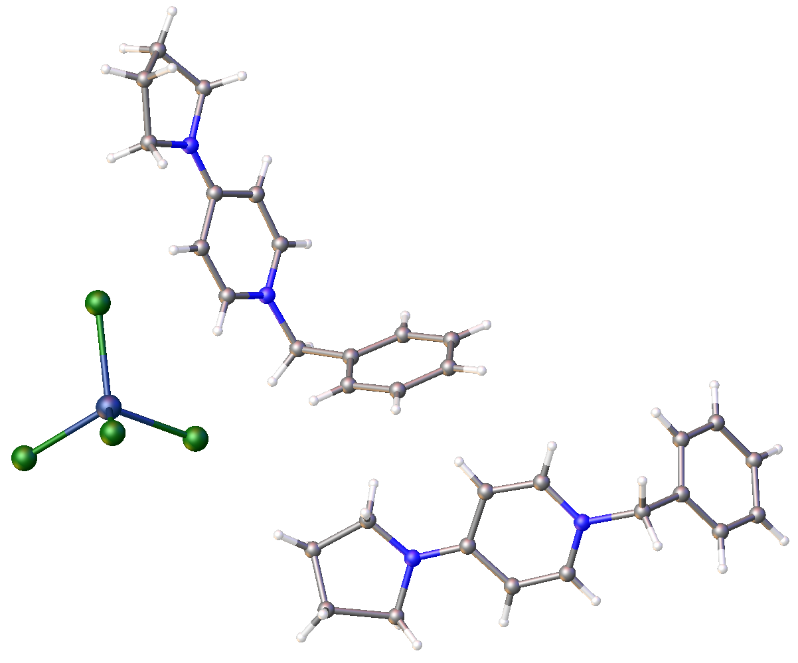
Figure 6. Single crystal X-ray structure of [G₂][CdCl₄] shown in ball and stick representation. Colour code: C – grey, H – white, N – royal blue, Cd – dark blue, Cl – green. One heterocycle is disordered but shown in only one of two positions for clarity.

Single crystals of the host-guest complexes formed between G and Q[8] were obtained in two cases through the addition of either Cd(II) or Zn(II) chloride to an acidic solution (6 M HCl solution), the aim being to promote crystallisation and to observe cavity occupation by G.
Single crystals of [(Q[8]@G)₂(H₃O)₈][Cd₆Cl₂₂] were found to be of the monoclinic cell type and the structure solution was performed in the space group P2₁/c. The ASU was found to contain one half of the aforementioned formula in the form of two half-Q[8] moieties, two disordered G cations, one half of the [Cd₆Cl₂₂]¹⁰⁻ anion and diffuse electron density associated with disordered water molecules and hydronium ions to provide charge balancing. The major components are discussed separately here for the sake of clarity. Symmetry expansion of the half-anion reveals a hexanuclear chain of Cd ions as shown in Figure 7 The four central Cd centres have octahedral coordination geometry, are linked by five bridging chlorides in each case, and have coordination spheres completed by a unidentate chloride. The chain terminates at each end with two Cd centres adopting distorted square pyramidal geometries, the coordination spheres of which contain two bridging and three unidentate chlorides. It should be noted that the formation of this type of polynuclear Cd-containing anion is not uncommon, and such species have been formed under various experimental conditions.^{[34, 35]}

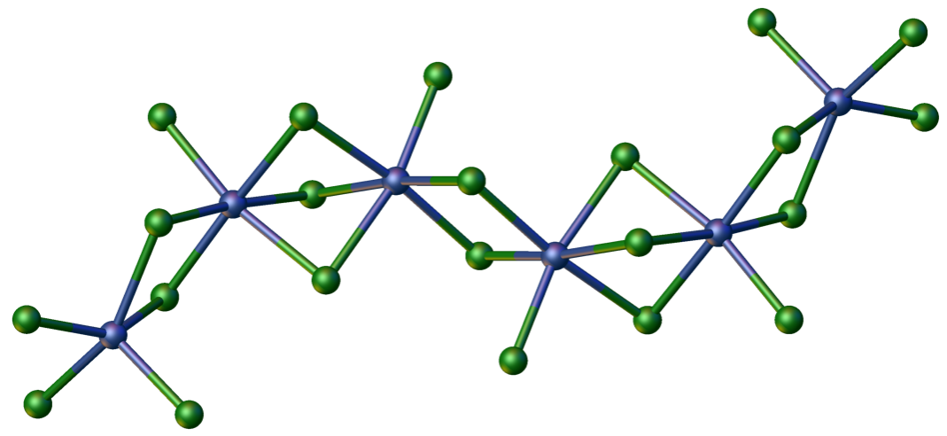
Figure 7. Part of the symmetry expanded single crystal X-ray structure of [(Q[8]@G)₂(H₃O)₈][Cd₆Cl₂₂] showing the anion in ball and stick representation. Colour code: Cd – dark blue, Cl – green.

As stated above, the ASU was found to contain two half-Q[8] moieties, the atoms of which were readily located and refined. Unfortunately, the electron density associated with the G cations was diffuse in both cases, and each G was found to be disordered over two positions within the Q[8] cavity (Figure 8). In both cases, it was possible to model the majority of the atoms in the disordered G cations, though this was not possible for all sections of the guests; these disordered sections protrude into areas also associated with disordered water molecules / hydronium ions. Inspection of Figure 8 shows the benzene ring of one disordered guest in two positions within one Q[8] cavity. Symmetry expansion around the guests reveals the second disordered position within each Q[8] cavity in each case, and the primary issue in locating the remaining atoms is that the low cavity occupancy, coupled with diffuse disordered water molecules and hydronium ions, means that the density associated with all of these partial occupancy species is very diffuse. As it was not possible to fully model all of the disorder, a solvent mask was applied to remove the remaining diffuse density, markedly improving the agreement indices as a result. The nature of the disorder in the extended structure is also problematic in discussing intermolecular interactions. There are C-H···O hydrogen bond interactions existing between the benzene group of G and the portal carbonyl group of Q[8] (C60···O11 = 3.441 Å), and also π...π interactions between the two benzene rings of guest molecule G in Q[8] cavity (Figure 8B).

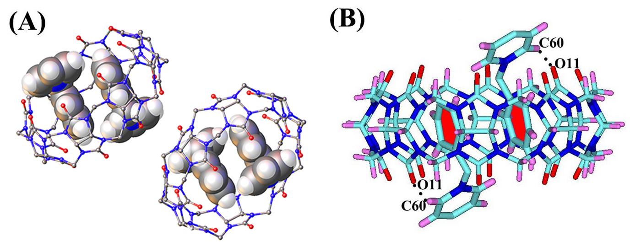
Figure 8. (A) Part of the symmetry expanded single crystal X-ray structure of [(Q[8]@G)₂(H₃O)₈][Cd₆Cl₂₂] showing the disordered guest the Q[8] cavities across two positions in each case. Note that it was not possible to fully refine all atoms of the guest cations due to severe disorder (50% occupancy in each position), but the majority of atoms were modelled in both cases. Guest cations and Q[8] hosts are shown in space filling and ball and stick representations, respectively, to emphasise their presence in the cavities. Colour code: C – grey, N – royal blue, O - red. H atoms omitted for clarity; (B) Single crystal X-ray structure of [(Q[8]@G)₂(H₃O)₈][Cd₆Cl₂₂] showing disordered guest cations and hydrogen bonding interactions.

Single crystals of [(Q[8]₂(Na(H₂O)₄)₂@G)(H₃O)₅][(ZnCl₄)₄] were found to be in an orthorhombic cell and the structure solution was performed in the space group Cmce. The ASU was found to contain one quarter of the aforementioned formula, and symmetry expansion affords a tubular cage-like arrangement as shown in Figure 9. The cage is composed of two Q[8] hosts tethered by two tetra-aquated Na ions (distorted octahedral geometry, aqua ligands disordered), meaning that the assembly can essentially be considered as a tubule. Diffuse density found within the cage conforms to a low-occupancy G ratio, which is in agreement with the solution phase studies outlined above. The nature of the density within the cage, coupled with symmetry imposed disorder, suggests that the guest cation is positioned in a total of eight different ways, and as such it was extremely challenging to model crystallographically. Although this is the case, it was possible to model an idealised guest within the cavity of the cage as shown in Figure 9A.
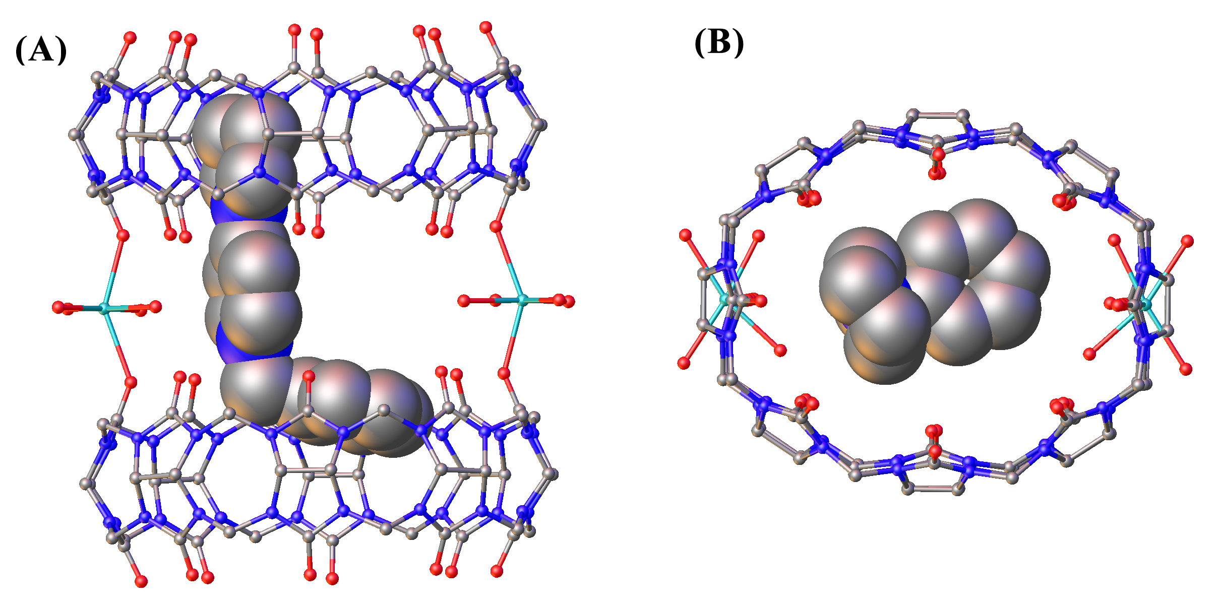
Figure 9. Two views of the molecular structure of [(Q[8]₂(Na(H₂O)₄)₂@G)(H₃O)₅][(ZnCl₄)₄] showing the disordered guest within the Q[8] cage held together by aquated sodium ions. Note that the latter is also disordered (50% occupancy in each position). Guest cations and the cage are shown in space filling and ball and stick representations, respectively, to emphasise their presence in the cavities. Colour code: C – grey, N – royal blue, O – red, Zn – dark blue, Na - aquamarine. H atoms, some disordered aquo ligands and ZnCl₄ ions omitted for clarity.

In addition to the above, there are also four ZnCl₄²⁻ ions found in the lattice, as well as a large number of disordered oxygen atoms associated with water molecules and hydronium ions that provide charge balance. Given that the crystals were formed under acidic conditions, it is reasonable to assume that charge balance for the assembly is provided in the form of five hydronium ions per cage. The severity of disorder associated with the water molecules and hydronium ions precludes identification and discussion of all associated positions and intermolecular interactions. As the diffuse density could not be modelled appropriately, a solvent mask was used to account for this. This had the effect of improving the agreement indices accordingly, though a relatively large residual peak was located near a heavy atom position (~1 Å) which is not uncommon. A search of the Cambridge Structural Database for organometallic Q[8] structures returns a total of 70 hits. Analysis of these results reveals that the tubular cage-like assembly shown in Figure 9 is a new assembly motif. We note though that coordination at the Q[8] rims has previously been observed for other metal ions, for example see CSD codes CIQKAQ,^{[36]} IPASOH,^{[37]} TONTIA.^{[38]} Given that the low-occupancies in solution also appear to be observed in the solid state, the addition of metal ions to form cage-like assemblies may be a useful approach to preventing these from partially residing in highly disordered environments, providing greater structural information relative to, for example, that provided in the structure of [(Q[8]@G)₂(H₃O)₈][Cd₆Cl₂₂]. This is a strategy we will explore further and report on in due course. Interestingly, there are multiple hydrogen bonding interactions existing between Q[8]-dimers including C-H···O hydrogen bonds between the methyl group of Q[8] and the portal carbonyl group of Q[8] (C25···O2 = 3.486 Å, C23···O4 = 3.309 Å), as well as O-H···O hydrogen bonds (O8···O13 = 2.729 Å, O8···O14 = 2.983 Å and O10···O14 = 2.729 Å) between the portal carbonyl group of Q[8] and water molecules coordinated with zinc ions, Figure 9C.

3. Experimental Section
3.1. General remarks
To analyze the host−guest complexation between G and the Q[n]s (TMeQ[6], Q[7], Q[8], and Q[10]), 2.0–2.5×10⁻³ mmol solutions of the Q[n] in 0.5–0.7 mL D₂O were prepared with G ratios ranging between 0 and 2. All the ¹H NMR spectra, including those for the titration experiments, were recorded at 298.15 K on a JEOL JNM-ECZ400S 400 MHz NMR spectrometer (JEOL) in D₂O. D₂O was used as a field-frequency lock, and the observed chemical shifts are reported in parts per million (ppm). All UV-visible spectra were recorded from samples in 1 cm quartz cells on an Agilent 8453 spectrophotometer, equipped with a thermostat bath (Hewlett Packard, California, USA). UV-visible spectra were obtained at 25 °C at a concentration of 2.00×10⁻⁵ mol·L⁻¹ G and at different Q[n] concentrations for the Q[n]@G system. MALDI-TOF mass spectra were recorded on a Bruker BIFLEX III ultra-high resolution Fourier transform ion cyclotron resonance (FT-ICR) mass spectrometer with ɑ-cyano-4-Hydroxycinnamic acid as matrix. 4-pyrrolidinopyridine was purchased from Aladdin Industrial Corporation, and the Q[n]s were prepared and purified according to the previously published methods.^{[15, 16]} All other reagents were of analytical grade and were used as received. Double-distilled water was used for all experiments.

3.2. Synthesis of guest G
4-pyrrolidinopyridine (296 mg, 0.00200 mol) and benzyl chloride (1520 mg, 0.0120 mol) were dissolved in acetonitrile (40 ml). The solution was stirred under an inert nitrogen atmosphere and heated to 80 °C and refluxed for 12 h. The resulting solution was filtered and then the yellow precipitate was washed with diethyl ether and then dried in vacuo to give G (467 mg, 85%). ¹H NMR (400 MHz,) δ 7.91 (d, J = 7.6 Hz, 2H), 7.35 (t, J = 6.8 Hz, 3H), 7.26 (d, 2H), 6.63 (d, J = 7.6 Hz, 2H), 5.20 (s, 2H), 3.39 (t, J = 6.8 Hz, 4H), 1.95 (t, J = 8.3, 5.3 Hz, 4H). ¹³C NMR (400 MHz,) δ 153.54, 141.24, 134.87, 129.40, 129.21, 128.23, 108.26, 60.56, 48.39, 24.77.Anal. Calcd. for C₁₁H₁₇N₂Br: C, 69.94; H, 6.97; N, 10.19; found C, 68.81 ; H, 7.13; N, 10.72. ¹H, ¹³C NMR, COSY spectra and mass spectrometry of the guest is presented in Figures S9-S12 in the ESI.

3.3. ITC measurements
Microcalorimetric experiments were performed using an isothermal titration calorimeter Nano ITC (TA, USA). The experiments of G with TMeQ[6], G with Q[7], G with Q[8], and G with Q[10] consisted of 40 consecutive injections (6 μL) of a guest solution into the microcalorimetric reaction cell (1.3 mL) charged with a solution of TMeQ[6], Q[7], Q[8] or Q[10] at 25 °C. The heat of reaction was corrected for the heat of dilution of the guest solution determined in separate experiments. All solutions were degassed prior to the titration experiment by sonication. Computer simulations (curve fitting) were performed using the Nano ITC analyze software.
3.4. Crystallisation and structure determination details
Crystals of [G₂][CdCl₄] were synthesised by dissolving G (14.0 mg, 0.0500 mmol) and CdCl₂·4H₂O (12.0 mg, 0.0510 mmol) in HCl (4 mL, 6mol/L). The mixture was heated until complete dissolution. Slow evaporation of the volatiles from the solution over a period of about two weeks provided colourless crystals.
Crystal Data for [G₂][CdCl₄] (CCDC 1954807): C₃₂H₃₈CdCl₄N₄ (M =732.86 g/mol): monoclinic, space group C2/c (no. 15), a = 27.476(4) Å, b = 16.376(3) Å, c = 18.658(3) Å, β = 126.789(3)°, V = 6723.1(18) Å³, Z = 8, T = 296(2) K, μ(MoKα) = 0.995 mm⁻¹, Dcalc = 1.448 g/cm³, Bruker Apex II Diffractometer, 54015 reflections measured (3.702° ≤ 2Θ ≤ 51.998°), 6596 unique (R_{int} = 0.0578, R_{sigma} = 0.0422) which were used in all calculations. The final R₁ was 0.0369 (I > 2σ(I)) and wR₂ was 0.0731 (all data).
Crystals of [(Q[8]@G)₂(H₃O)₈][Cd₆Cl₂₂] were synthesised by dissolving Q[8] (7.54mg, 0.005 mmol), G (14.0 mg, 0.0500 mmol) and CdCl₂·4H₂O (12.0 mg, 0.0510 mmol) in HCl (4 mL, 6mol/L). The mixture was heated until complete dissolution. Slow evaporation of the volatiles from the solution over a period of about two weeks provided colourless crystals.
Crystal Data for [(Q[8]@G)₂(H₃O)₈][Cd₆Cl₂₂] (CCDC 1954808): C₆₀H₇₉Cd₃Cl₁₁N₃₄O₂₀ (M =2323.72 g/mol): monoclinic, space group P2₁/c (no. 14), a = 20.6911(4) Å, b = 32.6874(6) Å, c = 20.6631(4) Å, β = 100.9000(10)°, V = 13723.1(5) Å³, Z = 2, T = 100(2) K, μ(CuKα) = 6.137 mm⁻¹, Dcalc = 1.125 g/cm³, Bruker D8 Venture diffractometer, 228968 reflections measured (5.12° ≤ 2Θ ≤ 144.244°), 26957 unique (R_{int} = 0.0470, R_{sigma} = 0.0312) which were used in all calculations. The final R₁ was 0.0562 (>2sigma(I)) and wR₂ was 0.1800 (all data). Diffuse density associated with water of crystallisation and badly disordered hydronium ions was removed due to extreme challenges with modelling disorder. Though many of the atoms associated with the guest cations could be identified in the difference map, part of each disordered guest cation protrudes into an area of diffuse density associated with the aforementioned disorder problems. It was not possible to model this, and this also gives rise to a discrepancy between reported and calculated formulae as a result.
Crystals of [(Q[8]₂(Na(H₂O)₄)₂@G)(H₃O)₅][(ZnCl₄)₄] were synthesised by dissolving Q[8] (8.0 mg, 0.0050 mmol), G (14.0 mg, 0.0500 mmol) and ZnCl₂·4H₂O (10.6 mg, 0.051 mmol) in HCl (4 mL, 6mol/L). The mixture was heated until complete dissolution. Slow evaporation of the volatiles from the solution over a period of about two weeks provided colourless crystals. It is noteworthy that NaCl was employed as a template reagent in the process of preparing cucurbit[n]urils, which accounts for the presence of the Na ion included in this crystal structure.
Crystal Data for [(Q[8]₂(Na(H₂O)₄)₂@G)(H₃O)₅][(ZnCl₄)₄] (CCDC 1954809): C₁₁₂H₁₄₆Cl₁₆N₆₆Na₂O₄₅Zn₄ (M =4011.60 g/mol): orthorhombic, space group Cmce (no. 64), a = 32.023(3) Å, b = 22.025(2) Å, c = 28.035(3) Å, V = 19773(3) Å³, Z = 4, T = 223(2) K, μ(MoKα) = 0.782 mm⁻¹, Dcalc = 1.348 g/cm³, Bruker Apex II diffractometer, 94549 reflections measured (4.902° ≤ 2Θ ≤ 56.652°), 12491 unique (R_{int} = 0.0354, R_{sigma} = 0.0215) which were used in all calculations. The final R₁ was 0.0845 (I > 2σ(I)) and wR₂ was 0.2777 (all data). Diffuse density associated with water of crystallisation and badly disordered hydronium ions was removed due to extreme challenges with modelling disorder. Though many of the atoms associated with the guest cations could be identified in the difference map, this species is disordered over several positions on the inner-phase of the cage-like assembly. Given this problem a model of the guest was placed on the inner-phase at partial occupancy to reflect disorder over all of the aforementioned positions. Disorder is also present in the aquo ligands of the sodium cations and these have been modelled at partial occupancies.

4. Conclusion
In summary, we have investigated the binding interactions of a benzyl substituted 4-pyrrolidinopyridinium salt with a series of Q[n]s, namely (TMeQ[6], Q[7], Q[8] and Q[10]), using ¹H NMR and UV spectroscopy, mass spectrometry, Isothermal Titration Calorimetry and X-ray crystallography. Results revealed that the different size of the cavity of the Q[n]s determines the binding interactions between the benzyl substituted 4-pyrrolidinopyridinium salt and each Q[n]. In the case of TMeQ[6], the pyridine and pyrrole rings are out the portal of TMeQ[6] and the benzyl is accommodated within the cavity. For Q[7] and Q[8], the G was moving in the cavity of Q[7/8], and this indicates that the pyridine ring, the pyrrole ring and the benzyl are all accommodated within the cavity of Q[7/8], the Q[7/8] can shuttle on the guest G in a state of dynamic equilibrium. For Q[10], all of the G molecule including the pyridine ring, the pyrrole ring and the benzyl group are all located within the cavity of Q[10], due to the larger cavity of Q[10].

Conflicts of interest
No potential conflict of interest was reported by the authors.

Acknowledgements
We thank the National Natural Science Foundation of China (NSFC no 21861011), the Major Program for Creative Research Groups of Guizhou Provincial Education Department (2017-028) and the Innovation Program for High-level Talents of Guizhou Province (No. 2016-5657) are gratefully acknowledged for financial support. CR thanks the EPSRC for an Overseas Travel Grant.
References
[1] J. M. Lehn in Supramolecular Chemistry: Concepts and Perspectives,VCH, Weinheim, 1995.
[2] G. W. Gokel in Comprehensive Supramolecular Chemistry, Vol. 1: Molecular Recognition: Receptors for Cationic Guests, Pergamon Press, Oxford, United Kingdom, 1996.
[3] J. W. Steed, J. L. Atwood in Supramolecular Chemistry, Wiley, Chichester, 2000.
[4] S. H. Gellman, Chem. Rev. 1997, 97, 1231-1232.
[5] G. V. Oshovsky, D. N. Reinhoudt, W. Verboom, Angew. Chem. Int. Ed. 2007, 46, 2366-2393.
[6] A. E. Hargrove, S. Nieto, T. Zhang, J. L. Sessler and E. V. Anslyn, Chem. Rev. 2011, 111, 6603-6782.
[7] N. C. Gianneschi, M. S. Masar, C. A. Mirkin, Acc. Chem. Res. 2005, 38, 825-837.
[8] M. W. Peczuh, A. D. Hamilton, Chem. Rev. 2000, 100, 2479-2494.
[9] D. A. Uhlenheuer, K. Petkau, L. Brunsveld, Chem. Soc. Rev. 2010, 39, 2817-2826.
[10] F. Wang, C. Han, C. He, Q. Zhou, J. Zhang, C. Wang, N. Li and F. J. Huang, J. Am. Chem. Soc. 2008, 130, 11254-11255.
[11] Z. Zhang, Y. Luo, J. Chen, S. Dong, Y. Yu, Z. Ma; k) F. Huang, Angew. Chem. Int. Ed. 2011, 50, 1397-1401.
[12] S. Dong, Y. Luo, X. Yan, B. Zheng, X. Ding, Y. Yu, Z. Ma, Q. Zhao, F. Huang, Angew. Chem. Int. Ed. 2011, 50, 1905-1909.
[13] X. Yan, D. Xu, X. Chi, J. Chen, S. Dong, X. Ding, Y. Yu and F. Huang, Adv. Mater. 2012, 24, 362-369.
[14] X. J. Cheng, L. L. Liang, K. Chen, N. N. Ji, X. Xiao, J. X. Zhang, Y. Q. Zhang, S. F. Xue, Q. J. Zhu, X. L. Ni, Z. Tao, Angew. Chem. Int. Ed. 2013, 52, 7252–7255.
[15] T. X. Xiao, W. W. Zhong, L. Zhou, L. X. Xu, X. Q. Sun, R. B. P. Elmes, X. Y. Hu, L.Y. Wang
Chin. Chem. Lett., 2019, 30, 31-36.
[16] T. X. Xiao, L. J. Qi, W. W. Zhong, C. Lin, R. B. Wang, L. Y. Wang, Mater. Chem. Front., 2019, 3, 1973-1993
[17] S. Wang, W. Gao, X. Y. Hu, Y. Z. Shen ,L. Y. Wang, Chem. Commun., 2019, 55, 4137-4149.
[18] J. Kim, I. S. Jung, S. Y. Kim, E. Lee, J. K. Kang, S. Sakamoto, K. Yamaguchi, K. Kim, J. Am. Chem. Soc. 2000, 122, 540–541.
[19] A. I. Day, A. P. Arnold, Method for synthesis cucurbiturils. WO 00682322000, 8;
[20] Q. Li, Y. Q. Zhang, Q. J. Zhu, S. F. Xue, Z. Tao, and X. Xiao, Chem. Asian. J. 2015, 10, 1159-1164.
[21] K. I. Assaf, and W. M. Nau, Chem. Soc. Rev. 2015, 44, 394-418.
[22] B. H. Tang, W. L. Li, Y. Jiao, J. B. Lu, J. F. Xu, Z. Q. Wang, J. Li, X. Zhang, Chem. Sci., 2018, 9, 5015-5020.
[23] Y. T. Kang, X. Y. Tang, H. D. Yu, Z.G. Cai, Z. H. Huang, D. Wang, J. F. Xu, X. Zhang, Chem. Sci., 2017, 8, 8357-8361
[24] O. Reany, A. Li, M. Yefet, M. K. Gilson, E. Keinan, J. Am. Chem. Soc., 2017, 139, 8138−8145
[25] Y. M. Zhang, J. H. Liu, Q. L. Yu, X. Wen, Y. Liu, Angew. Chem. Int. Ed., 2019, 58, 10553–10557
[26] K. Kim, N. Selvapalam, Y. H. Ko, K. M. Park, D. Kim, J. Kim, Chem. Soc. Rev. 2007, 36, 267-279.
[27] Z. Gao, D. Bai, L. Chen, Z. Tao, X. Xiao, T. J. Prior, C. Redshaw, RSC Adv. 2017. 7, 461-467; [28] D. Bai, Z. Gao, Z. Tao, X. Xiao, T. J. Prior, G. Wei, Q. Liu, C. Redshaw, New J. Chem. 2018,
42, 11085-11092.
[29] H. B. Hou, Z. Z. Gao, D. Bai, Z. Tao, T. J. Prior, C. Redshaw and X. Xiao,Supramol. Chem. 2017, 29, 680-685.
[30] W. T. Xu, J. L. Kan, B. Yang, T. J. Prior, B. Bian, X. Xiao, Z. Tao, C. Redshaw. Chem. Asian J. 2019, 14, 235-242.
[31] W. T. Xu, M. Liu, M. C . Escanõ, C. Redshaw, B. Bian,Y. Fan, Z. Tao, X. Xiao. New J. Chem. 2019, 43, 7028-7034.
[32] The pictures for the Q[n]s in chart 1 depict their crystals structures as report for TMeQ[6]: Y. J. Zhao, S. F. Xue, Q. J. Zhu, Z. Tao, J. X. Zhang, Z. B. Wei, L. S. Long, M. L. Hu, H. P. Xiao, A. I. Day, Chin. Sci. Bull. 2004, 49, 1111-1116; for Q[7] and Q[8]: J. Kim, I. S. Jung, S. Y. Kim, E. Lee, J. K. Kang, S. Sakamoto, K. Yamaguchi and K. Kim J. Am. Chem. Soc. 2000, 122, 540-541; for Q[10]
: A. I. Day, R. J. Blanch, A. P. Arnold, S. Lorenzo, G. R. Lewis and I. Dance, Angew. Chem. 2002, 114, 285-287.
[33] F. V. Bright, T. L. Keimig, L. B. Mcgown, Anal. Chim. Acta., 1985, 175, 189-201.
[34] F. Luo, Y. X. Che, J. M. Zheng, J. Mol. Struct. 2007, 828, 162-165.
[35]F. F. Jian, P. S. Zhao, Q. X. Wang, Y. Li, Inorg. Chim. Acta. 2006, 359, 1473-1477.
[36] X. J. Cheng, N. N. Ji, Y. Zhao, X. Xiao, Y. Q. Zhang, S. F. Xue, Q. J. Zhu, Z. Tao, CrystEngComm. 2014, 16, 144-147.
[37] M. N. Sokolov, T. V. Mitkina, O. A. Gerasko, V. P. Fedin, A. V. Virovets, R. Llusar, Z. Anorg, Allg. Chem. 2003, 629, 2440-2442.
[38] P. Thuéry, Cryst. Growth Des. 2008, 8, 4132-4143.

