Figures (Legends page on manuscript document)

Fig. 1.
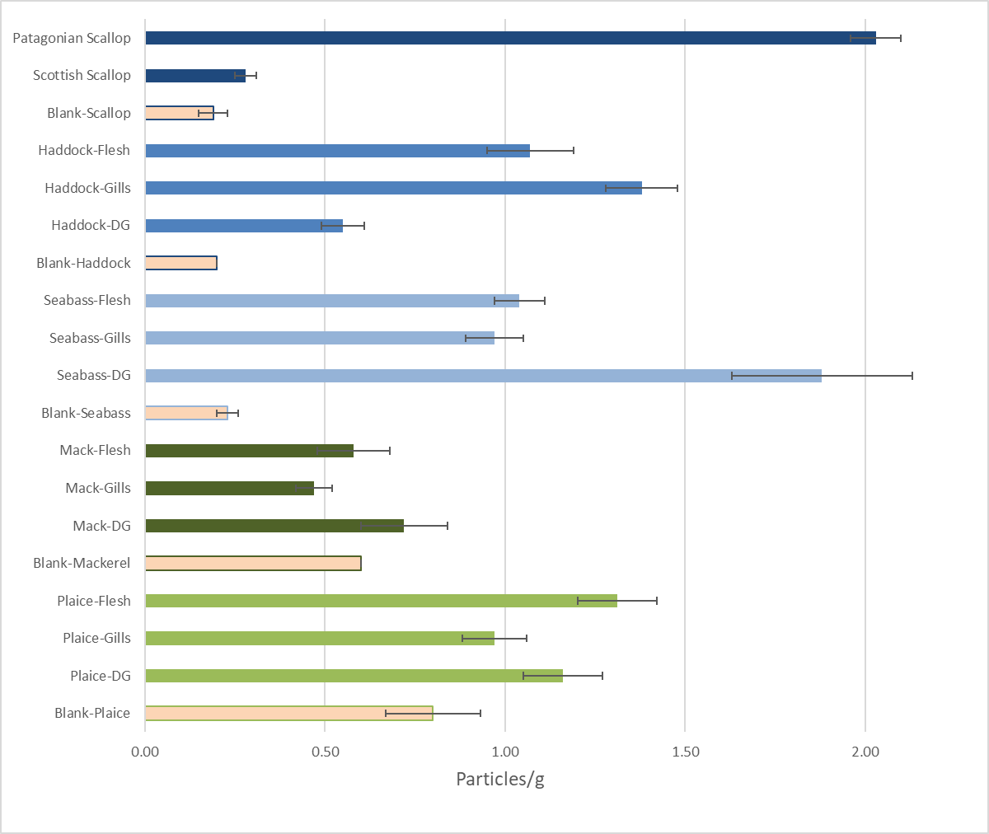

Fig. 2.

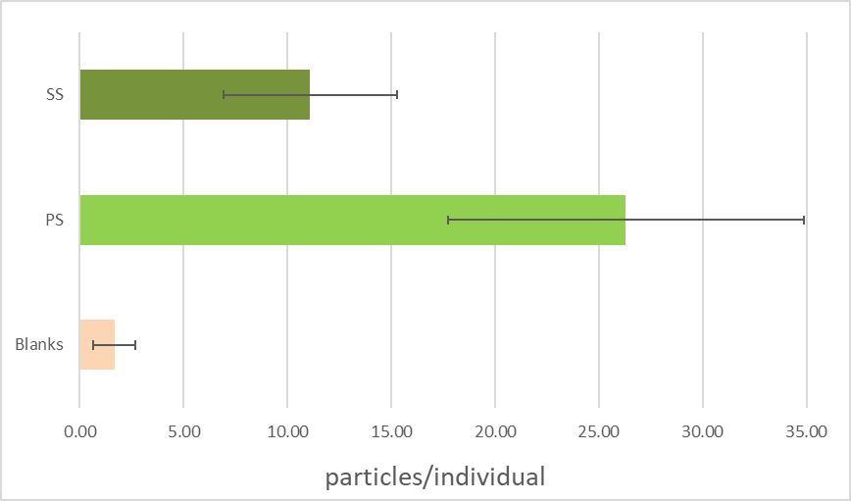

Fig. 3.

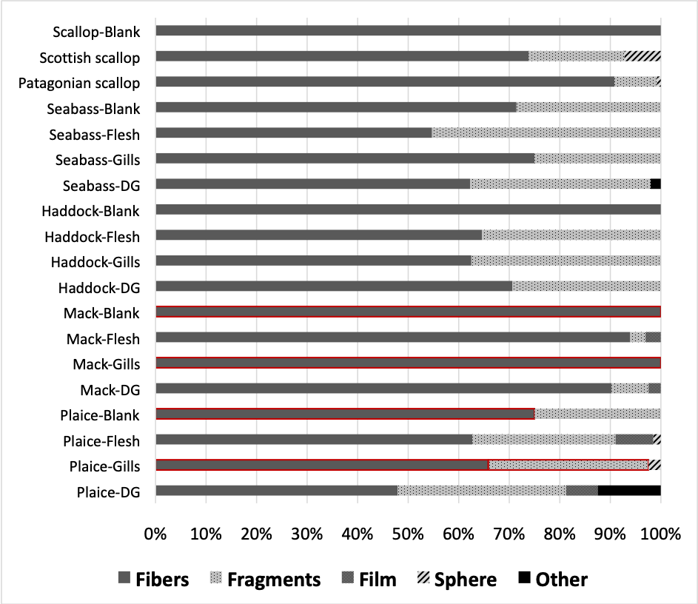

Fig. 4.

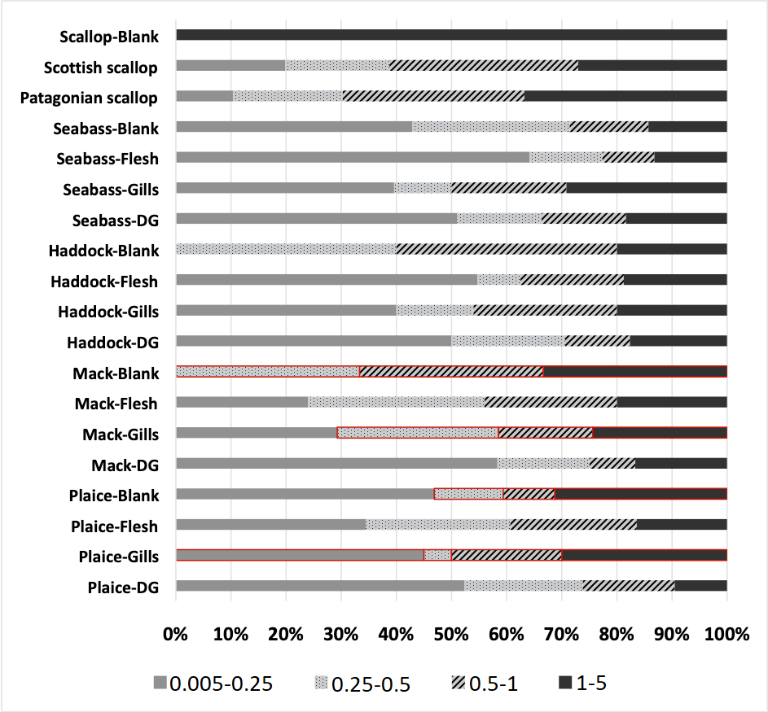

Fig. 5.
- Haddock, M. aeglefinus B. Mackerel, S. scombrus
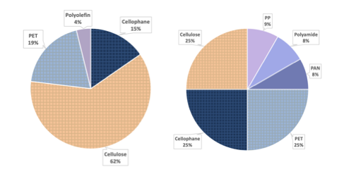
C. Plaice, P. platessa D. Seabass, D. labrax
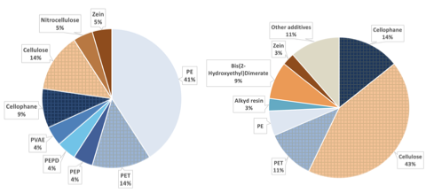
E. Scottish scallop, P. maximus F. Patagonian scallop, Z. patagonica
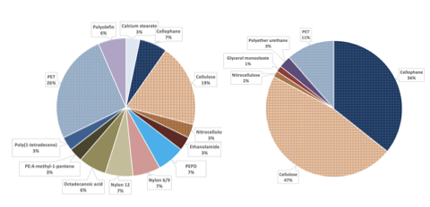

Fig. 6.

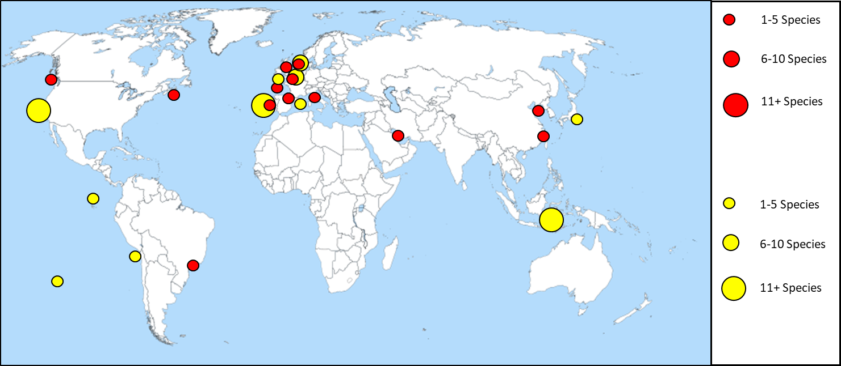

Fig. 7. A) B)
