Title
The provision of NICE recommended Varicose Veins Treatment in the NHS
Authors
Louise Helen Hitchman¹, Abduraheem Mohamed ^{1,2}, George Edward Smith ^{1,2}, Sean Pymer ^{1,2}, Ian Clifford Chetter^{1,2}, James Forsyth,³ Dan Carradice^{1,2}
¹ Academic Vascular Surgery Unit, Hull York Medical School
²Academic Vascular Surgery Unit, Hull University Teaching Hospitals NHS Trust
³Department of Vascular Surgery, Leeds University Teaching Hospital NHS Trust
Correspondence to:
Ms. Louise Hitchman (ORCiD: 0000-0001-9681-6749), Academic Vascular Surgery Unit, 2nd Floor Allam Building, Hull Royal Infirmary, Anlaby Road, Hull, HU3 2JZ, l.hitchman@nhs.net
Category: Original articles

Abstract (250 words)
Background
There is widespread non-compliance of Clinical Commissioning Group (CCG) policies with NICE guidelines (CG168) leading to geographical variation in access to varicose vein (VV) treatment. The Evidence Based Intervention (EBI) programme was introduced to improve care quality and support the implementation of CG168. This study assesses access to VV treatment and the impact of EBI.
Methods
CCG policies were obtained from 2017(pre-EBI) and 2019(post-EBI) and categorised by two independent reviewers into levels of compliance. Hospital episode statistics data were compared with the NICE commissioning model predictions. A quality adjusted life year was valued at £20,000.
Results
The introduction of EBI was associated with 33.0%(63/191) of CCG policies becoming less compliant and only 7.3%(14/191) changed to become fully compliant. There was a fall in the proportion of fully compliant CCG policies from 34.0%(64/191) to 29.0%(55/191). Overall 66.5%(127/191) of CCGs provided less than the recommended intervention rate pre-EBI and this increased to 73.3%(140/191) post-EBI. The overall proportion of patients estimated to require treatment annually who received treatment; fell from 44.0% to 37.0%. The associated estimated loss in net health benefit was between £164-174million over 3 years. A compliant policy was associated with a higher intervention rate, however commissioning policy was associated with only 16.8% of the variation in intervention rate (R²=0.168, p<0.001).
Conclusion
VV commissioning policy is not following CG168 and more than half of patients in need are not receiving treatment, with widespread geographical inequality. EBI has not been associated with any improvement in commissioning or access to treatment.

Introduction
Varicose veins are a common condition affecting around 40% of adults in the UK^{(1, 2)}. Many patients have complications including pain, swelling, soft tissue injury and chronic ulceration and in 2012 the National Institute of Health and Care Excellence (NICE) published its clinical guideline on its management (CG168)⁽³⁾. This guideline assessed the best available evidence and concluded that treatment of those with symptoms or complications was highly clinically and cost effective. It was recommended that such patients were assessed and offered interventional treatment by a vascular service without delay. A previous study published in 2018 found that the commissioning policies of the Clinical Commissioning Groups (CCGs) in England were often non-compliant with CG168, creating geographical variation in access to NICE recommended treatment⁽⁴⁾.
The document Evidence-Based Intervention (EBI): Guidance for CCGs was published in November 2018 and identified 17 areas, including intervention for varicose veins, where evidence-based practice was not widely adopted into CCG policies⁽⁵⁾. It was noted that this resulted in inefficient use of healthcare resources, poor clinical outcomes and public dissatisfaction in a ‘postcode lottery’ for certain treatments. The programme included guidance to reduce patient harm, improve clinical efficacy and to reduce wasted resources. EBI supported the unaltered implementation of NICE CG168 for varicose veins.
The aims of this paper were to evaluate the success of the EBI programme in supporting the implementation of NICE CG168 and reducing healthcare inequality; and furthermore, to explore the ability of the NHS to deliver CG168 and meet the population need for treatment.

Methods
Each CCG policy was acquired from website resources, direct consultation or via freedom of information requests. In the preceding study, CCG policies were assessed between 17th and 24th April 2017, and this determined the pre-EBI-programme policy status ⁽⁴⁾. This process was repeated between 26th October and 12th December 2019 to determine post-EBI-programme policy status. Two independent reviewers recorded the commissioning criteria and then compared results. Any disagreements were resolved by a third reviewer. Between 2017 and 2019, the number of CCGs reduced due to mergers from 2017 to 2019. For these merged CCGs, the previous policy was taken to be the most compliant of the original individual policies from 2017 was used for comparison.
Where CCG policies were non-compliant, the criteria in which they deviated from CG168 (Table1) were noted. CCG policies were split into three groups: Red, Amber and Green. Green CCG policies were fully compliant with NICE guidance. Amber CCG policies were not compliant for example not allowing the routine treatment of patients with symptomatic uncomplicated varicose veins (Class C2) but did allow for treatment of patients with tissue complications (Class C3 and above), or they allowed the treatment of C2 varicose veins with some restriction or limitation(6). Red CCG policies only permitted routine treatment for patients with venous leg ulcer disease (C5 and C6) or acute complications such as bleeding.
To investigate the impact of EBI and association of CCG policy with actual practice, Hospital Episode Statistics (HES) for each CCG in England were acquired from NHS Digital. These data included treatment spells associated with a varicose vein intervention from April 2017 to March 2020 for each CCG. Where the number delivered by a CCG was between 0 and 5, this was documented as 5*, to prevent the possibility of individual patient identification from the data. For analysis, 5* was taken as 5. The caseload per CCG was standardised as number of interventions per 100,000 patients per year to allow direct population level comparison.
The NICE costing template was produced as a workstream of NICE CG168⁽³⁾. The costing model was developed to aid CCGs with predictions for the number of expected interventions and the associated costs, under the new guidance. This model was based upon the available epidemiological data and the local population for each CCG.
When determining the deficit/excess intervention rate per CCG a 10% allowance between the actual and NICE predicted number of interventions was used. For example, CCGs with intervention rates of between 90% and 110% of their NICE prediction were considered to be providing treatment as expected. CCGs with intervention rates of less than 90% of predicted were considered to be providing less than the expected intervention rate and CCGs with intervention rates of greater than 110% of predicted were considered to be providing more than the expected rate.
Intervention rates are reported as counts and medians with confidence intervals. Data related to policy are presented as counts and percentages. To explore the relationship between policy, change in policy and intervention rate, data were checked for normality and entered into a linear regression model.
The overall difference between actual and predicted interventions across England was calculated and the difference in Quality Adjusted Life Years (QALY) estimated using QALY gain data for intervention versus conservative management from the NIHR REACTIV trial for each year (2017/2018; 2018/2019; 2019/2020) as well as over the entire 3-year study period (April 2017 to April 2020)⁽⁷⁾.
The data was entered onto a bespoke spreadsheet and analysed using Microsoft Excel® (Microsoft Corporation, Washington, U.S.) and SPSS (IBM, Version 28, New York, U.S.). Maps were created on Tableau (Tableau Software. LCC. Seattle, US) using CCG boundaries (April 2019) available at geoportal.statistics.gov.uk⁽⁸⁾.
Ethical approval was not sought as all data is publicly available and anonymised.
Patient and Public Involvement
This study aims to help address the number one research priority identified during the James Lind Alliance research Priority Setting Partnership by patients with venous diseases: ‘How can all patients be given the opportunity to access the specialist assessment and treatment they need?’⁽⁹⁾.
Results
191 CCGs were included in the analysis. 188 had a policy for the treatment of varicose veins in 2017. All CCGs had a policy for the treatment of varicose veins by 2019.
The overall CCG policy compliance rates decreased following EBI from 34.0% to 29.0% (Figure 1 and 2). Over this timeframe 21.5% (41/191) of CCG policies remained fully compliant, 7.3% (14/191) changed to become compliant, 12.6% (24/191) became more compliant but fell short of full compliance, 25.7% (49/191) remained the same and not fully compliant and 33.0% (63/191) of CCG’s policies became less compliant than previous (Figure 3).
The most common deviations from CG168 were limiting treatment to more clinically advanced disease (C4 and above) and delaying intervention for a trial of conservative therapy (Figures 4 and 5). In most CCGs this involved 6 months of compression hosiery before referral to a specialist service
In 2017/18, the total number varicose vein interventions were 30,020. This decreased to 25,770 in 2019/20 (14.2% reduction). The overall intervention rate in England during 2017/18 was 68/100,000 falling to 59/100,000 in 2019/20. This compares to a NICE predicted national intervention rate for England of 112/100,000. The median intervention rate across CCGs in England declined from 66/100,000 (range 4-195/100,000) in 2017/18 to 53/100,000 (range 2-173/100,000) in 2019/20 (Figures 6 and 7). Assuming that all procedures completed were in line with NICE guidelines, there was a deficit of 38,754 procedures in 2017/18 and 43,040 in 2019/20, meaning that the proportion of predicted procedures actually performed was 44% and 37% respectively. If all procedures over 110% of predicted for individual CCGs were assumed to be outside of NICE recommended treatment, the deficit could be as high as 58% and 64%. Overall, before EBI, 9.4% (18/191) of CCGs met the predicted intervention rate, 66.5% (127/191) did not meet the predicted rate and 24.1% (46/191) exceeded it. After EBI, 11.0% (21/191) of CCGs met the predicted intervention rate, 73.3% (140/191) did not meet the predicted rate; and 15.7% (30/191) exceeded it.
For CCGs with compliant (green) policies, the median intervention rate fell slightly from 78/100,000 (range 24-195/100,000) in 2017/18 to 76/100,000 (5-173/100,000) in 2019/20 (Figure 8). Before EBI, 12% (8/65) of Green CCGs met the predicted intervention rate, 49% (32/65) did not meet the expected rate; and 39% (25/65) exceeded it. After EBI, these proportions were 16% (9/56), 64% (36/56); and 20% (11/56) respectively.
The fall in intervention rate between 2017/18 and 2019/20 was most marked in the amber and red CCG policy compliancy groups (Figure 8). In the amber group the median intervention rate fell from 56/100,000 (range 6-168/100,000) to 48/100,000 (range 6-128/100,000)(Figure 7). Before EBI, 7% (7/106) of amber CCGs met the predicted intervention rate, 77% (82/106) did not and 16% (17/106) exceeded it. After EBI, these proportions were 8% (10/119), 75% (89/119) and 17% (20/119) respectively.
In the red CCG policy compliancy group, the median intervention rate fell from 46/100,000 (range 4-109/100,000) to 30/100,000 (range 2-101/100,000) (Figure 8). Before EBI, 6% (1/17) of red CCGs met the predicted intervention rate, 76% (13/17) did not; and 18% (3/17) exceeded it. After EBI, these proportions were 13% (2/16), 81% (13/16); and 6% (1/16) respectively.
For the 3 CCGs that did not have a varicose vein treatment policy in 2017, one had a higher than predicted intervention rate and two were within the predicted range in 2019/20.
When comparing CCG policy to intervention rate, a compliant policy was associated with a higher intervention rate. When compared with green CCGs, amber CCGs performed 24/100,000 less procedures (95% CI 14-33/100,000; p<0.001) and red CCGs performed 44/100,000 less (95% CI 27-60/100,000; p<0.001). CCG policy status accounted for approximately 17% of the variation in intervention rate (R²=0.168; p=<0.001).
For CCGs whose policy improved to being fully compliant by 2019/20, the intervention rate was comparable to CCGs with established fully compliant policies (p=0.660). For CCGs whose policies improved but were still not fully compliant the intervention rate was 20/100,000 less than fully compliant CCGs (95% CI 5-35/100,000; p=0.010). For CCGs whose policy did not change and remained non-compliant the intervention rate was 30/100,000 less than fully compliant CCGs (95% CI 18-43/100,000; p<0.001). In CCGs with decreasing compliance the intervention rate was 25/100,000 less than fully compliant CCGs (95% CI 14-37/100,000; p<0.001). A change in policy accounted for approximately 16% of the change in CCG intervention rate (R²=0.164; p=<0.001).
Assuming all procedures performed were within NICE guidelines, the estimated lost opportunity in annual QALY gain was 2095 in 2017/18, 2162 in 2018/19 and 2324 in 2019/20. Over the whole study period, the cumulative estimate of lost QALY gain is 12,931 (March 2017-March 2020). At a willingness to pay threshold of £20,000/QALY the value of this deficit is £258,625,229. The cost of providing the additional procedures would have been an estimated £95,050,106; assuming all were treated with endothermal ablation. The net loss from this failure to provide treatment in line with NICE guidance is therefore an estimated £163,575,453. This figure will rise exponentially until the issue is addressed.
If it is assumed that procedures over and above 110% predicted within a CCG were outside of NICE guidance, the cumulative estimate of lost QALY gain increases to 13,456 (March 2017-March 2020), with an estimated value of £269,118,839. The cost of the additional procedures (outside of NICE guidance £3,533,400) would be added to this. The cost of providing the procedures (within NICE guidance) would be to £98,583,506. The net estimated loss in this scenario would therefore rise to £174,068,733.
Discussion
Third party payers and government provided healthcare systems throughout high- and middle-income countries commonly see varicose vein procedures as a procedure of low clinical value and an opportunity for reducing costs. Nothing could be further from the truth: NICE Clinical Guideline 168 ⁽³⁾ performed a detailed review of the evidence base and found these procedures to be highly clinically and cost effective for patients with symptoms or complications from their superficial venous reflux and recommended that interventional treatment is offered. Unfortunately, globally large numbers of patients continue to fail to receive the treatment they need for this condition.
The objective of the NHS EBI programme was to address any discrepancy between evidence-based guidelines, CCG policy and CCG intervention rates. A stated aim of the EBI programme is ‘to reduce the number of inappropriate interventions carried out by clinicians…and to improve the quality-of-care patients receive’ ⁽⁵⁾. Regarding the management of patients with varicose veins there was a clear and unambiguous statement that CCGs should follow NICE Clinical Guideline 168 ⁽³⁾. In the opening statement of the most recent iteration of EBI there was a further clarification of the EBI’s mission: “reducing harm to patients, minimising unwarranted variation…and optimising the use of finite NHS resources”⁽¹⁰⁾. It is important to note that prior to the EBI programme CCGs in England performed 30,020 interventions for varicose veins, this represents only 44% of the NICE estimated annual procedural numbers with full implementation of the guideline. In this scenario therefore the aim of the EBI programme was to increase the number of appropriate interventions improving compliance with NICE CG168.
Unfortunately, the data suggest that the EBI programme was not associated with increasing compliance. Overall CCG policy compliance with NICE CG168 actually decreased, with the proportion of green (fully compliant) CCGs falling from 34% to 29%. This, however, is not the full story, as 33% of CCGs became more restrictive and less compliant than they were before the EBI programme. This decrease in the quality of commissioning was associated with a 14% fall in procedural numbers with a treatment deficit of over 43,000 cases. This has resulted in an estimated cumulative loss of 12,900 to 13,500 QALYs over this short study period, with a net loss in health benefit of £164 to 174 million. This doesn’t include the full additional healthcare costs such as community dressings, the ongoing use of compression garments and recurrent primary care and in some cases emergency department attendances. Nor does it include the societal loses in a working age population with disruption of both employment productivity and caring roles. These costs will escalate exponentially as the lost QALYs will persist and in some cases increase for the lifetime of the population along with the addition of each year’s incident unmet need.
Before the EBI programme there was significant geographical variation in access to treatment, with CCG intervention rates ranging from 4 to 195 interventions per 100,000 per year. There was a slight reduction in variation post EBI (2 to 173 per 100,000 per year), but this came at the cost of the median rate falling further behind the estimated ideal and the magnitude of variation remains remarkable. This equates to a range in the number of procedures performed annually of between 64 and 1,384 for the average sized vascular surgical service serving a population of around 800,000, which is remarkable.
Some CCGs saw higher than expected procedure rates. The incidence of this was greatest in (but not limited to) Green CCGs. There are several potential explanations for this. The first is that some may be related to “over-treatment” (treatment of patients outside of the NICE guidelines). A second explanation is related to limitations in coding. The advent of minimally invasive treatment has resulted in pathway changes. For example, previously a patient requiring treatment to both legs would have this done as a single procedure under general anaesthetic. A two-stage procedure for bilateral disease is now more common with local anaesthetic techniques. It is possible that this may be differentially coded as 1 or multiple consultant spells for the purposes of HES data. Also, despite best evidence to the contrary^{(11, 12)}, varicose tributaries are variably treated during the first procedure and in some centres, patients return for secondary treatments, again potentially inflating the intervention rate. The final possibility is that the predicted intervention rates may not be correct, with the actual figure being higher. Further research is required to understand this finding and its underlying causes.
There was a significant association between the level of CCG policy compliance and the intervention rate, but interestingly it only accounted for 17% of the variation observed. There was also significant crossover with some Red CCGs having higher intervention rates than some Green CCGs. This suggests that there are other significant factors involved. One factor may be related to CCG processes that make the practicality of commissioning more, or less restrictive than is apparent from the published policy. For example, some CCGs may use a case review system via individual funding request applications, which may not be applied in line with the published policy making it more restrictive. Alternatively, CCGs may use a form-based application where as long as the correct boxes are ticked, funding is granted; making it potentially less restrictive. Other factors may occur throughout the patient pathway that are related to: education and awareness of the local patient population, alteration in the rate at which patients present to healthcare services, the approach and education of primary care, a commonly held belief that varicose veins are simply of cosmetic concern, or that venous leg ulcers are inappropriately referred to other services. Similarly, there may be differing attitudes from vascular services towards this patient group. More likely however, is that the weight of the critical lifesaving and limb salvage arterial workload on the background of a workforce crisis is a contributing factor⁽¹³⁾. There is little data to unpick these issues at present, but this area is worthy of further research.
NHS England and the Secretary of State for Health and Social Care share a legal duty to promote a comprehensive health service in England, in accordance with the National Health Service Act 2006 (as amended by the Health and Social Care Act 2021) ^{(14, 15)}. This is supported by the commitments set out in the NHS Long Term Plan (2019/20), NHS Long Term Plan Implementation Framework and criteria set by the Secretary of State to address and reduce health inequalities ^{(16, 17)}. The NHS Long Term Plan lays out specific ambitions for the NHS to take a ‘more concerted and systematic approach to reducing health inequalities’ by addressing unwarranted variation in access to, experience of, and outcomes from, treatment and care ⁽¹⁶⁾. It is outlined that Sustainability and Transformation Partnerships (STPs) and Integrated Care Systems (ICSs) will have the responsibility to strategize and deliver the NHS Long Term Plan objectives and respond to local needs to reduce local health inequalities and unwarranted variation in access to services and care. In geographical areas of poor policy compliance and low intervention rates STP/ICSs should concentrate their efforts on the services, workforce and finances needed to deliver venous care in line with NICE CG168. It is not clear how STP/ICSs are proposed to succeed where CCGs have failed. Furthermore, the recovery of services to pre-pandemic levels stands to be an enormous challenge nationally, which will be furthered by the need to improve upon these levels. The stakes are high; patients have been denied the right to access NICE recommended treatment under the NHS constitution for almost a decade ⁽¹⁸⁾, there has been a dramatic curtailment in venous services during the SARS Cov-2 pandemic and the numbers of patients in need of treatment, the lost QALYs and the lost benefit of healthcare expenditure is spiralling.

Acknowledgements
The authors would like to acknowledge the support of the following members of the Academic Vascular Surgical team Claire Acey, Bankole Akomolafe, Lynne Andrews, Anna Firth, Josie Hatfield, Caroline Jennison, Brian Johnson, Rakesh Kapur, Judith Long, Robert Lonsdale, Anthony Mekako, Louise McLean, Paul Renwick and Tracey Roe and Junaid Sultan.
The authors would also like to acknowledge the considerable support and contribution of Prof Bruce Campbell during the early phase of this work.
Funding: Medtronic (Medtronic Limited, Minneapolis, Minnesota, US)
Details of role of study sponsors: Medtronic provided funding to access the HES data. This was done without obligation and was the limitation of their role in the study. They were not involved in the development of the research question or methods, data, analysis, interpretation, decision to publish or the drafting of the manuscript. The study did not receive any other source of funding.

Table 1: Guidance on patient groups for referral to a vascular service for assessment and interventional treatment for varicose veins in both NICE Clinical Guideline 168 and “Evidence Based Interventions”
Clinical Feature of Varicose Veins |  | NICE recommendation
CEAP - C0 | No visible/palpable venous disease | Not recommended
CEAP - C1 | Telangiectasias or reticular veins | Not recommended
CEAP - C2 | Varicose veins plus symptoms (pain, aching, discomfort, heaviness, itching) | Recommended*
CEAP - C3 | Lower limb oedema due to CVI | Recommended*
CEAP - C4 | Pigmentation and/or eczema due to CVI | Recommended*
CEAP - C5 | Healed varicose leg ulcer | Recommended*
CEAP - C6 | Varicose ulcer (break in the skin below the knee present for $≥$2 weeks) | Recommended*
Complications | Bleeding varicose vein | Recommended – Immediate*
CEAP: Clinical, Etiological, Anatomical, Pathophysiological; CVI: Chronic Venous Insufficiency *: Do NOT offer compression as a treatment unless patient is unsuitable for interventional treatment.

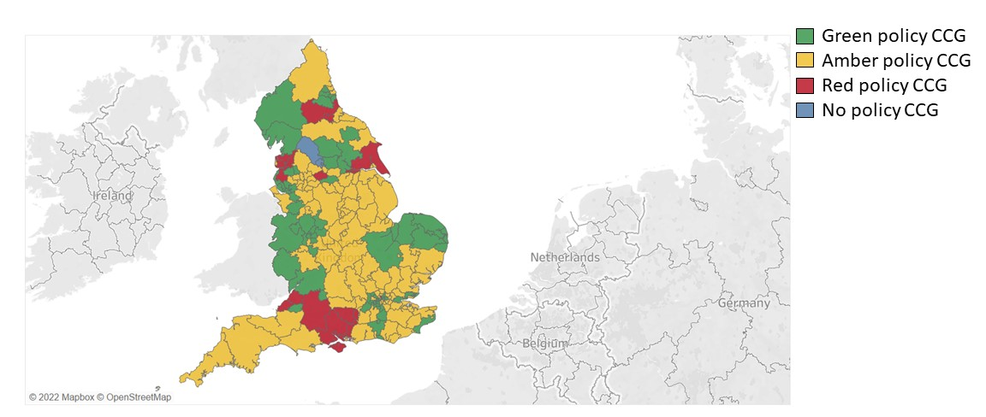
Figure 1: CCG policy compliancy with NICE pre-EBI guidance. Green represents fully compliant, Amber is non-compliant but allows treatment in some circumstances, Red allows treatment only for ulceration or bleeding.
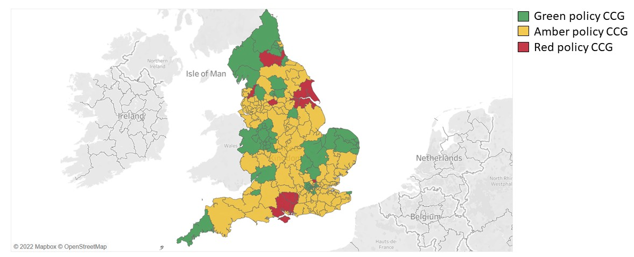
Figure 2: CCG policy compliancy with NICE post-EBI guidance. Green represents fully compliant, Amber is non-compliant but allows treatment in some circumstances, Red allows treatment only for ulceration or bleeding.

Figure 3: Change in CCG policy compliance from pre-EBI guidance (2017) to post-EBI guidance (2019)

Figure 4: The ways in which CCG policies deviated from NICE CG168

Figure 5: CEAP clinical score of venous disease treated by CCGs
Figure 6: Varicose vein intervention rate by CCG in 2017/2018
Figure 7: Varicose vein intervention rate by CCG 2019/2020
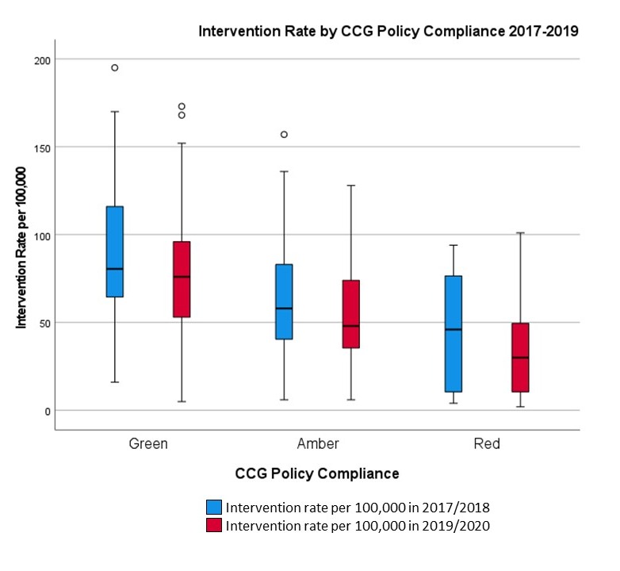

Figure 8: Intervention rate by CCG policy compliance group in 2017 and 2019
References:
1. Robertson L, Lee AJ, Evans CJ, Boghossian S, Allan PL, Ruckley CV, et al. Incidence of chronic venous disease in the Edinburgh Vein Study. J Vasc Surg Venous Lymphat Disord. 2013;1(1):59-67.
2. Rabe E, Pannier-Fischer F, Bromen K, Schuldt K, Stang A, Poncar C, et al. Epidemiologische Untersuchung zur Frage der Häufigkeit und Ausprägung von chronischen Venenkrankheiten in der städtischen und ländlichen Wohnbevölkerung. Phlebologie. 2003;32(01):1-14.
3. NICE. Varicose veins: diagnosis and management Clinical guideline [CG168]. 2013.
4. Carradice D, Forsyth J, Mohammed A, Leung C, Hitchman L, Harwood AE, et al. Compliance with NICE guidelines when commissioning varicose vein procedures. BJS Open. 2018;2(6):419-25.
5. NHS England Medical directorate and Strategy and Innovation. Evidence-Based Interventions: Guidance for CCGs. 2018. [Available from: https://www.necsu.nhs.uk/wp-content/uploads/2019/02/2018-11-Evidence-basedInterventions-GuideForCCGs-NHSE-2.pdf; accessed 19/04/2022]
6. Eklöf B, Rutherford RB, Bergan JJ, Carpentier PH, Gloviczki P, Kistner RL, et al. Revision of the CEAP classification for chronic venous disorders: consensus statement. J Vasc Surg. 2004;40(6):1248-52.
7. Michaels JA, Campbell WB, Brazier JE, Macintyre JB, Palfreyman SJ, Ratcliffe J, et al. Randomised clinical trial, observational study and assessment of cost-effectiveness of the treatment of varicose veins (REACTIV trial). Health Technol Assess. 2006;10(13):1-196, iii-iv.
8. Office of National Statistics. Clinical Commissioning Groups (April 2019) Boundaries EN BGC [Available from: https://geoportal.statistics.gov.uk/datasets/7f248e495b724c9a915a1823d30c0f81/explore?location=52.839152%2C-2.000000%2C6.00; accessed 19/04/2022].
9. Long J, Chetter I, Gronlund T. The Vascular Priority Setting Partnership: Setting the Agenda for UK Vascular Research. J.Vasc.Soc.G.B.Irel.2021. p. S1-S31.
10. Academy of Medical Royal Colleges. Evidence-based Interventions: List 3 clinical guidance Proposals. 2022.[Available from: https://www.aomrc.org.uk/ebi/wp-content/uploads/2022/01/EBI_List_3_cinical_guidance_Proposals.pdf; accessed 19/04/2022]
11. Carradice D, Mekako AI, Hatfield J, Chetter IC. Randomized clinical trial of concomitant or sequential phlebectomy after endovenous laser therapy for varicose veins. Br J Surg. 2009;96(4):369-75.
12. Lane TR, Kelleher D, Shepherd AC, Franklin IJ, Davies AH. Ambulatory varicosity avulsion later or synchronized (AVULS): a randomized clinical trial. Ann Surg. 2015;261(4):654-61.
13. Vascular Society of Great Britain and Ireland. Vascular Surgery Workforce and Wellbeing Survey 2021. 2021.[Available from: https://www.vascularsociety.org.uk/_userfiles/pages/files/Resources/Vascular%20Surgery%20Workforce%20and%20Wellbeing%20Survey%202021%20V3_0(1).pdf; accessed 10/06/2022]
14. The NHS Constitution. Annual Report 2019/2020. 2021.[Available from: https://www.england.nhs.uk/wp-content/uploads/2021/01/nhs-england-annual-report-2019-20-full.pdf; accessed 19/04/2022].
15. The Health and Social Care Act 2008 (Regulated Activities) (Amendment) (Coronavirus) Regulations 2021. [Available from: https://www.legislation.gov.uk/uksi/2021/891/contents/made; accessed 19/04/2022].
16. The NHS Long Term Plan. 2019.[Available from: https://www.longtermplan.nhs.uk/wp-content/uploads/2019/08/nhs-long-term-plan-version-1.2.pdf; accessed 19/04/2022].
17. NHS Long Term Plan Implementation Framework. 2019. [Available from: https://www.longtermplan.nhs.uk/wp-content/uploads/2019/06/long-term-plan-implementation-framework-v1.pdf; accessed 19/04/2022].
18. The Department of Health and Social Care. NHS Constitution for England. 2021. [Available from: https://www.gov.uk/government/publications/the-nhs-constitution-for-england/the-nhs-constitution-for-england; accessed 19/04/2022].

