SUPPORTING DOCUMENTATION

Dataset

- 1834 Dorothy

ARCdoc
UK WHALING LOGBOOKS

ARCdoc
Data Pages
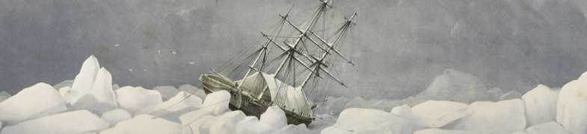

Summary

Dataset Title: 1834 Dorothy – ARCdoc UK Whaling Logbooks

Subject: Extracts from UK whaling logbooks for the following vessel(s):

- “Dorothy” 1834 relating primarily to climate data and related statistics.

Data Provider: Matthew Ayre
Dept of Geography
University of Sunderland
Email: m.ayre87@hotmail.com

Data Editor: John H Nicholls
Department of History
University of Hull
Email: j.nicholls@hull.ac.uk

Extent: > 1Mb 365 records

Keywords: Historical statistics; ARCdoc; Hudson’s Bay Company; whaling logs; climate records, climate change.

Citation: (a) The dataset: please cite as follows:

Ayre, Matthew (2014). ARCdoc UK Whaling Logbooks, in Nicholls, John (comp.) ARCdoc Data Pages, Hull: (http://www.hull.ac.uk/mhsc/ARCDOC).

(b) Supporting documentation: please cite as follows:

Ayre, Matthew, Wheeler, Dennis & Nicholls, John (eds.) (2014). ARCdoc UK Whaling Logbooks, Supporting Documentation, in Nicholls, John (comp.) ARCdoc Data Pages, Hull: (http://www.hull.ac.uk/mhsc/ARCDOC).

Contents

Summary 2
Contents 3
Research Context & Objectives 3
Primary Source Materials 3
Metadata: Explanation of Data Fields 4
Outcomes 11
Supplementary Information 11

Sources / Provenance

The collection of UK whaling logbooks represent a significant addition to those of the Hudson’s Bay Company (HBC) described in another of the guidance notes. The whaling logbooks used in this project are confined to the period 1750 to 1850 although most of them post-date 1800. Attention is also confined to UK logbooks. In contrast to the HBC logbooks, those of the whaling vessels do not cover every year of the study period and only some 40 have survived of the original many thousands of voyages. Furthermore the logbooks are not collected in any single archive and are scattered around a number of locations, mostly those of the old whaling centres such as Hull, Whitby and Dundee. Of these the Hull collection, now held in the Hull History Centre (http://www.hullhistorycentre.org.uk), is the most important and holds 24 whaling logbooks of vessels that operated from the port in its heyday as a whaling base. A provisional list of all such UK whaling logbooks can be found in Brown et al. (2008).

The whalers operated in two areas of the polar seas; earlier expeditions focused on the Fram Sea to the east of Greenland around Svalbard, but later activities concentrated on the waters of the Davis Straits between Greenland and the Canadian Archipelago. As with the HBC logbooks, activities are confined to the summer months but unlike the latter, these vessels sailed far further north in search of their quarry. Hence, whilst the whaling logbooks are fewer in number they provide information from some of the remotest parts of the planet not otherwise visited except by occasional scientific and exploratory ventures. The information they contain on ice cover is particularly valuable and is discussed later.

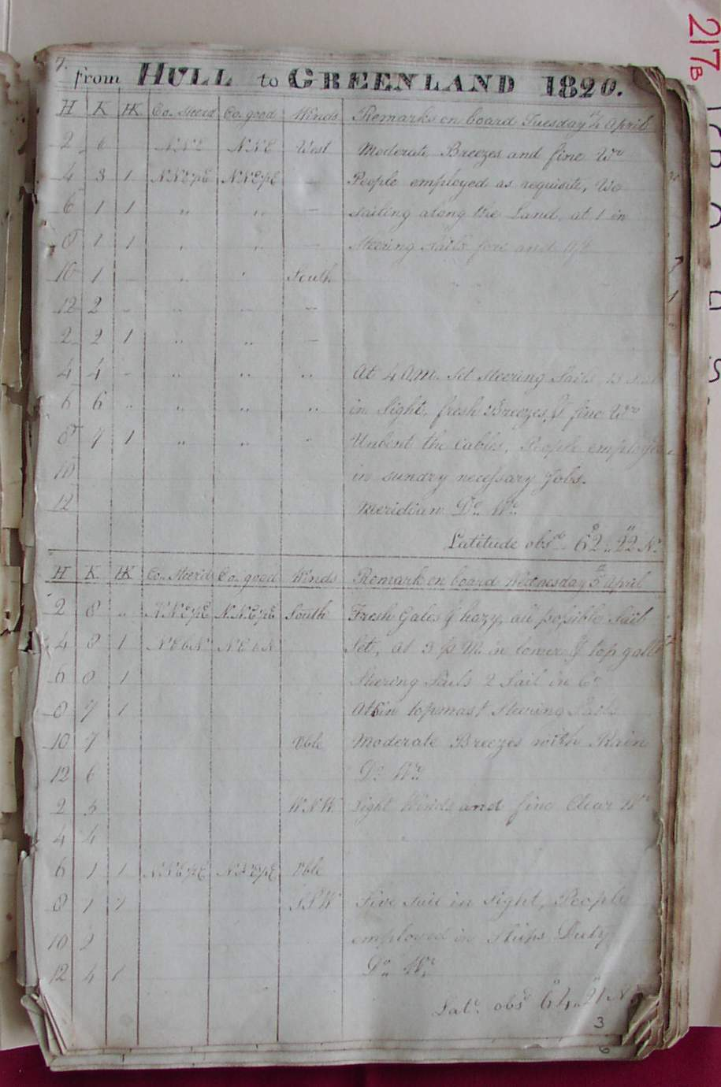
Figure 1. Page from the logbook of the Hull whaler Eagle, from 1820

Methodology

The whaling logbooks are written and presented in a form common to all such documents of the time (Figure 1). The logbook pages cannot however be read by automatic OCR methods and have to be transcribed by hand. They contain much historically useful information but attention is here focused exclusively on the daily climatic record. This is entirely non-instrumental in nature, and is concerned with wind force, wind direction and the general state of the weather. Sea ice is also recorded in some detail and is important as whaling activities were often concentrated along the ice front, following it as it retreated north each summer and providing an important record of its extent in those pre-satellite and pre-instrumental times.

These data were transcribed into the ‘first generation’ set of spreadsheets that can be found on this site. No attempt at this stage was made to modify, correct or adapt the data and this set of spreadsheets contain only the ‘raw’ observations. They contain also the metadata relating to the date of the observation, details of the ship, its approximate position each day, the recording officer and catalogue details. By this means the data can be traced back to the source material and provide helpful background material.

However these raw data are not always in a form that renders them immediately suitable for scientific study and various changes need to be made, as follows:

- In contrast to the HBC logbooks, the location of the whaling vessels and their detailed routes are not fully described. Latitude is included, but not on a daily basis, whilst longitudes are only rarely identified. Such latitudes and longitudes are however required for many subsequent applications of the data. The problem was resolved by carefully reconstructing each voyage using the often scant evidence for such information as bearings to land marks. This process could not be automated and required considerable manual effort using logbook evidence and detailed marine charts to provide ‘best estimate’ positions each day.
- The wind directions, which are recorded on the magnetic compass, need to be corrected to true north directions. For this purpose information was required on magnetic variation (the degree to which true and magnetic north depart). This latter quantity varies over space and time and is important in the Arctic region as it can be as much as 100° and requires (see above) a reliable estimate of the ship’s location. In this case we acknowledge the support of the British Geological Survey who provided access to their database of historic magnetic variation.
- The archaic wind force terms need to be re-expressed in modern-day Beaufort Force equivalents along the lines developed by the CLIWOC project (http://pendientedemigracion.ucm.es/info/cliwoc/ ).
- The wind directions, recorded on a 32-point compass, are reduced to a 4-point compass (N, S, E and W) to facilitate later analysis.
- The days when fog, rain and snow are recorded are noted.

One of the features that distinguish the whaling logbooks are the detailed records of ice cover that were encountered. HBC vessels rarely sailed far enough northwards to make such observations. Hence the whaling datasets contain additional information not found in those derived from HBC sources.
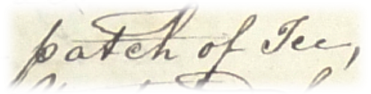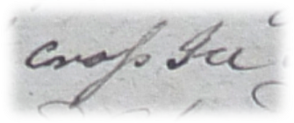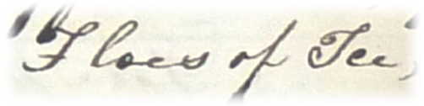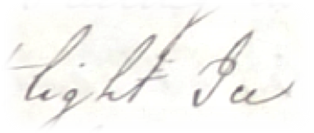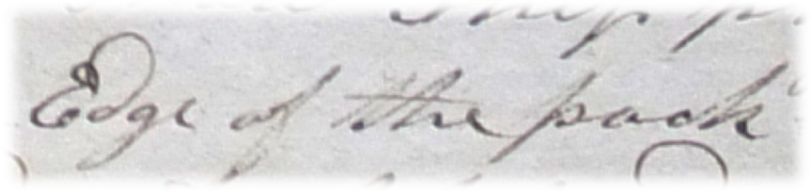
Figure 2. Typical whaling logbook entries describing sea ice.

This information includes:

- A simple indication of daily ice sightings, i.e. was ice sighted or not?
- A derived and indexed estimate of coverage with terms being equated to classes of percentage coverage where: 1 = 0 -24%, 2 = 25 – 49%, 3 = 50 – 74%, 4 = 75% or more and 5 = the solid ice limit.
- A scaled measure of ice age, where 1 = grease ice, 2 = nilas ice, 3 = first year ice, 4 = multi-year ice and 5 = brash ice.¹
- An iceberg index, in which 1 = single iceberg, 10 = between 2 and 100 icebergs, 100 = 101 to 1000 icebergs and 1000 = more than 1000 icebergs.
- The number of whales caught each day is also included

All such transformed data are available in the ‘second generation’ of spreadsheets, which include also the monthly aggregated totals and means of the various observed phenomena.

¹ The methods by which these indices were derived from the narrative logbook accounts are described in Ayre, M. and Molloy, D. “Understanding nineteenth century sea ice terminology”. Environment and History, in press.

Metadata: Explanation of Data Fields

The entries below are outlined as per the field headings of the ARCdoc Dataset 1 spreadsheet(s). An explanation is offered for each field in general terms, and where relevant, in dataset specific terms.

NOTE:
Each work sheet represents one year and contains two voyages. One outgoing voyage from the UK to Hudson Bay, normally leaving at the end of June, beginning of July, and one return journey leaving Hudson Bay in September and returning to the UK in October.

ID
Unique Identifier code for each entry (e.g. 1, 2, 3, etc.).

Day number
Count of days in the year of the voyage from 1 to 365 (e.g. 1, 2, 3, etc.).

Day
Day of the month of the year of the voyage (e.g. 1, 2, 3, etc.).

Month
Month of the year of the voyage (e.g. January, February, etc.).

Year
Year of the voyage (e.g. 1825, 1826, etc.).

Project name
Name of the research project (e.g. ARCdoc)

Funder
Name of the project funding body (e.g. Leverhulme).

Dates of project
Project duration dates (e.g. 2011-2014).

Transcriber
Name of the log book transcriber (e.g. Matthew Ayre).

Citation
Citation is the field where the formal attribution is shown for users of the ARCdoc Datasets to cite; it credits the researchers and editors of a Dataset together with its database compilers. This citation must be quoted whenever records are referenced or employed for any purpose.

Please quote the relevant citation when using extracts or details from this Dataset:

Ayre, Matthew (2014). ARCdoc UK Whaling Logbooks, in Nicholls, John (comp.) ARCdoc Data Pages, Hull: (http://www.hull.ac.uk/mhsc/ARCDOC).

Source
Source of the research materials (e.g. UK whaling logbooks).

Date range
Range of dates of the research period (e.g. 1825).

Civil or Nautical
Purpose of voyage (e.g. Nautical).

Julian or Gregorian
Calendar type (e.g. Julian).

Instrument makers
Name of instrument makers where available (e.g. Smith and Co).

Vessel
Name of the vessel undertaking the voyage (e.g. Brunswick).

Officer
Name of the officer on board ship who kept the observations (e.g. Captain Smith).

Voyage
Start and destination ports for the voyage (e.g. Hull to Riga).

Meridian
Landmark that is used by the ship to calculate it's longitude.

Latitude degrees
Degrees of latitude (e.g. 57). Where specific information is available this may be recorded as text (e.g. “Stranded Isle of Sefsoe, Callagate”).

Latitude minutes
Minutes of latitude (e.g. 5).

Longitude degrees
Degrees of longitude (e.g. 4).

Longitude minutes
Minutes of latitude (e.g. 17).

West/East
Indicates East or West of the Meridian (e.g. West)

Interpolated latitude
Calculated latitude expressed in radians (e.g. 58.85).

Interpolated longitude
Calculated longitude expressed in radians (e.g. -32.81).

Noon wind direction
Wind direction reading recorded nearest to noon (e.g. SE, Calm, etc).

Wind direction degrees
Calculated wind direction expressed in degrees (e.g. 355.91).

Corrected wind direction
Adjusted and converted noon wind direction based on magnetic variation provided by the British Geological Survey for the ship’s daily position.

Converted wind direction
True wind direction - corrected for magnetic variation and split into the 4 cardinal marks: N,S,E, W.

Noon wind
Wind strength recorded nearest to noon (e.g. Fresh Breezes, Strong Gales, etc).

Noon Beaufort force
Noon wind (from “Noon wind” column) converted into Beaufort numerical scale using CLIWOC meteorological dictionary (e.g. 4).

Daily max gust
Reading of the maximum gust recorded over 24 hours (e.g. Strong gales).

Daily Beaufort force
Daily maximum gust (from “Daily max gust column) converted into Beaufort numerical scale using CLIWOC meteorological dictionary (e.g. 3).

Daily Beaufort force count
Values taken from the “Daily Beaufort force”, with indices for no observation (-99) and unidentified wind force term (100).

Rain
Simple indicator of whether rain was recorded over 24 hours: “1” = rain, “0” = no rain.

Snow
Simple indicator of whether snow was recorded over 24 hours: “1” = snow, “0” = no snow.

Fog
Simple indicator of whether fog was recorded over 24 hours: “1” = fog, “0” = no fog.

Sea state
Phrase indicating the state of the sea over 24 hours (e.g. Rough, Calm, etc.)

Ice
Times when ice was recorded (e.g. edge of packed ice, cross ice, streams).

Ice days
Occurrence of observation of sea ice in a 24 hour period; 1= sea ice observed, blank = no observation.

Coverage
Index of observed sea ice terms relating to coverage. 1=0-24%, 2=25-49%, 3=50-74%, 4=75+%, 5=Pack edge.

Thickness
Ice age. Index of observed sea ice terms relating to ice age/thickness. 1=grease ice, 2=nilas ice, 3=first year ice, 4=multi year ice 5=brash ice.

Icebergs
Index of number of icebergs observed. 1=1 iceberg, 10=>1, <100 icebergs, 100=>100, <1000 icebergs, 1000=>1000 icebergs

Magnetic variation
Magnetic variation given in degrees, provided for each daily position by the British Geological Survey.

Vessels in company
List of other vessels accompanying (e.g. Margaret, Walker, etc.)

Whales caught
Number of whales caught over 24 hours (e.g. 2)

Remarks
Recorded relevant or pertinent remarks made (e.g. “Land 50 miles distant”).

Observation days
Calculated field of days when any information has been entered in the logbook, defined by at least one occurrence.

Observation days 2
Calculated field of days when any information has been entered in the logbook, defined by at least one occurrence.

Wind force 0
Daily tally of wind force reading of 0.

Wind force 1-3
Daily tally of wind force reading of 1-3.

Wind force 4
Daily tally of wind force reading of 4.

Wind force 5
Daily tally of wind force reading of 5.

Wind force 6
Daily tally of wind force reading of 6.

Wind force 7
Daily tally of wind force reading of 7.

Wind force 8
Daily tally of wind force reading of 8.

Wind force 9
Daily tally of wind force reading of 9.

Wind force 10
Daily tally of wind force reading of 10.

Wind force 11
Daily tally of wind force reading of 11.

Unidentified
Missing or unavailable wind force readings.

total
Total tally of wind force readings.

Wind direction N
Count of readings indicating N.

Wind direction E
Count of readings indicating E.

Wind direction S
Count of readings indicating S.

Wind direction W
Count of readings indicating W.

Days missing or not conv.
Missing or unavailable wind direction readings.

Gale frequency gale force 8+
Frequency of Beaufort scale readings registering as 8 , 9 or 10.

Gale frequency totals
Frequency of gales registered as a cumulative count of gales above force 8.

Ice days
Record of days when ice coverage was observed. Observed = 1.

Ice coverage 1
Index of ice coverage on a scale of 1 to 5. Observed = 1.

Ice coverage 2
Index of ice coverage on a scale of 1 to 5. Observed = 1.

Ice coverage 3
Index of ice coverage on a scale of 1 to 5. Observed = 1.

Ice coverage 4
Index of ice coverage on a scale of 1 to 5. Observed = 1.

Ice coverage 5
Index of ice coverage on a scale of 1 to 5. Observed = 1.

Ice thickness 1
Index of ice thickness on a scale of 1 to 5. Observed = 1.

Ice thickness 2
Index of ice thickness on a scale of 1 to 5. Observed = 1.

Ice thickness 3
Index of ice thickness on a scale of 1 to 5. Observed = 1.

Ice thickness 4
Index of ice thickness on a scale of 1 to 5. Observed = 1.

Ice thickness 5
Index of ice thickness on a scale of 1 to 5. Observed = 1.

Outcomes

The outcomes are a series of monthly summary statistics for each month of the voyages. As noted above, these are confined to the summer season as the vessels could not sail in winter, but provide nonetheless a valuable series of first-hand observations. These are expressed as a series of indices quantifying the frequency of winds from each of the four quadrants (N, S, E & W), gales, fog, snow and rain. The mean wind force can also be calculated for each month. The whaling logbooks provide a unique additional set of daily and monthly-aggregated data on sea ice cover and character.

In addition to the detailed first and second generation spreadsheets, which contain the daily data, a summary of the indices over the period covered by these logbooks is also included on this site.

The Hull whaling logbook collection has been imaged in its entirety and access to the digital store is available through this website, allowing researchers to follow the research track from original document to final summary statistics.

Supplementary Information

Enquiries regarding the information contained in this document and the accompanying dataset should be directed to John Nicholls (j.nicholls@hull.ac.uk).

ARCdoc Data Pages

(www.hull.ac.uk/mhsc/ARCDOC)

