SUPPORTING DOCUMENTATION

Dataset

- 1816 Hadlow

ARCdoc
HUDSON’S BAY VOYAGES

ARCdoc
Data Pages


Summary

Dataset Title: 1816 Hadlow- ARCdoc Hudson’s Bay Voyages

Subject: Extracts from the Hudson’s Bay Company Logbooks for the following vessel:

- “Hadlow” 1816 relating primarily to climate data and related statistics.

Data Provider: Catharine Ward
Faculty of Applied Science
University of Sunderland
Email: catharine@oceanclimate.co.uk

Data Editor: John H Nicholls
Department of History
University of Hull
Email: j.nicholls@hull.ac.uk

Extent: > 1Mb 365 records

Keywords: Historical statistics; ARCdoc; Hudson’s Bay Company; ships’ logbooks; climate records, climate change

Citation: (a) The dataset: please cite as follows:

Ward, Catharine (2014). ARCdoc Hudson’s Bay Voyages, in Nicholls, John (comp.) ARCdoc Data Pages, Hull: (http://hydra.hull.ac.uk/resources/hull:8834).

(b) Supporting documentation: please cite as follows:

Ward, Catharine, Wheeler, Dennis & Nicholls, John (eds.) (2014). ARCdoc Hudson’s Bay Voyages, Supporting Documentation, in Nicholls, John (comp.) ARCdoc Data Pages, Hull: (http://hydra.hull.ac.uk/resources/hull:8834).

Contents

Summary 2
Contents 3
Sources / Provenance 4
Methodology 5
Metadata: Explanation of Data Fields 7
Outcomes 12
Supplementary Information 12

Sources / Provenance

These logbooks are valuable for covering the whole of the 100-year study period of the ARCdoc project (1750 to 1850) with only a few gaps (four years only are missing). The original documents are held in the Manitoba State Archives (http://www.gov.mb.ca/chc/archives/hbca/) but microfilm copies are available in the UK National Archives in Kew (http://www.nationalarchives.gov.uk), the latter are however not of good quality.

The original logbooks were prepared by the various captains who sailed annually between London and the Company’s factories in Hudson’s Bay. The ships set out in early summer, returning usually in September; voyages planned to avoid the winter ice. They tended to take the same route each year following more-or-less the same latitude, and for the purposes of climate studies this is a great advantage as replicate routes provide for a geographically consistent data set.

The Hudson’s Bay Company logbooks are a unique and welcomingly complete set of merchant shipping documents that have provided much useful Arctic climatic information not available from any other source. A review of Hudson Bay Company logbooks and their potential for climate studies can be found in Ward and Wheeler (2012).

Methodology

The logbooks of HBC logbooks are written and presented in a form common to all such documents of the time (Figure 1). The logbook pages cannot however be read by automatic OCR methods and have to be transcribed by hand. They contain much historically useful information but attention is here focused exclusively on the daily climatic record. This is entirely non-instrumental in nature, and is concerned with wind force, wind direction and the general state of the weather.

However these raw data are not always in a form that renders them immediately suitable for scientific study and various changes need to be made, as follows:

- The wind directions, which are recorded on the magnetic compass, need to be corrected to true north directions. For this purpose information was required on magnetic variation (the degree to which true and magnetic north depart). This latter quantity varies over space and time and is important in the Arctic region as it can be as much as 100° and requires (see above) a reliable estimate of the ship’s location. The location data are provided and, in most cases, an estimate made by the recording officer of magnetic variation is also included.
- The archaic wind force terms need to be re-expressed in modern-day Beaufort Force equivalents along the lines developed by the CLIWOC project (http://pendientedemigracion.ucm.es/info/cliwoc/).
- The wind directions, recorded on a 32-point compass, are reduced to a 4-point compass (N, S, E and W) to facilitate later analysis.
- The days when fog, rain and snow are recorded are noted.

All such transformed data are available in the ‘second generation’ of spreadsheets, which include also the monthly aggregated totals and means of the various observed phenomena.

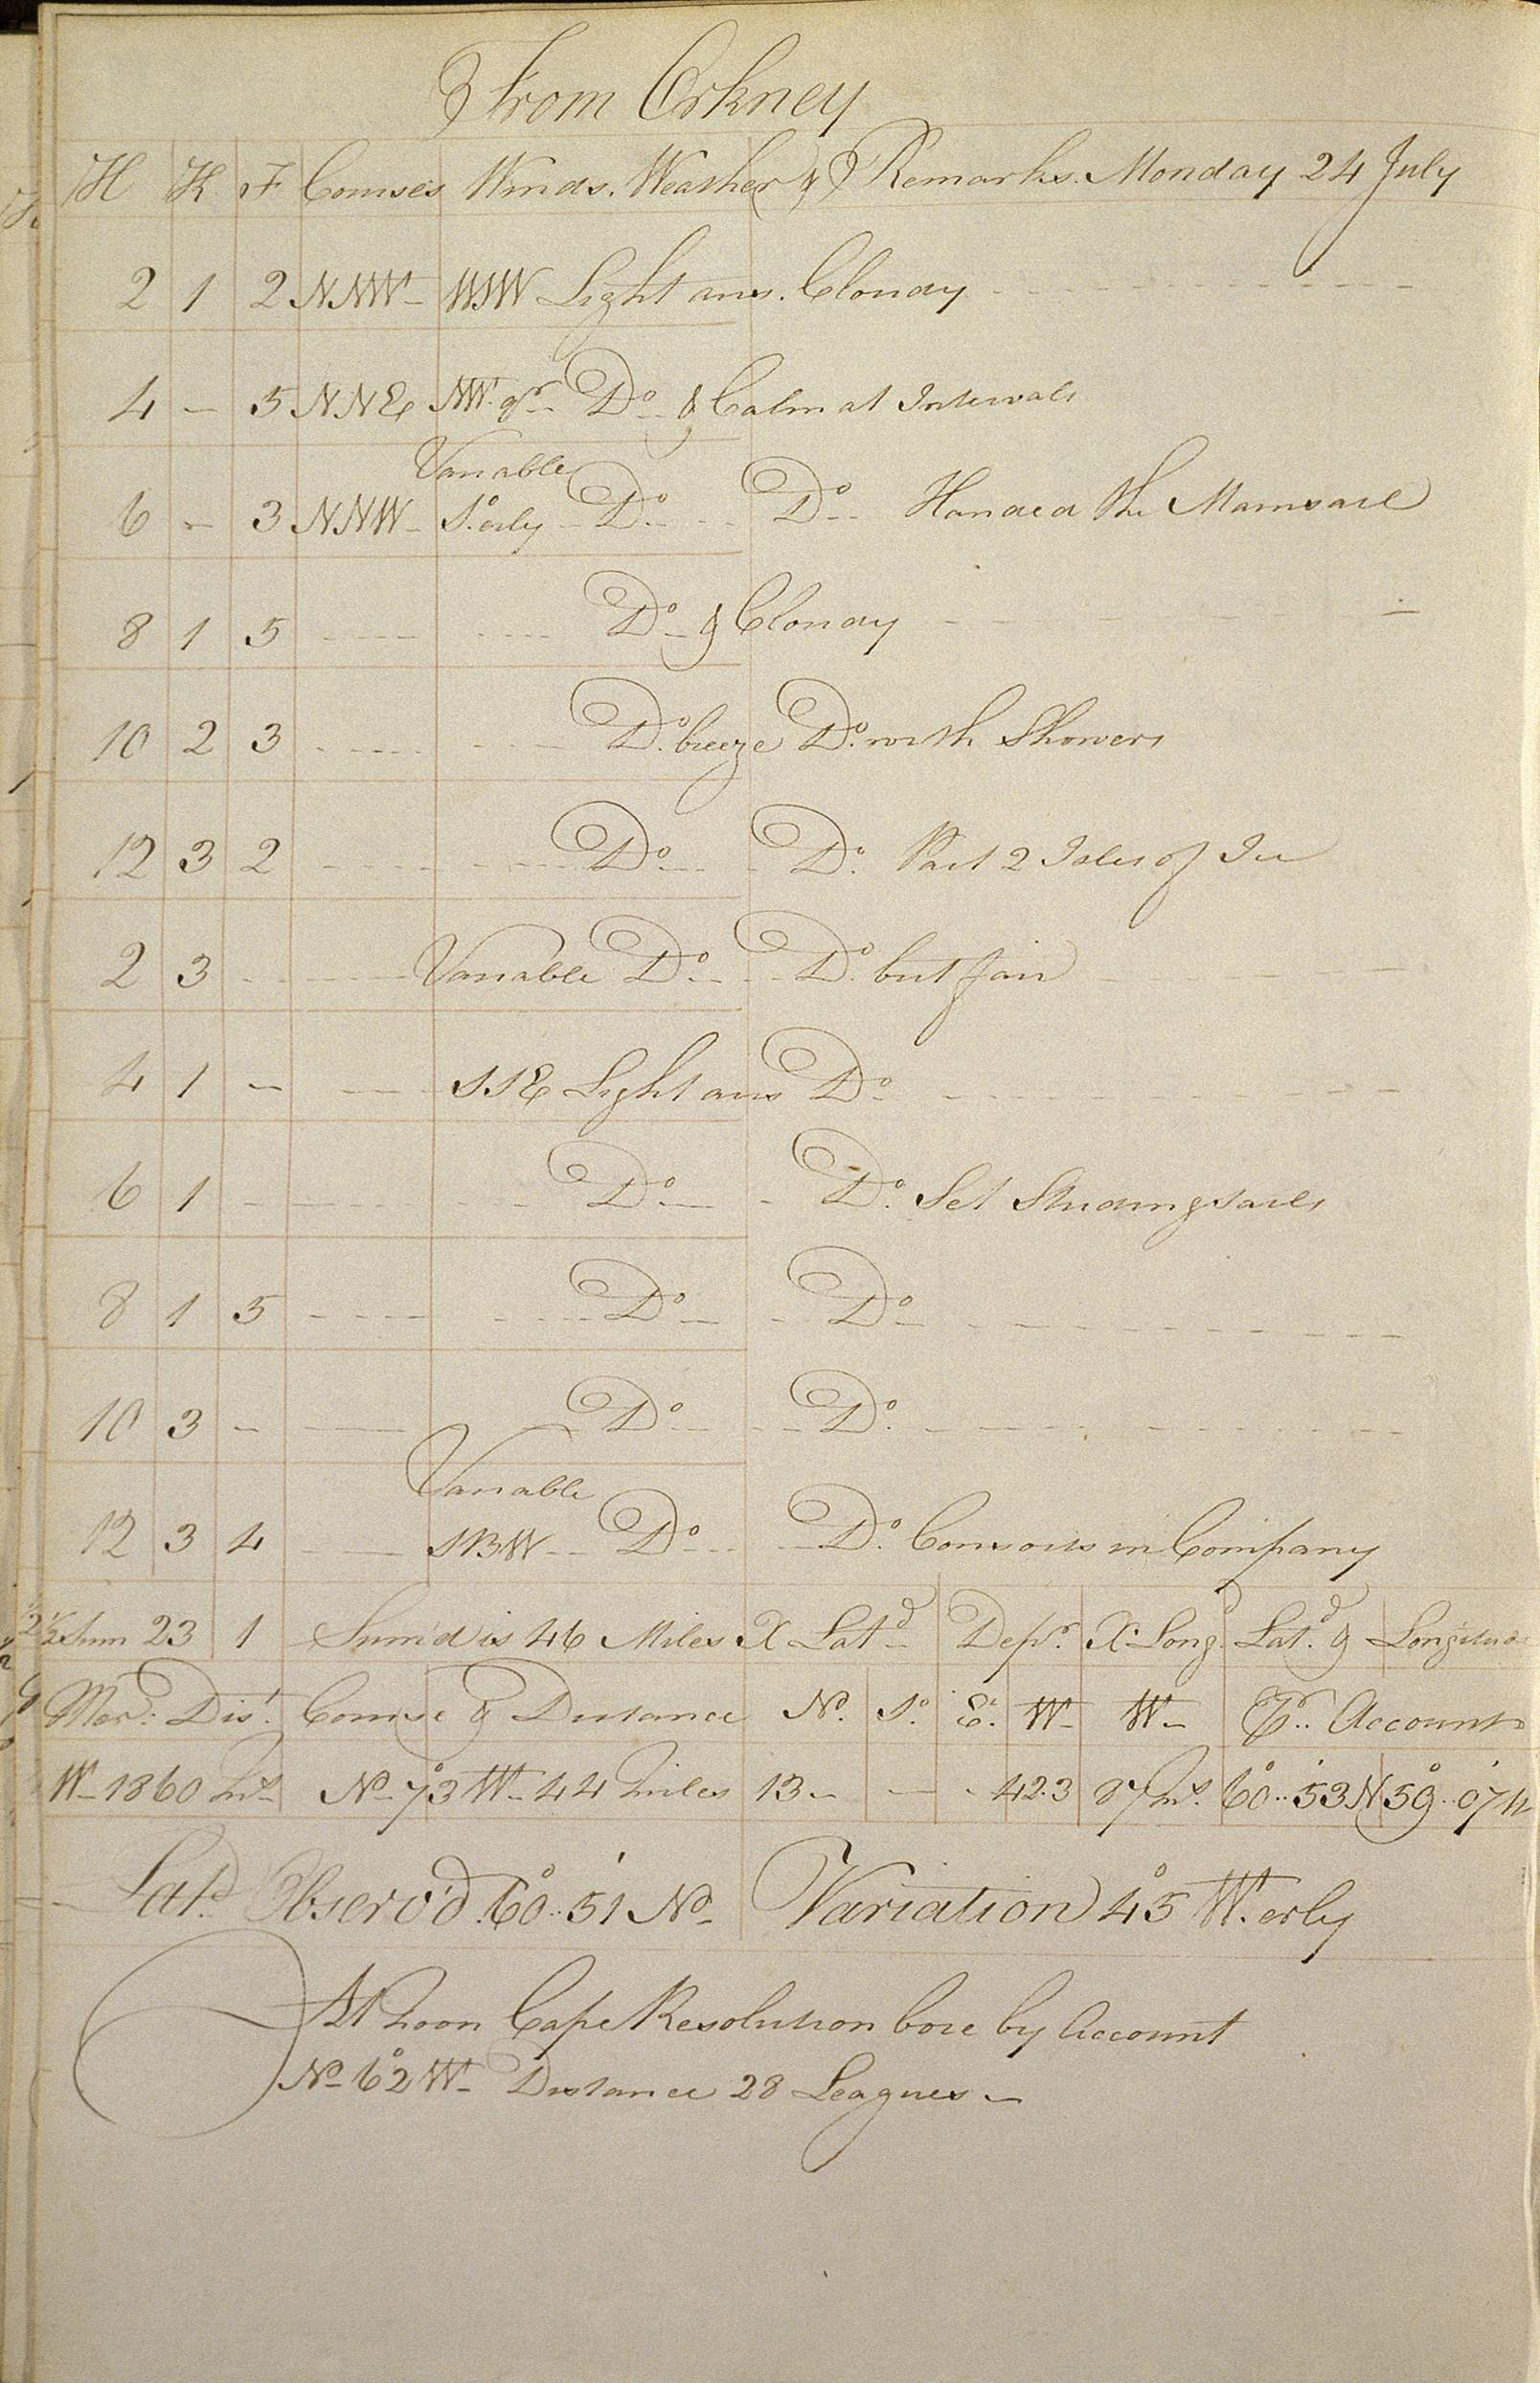
Figure 1. Typical page from a Hudson’s Bay Company logbook.
This page is from the logbook of the Queen Charlotte (24th July 1797).

Metadata: Explanation of Data Fields

The entries below are outlined as per the field headings of the ARCdoc Dataset 1 spreadsheet(s). An explanation is offered for each field in general terms, and where relevant, in dataset specific terms.

NOTE:
Each work sheet represents one year and contains two voyages. One outgoing voyage from the UK to Hudson Bay, normally leaving at the end of June, beginning of July, and one return journey leaving Hudson Bay in September and returning to the UK in October.

ID
Unique Identifier code for each entry (e.g. 1, 2, 3, etc.).

Day number
Count of days in the year of the voyage from 1 to 365 (e.g. 1, 2, 3, etc.).

Day
Day of the month of the year of the voyage (e.g. 1, 2, 3, etc.).

Month
Month of the year of the voyage (e.g. January, February, etc.).

Year
Year of the voyage (e.g. 1825, 1826, etc.).

Project name
Name of the research project (e.g. ARCdoc)

Funder
Name of the project funding body (e.g. Leverhulme).

Dates of project
Project duration dates (e.g. 2011-2014).

Transcriber
Name of the log book transcriber (e.g. Catharine Ward).

Citation
Citation is the field where the formal attribution is shown for users of the ARCdoc Datasets to cite; it credits the researchers and editors of a Dataset together with its database compilers. This citation must be quoted whenever records are referenced or employed for any purpose.

Please quote the relevant citation when using extracts or details from this Dataset:

Ward, Catharine (2014). ARCdoc Hudson’s Bay Voyages, in Nicholls, John (comp.) ARCdoc Data Pages, Hull: (http://hydra.hull.ac.uk/resources/hull:8572).

Source
Source of the research materials (e.g. Hudson Bay Company log Books).

HBCA catalogue ref. reel
Location reference of the Hudson Bay Company Archive material (where available) (e.g. LZ 123).

Image number range
Range of log sheet images accessed (e.g. LZ1-LZ200).

Date range
Range of dates of the research period (e.g. 1825).

Civil or Nautical
Purpose of voyage (e.g. Nautical).

Julian or Gregorian
Calendar type (e.g. Julian).

Instrument makers
Name of instrument makers where available (e.g. Smith and Co).

Vessel
Name of the vessel undertaking the voyage (e.g. Brunswick).

Officer
Name of the officer on board ship who kept the observations (e.g. Captain Smith).

Voyage
Start and destination ports for the voyage (e.g. Hull to Riga).

Meridian Range
Range of landmarks used by the ship to calculate it's longitude.

Latitude degrees
Degrees of latitude (e.g. 57). Where specific information is available this may be recorded as text (e.g. “Stranded Isle of Sefsoe, Callagate”).

Latitude minutes
Minutes of latitude (e.g. 5).

Longitude degrees
Degrees of longitude (e.g. 4).

Longitude minutes
Minutes of latitude (e.g. 17).

West/East
Indicates East or West of the Meridian (e.g. West)

Meridian
Specific landmark that is used by the ship to calculate it's longitude.

Noon wind direction
Wind direction reading recorded nearest to noon (e.g. SE, Calm, etc).

Converted wind direction
True wind direction - corrected for magnetic variation and split into the 4 cardinal marks: N,S,E, W.

Noon Wind Force
Wind strength recorded nearest to noon (e.g. Fresh Breezes, Strong Gales, etc).

Noon Beaufort Force
Noon wind (from “Noon wind” column) converted into Beaufort numerical scale using CLIWOC meteorological dictionary (e.g. 4).

Daily max gust
Reading of the maximum gust recorded over 24 hours (e.g. Strong gales).

Daily Beaufort Force
Daily maximum gust (from “Daily max gust column) converted into Beaufort numerical scale using CLIWOC meteorological dictionary (e.g. 3).

Noon Weather
Description of general weather condition observed (e.g. cloudy)

Daily distance
Distance in nautical miles traversed during the day (e.g. 25)

Rain
Simple indicator of whether rain was recorded over 24 hours: “1” = rain, “0” = no rain.

Snow
Simple indicator of whether snow was recorded over 24 hours: “1” = snow, “0” = no snow.

Fog
Simple indicator of whether fog was recorded over 24 hours: “1” = fog, “0” = no fog.

Sea state
Phrase indicating the state of the sea over 24 hours (e.g. Rough, Calm, etc.)

Ice
Times when ice was recorded (e.g. edge of packed ice, cross ice, streams).

Magnetic variation
Magnetic variation given in degrees and estimated by the recording officer

Wind force 0
Daily tally of wind force reading of 0.

Wind force 1-3
Daily tally of wind force reading of 1-3.

Wind force 4
Daily tally of wind force reading of 4.

Wind force 5
Daily tally of wind force reading of 5.

Wind force 6
Daily tally of wind force reading of 6.

Wind force 7
Daily tally of wind force reading of 7.

Wind force 8
Daily tally of wind force reading of 8.

Wind force 9
Daily tally of wind force reading of 9.

Wind force 10
Daily tally of wind force reading of 10.

Wind force 11
Daily tally of wind force reading of 11.

Total days missing or not conv.
Missing or unavailable wind force readings.

Total
Total tally of wind force readings.

Wind directions N
Count of readings indicating N.

Wind directions E
Count of readings indicating E.

Wind directions S
Count of readings indicating S.

Wind directions W
Count of readings indicating W.

Days missing or not conv.
Missing or unavailable wind direction readings.

Gale frequency gale force 8+
Frequency of Beaufort scale readings registering as 8 , 9 or 10.

Totals
Frequency of gales registered as a cumulative count of gales above force 9.

Vessels spoken with
Other vessels communicated with (e.g. Margaret, Walker, etc.)

Ships in company
List of other vessels accompanying (e.g. Margaret, Walker, etc.)

Notes
Recorded relevant or pertinent remarks made (e.g. “Land 50 miles distant”).

Outcomes

The outcomes are a series of monthly summary statistics for each month of the voyages. As noted above, these are confined to the summer season as the vessels could not sail in winter, but provide nonetheless a valuable series of first-hand observations. These are expressed as a series of indices quantifying the frequency of winds from each of the four quadrants (N, S, E & W), gales, fog, snow and rain. The mean wind force can also be calculated for each month. The whaling logbooks provide a unique additional set of daily and monthly-aggregated data on sea ice cover and character.

In addition to the detailed first and second generation spreadsheets, which contain the daily data, a summary of the indices over the period covered by these logbooks is also included on this site.

Ward, C. and Wheeler, D. (2012) Hudson’s Bay Company ship’s logbooks: a source of far North Atlantic weather data. Polar Record, 48, 165 – 176.

Supplementary Information

Enquiries regarding the information contained in this document and the accompanying dataset should be directed to John Nicholls (j.nicholls@hull.ac.uk).

ARCdoc Data Pages

(www.hull.ac.uk/mhsc/ARCDOC)

