SUPPORTING DOCUMENTATION

Dataset

- 1813-1838 Prince of Wales I

ARCdoc
HUDSON’S BAY VOYAGES

ARCdoc
Data Pages
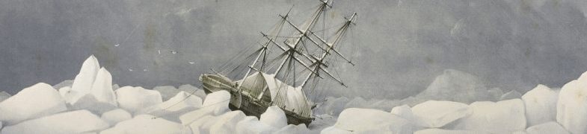

Summary

Dataset Title: 1813-1838 Prince of Wales I- ARCdoc Hudson’s Bay Voyages

Subject: Extracts from the Hudson’s Bay Company Logbooks for the following vessel:

- “Prince of Wales I” 1813-1838 relating primarily to climate data and related statistics.

Data Provider: Catharine Ward
Faculty of Applied Science
University of Sunderland
Email: catharine@oceanclimate.co.uk

Data Editor: John H Nicholls
Department of History
University of Hull
Email: j.nicholls@hull.ac.uk

Extent: > 1Mb 7,665 records

Keywords: Historical statistics; ARCdoc; Hudson’s Bay Company; ships’ logbooks; climate records, climate change

Citation: (a) The dataset: please cite as follows:

Ward, Catharine (2014). ARCdoc Hudson’s Bay Voyages, in Nicholls, John (comp.) ARCdoc Data Pages, Hull: (http://hydra.hull.ac.uk/resources/hull:8833).

(b) Supporting documentation: please cite as follows:

Ward, Catharine, Wheeler, Dennis & Nicholls, John (eds.) (2014). ARCdoc Hudson’s Bay Voyages, Supporting Documentation, in Nicholls, John (comp.) ARCdoc Data Pages, Hull: (http://hydra.hull.ac.uk/resources/hull:8833).

Contents

Summary 2
Contents 3
Historical Notes 4
Sources / Provenance 6
Methodology 7
Metadata: Explanation of Data Fields 9
Outcomes 14
Supplementary Information 14

Historical Notes

Two of the Prince of Wales I datasets have additional researched historical information that informs the data. These notes are reproduced here.

1819 Voyage of the Prince of Wales I
An account of the most remarkable voyages: from the discovery of America, by Columbus, to the present time. W. Darton, 1831 - 284 pages | About the same time with Captain Parry's voyages considerable interest was excited by the journey of Captain Franklin to the shores of the Polar Sea The main object of this gentleman's expedition was to determine the latitudes and longitudes of the chief places on the northern coast of North America and to survey that coast from the mouth of the Copper Mine River to the eastern extremity of that continent taking particular note of places where ships might enter or to which a boat could be sent and erecting conspicuous marks at such places He was likewise instructed to collect all information which might appear likely to be useful to Captain Parry Captain Franklin with three vessels under his command the Prince of Wales in which he himself sailed the Eddystone and the Wear took his departure from Gravesend on the 23rd of May 1819 On reaching Stromnessin Pomona the largest of the Orkney Islands the Captain as he knew that he should be obliged in the execution of his instructions to penetrate by going up the Indian rivers into some part of the interior thought it necessary to obtain a supply of able boatmen but on account of the great demand for their services in the herring fishery and the perilous nature of Captain Franklin's enter prize he could only procure four to whom he was obliged to give very high wages On the 25th of July the vessels arrived at the entrance of Davis's Straits where they fell in with a whaler the master of which informed Franklin and his companions that the ice had been heavier in those straits during that season than had ever been known his own vessel had suffered considerable injury and two others had been entirely crushed The Captain's party did not fall in with any icebergs till they arrived within thirty leagues of the coast of Labrador Of these they contrived to steer clear and proceeded with a favourable wind till they came off Resolution Island to the north of the entrance into Hudson's Straits early in the morning of the 7th of August Here a thick fog came on the breeze subsided into a perfect calm and left the Prince of Wales surrounded by loose ice while the Eddystone was driving rapidly towards some of the larger masses By ten the fog clearing shewed land two miles distant but the Captain's ship became unmanageable and was forced along by the currents between the masses of ice till she struck violently on a rock projecting from the island A gentle swell freed her from this alarming situation but she was still borne along by the current almost in contact with the rocky shore and at last forced against a large ice berg lying aground After this shock the ship was driven along the rear of the ice berg with such amazing rapidity that she escaped almost by a miracle being forced upon the rocks in her present disturbed state which must have decided her fate As it was she received water very fast and the pumps were in constant use and it was found necessary for the Eddystone to take her in tow But a heavy gale coming on the sails were split and as she was forcing through a stream flanked by ice the tow rope broke and at this very time there was upwards of five feet water in the hold so that there seemed great reason to fear that the ship must be abandoned By great exertions however thrusting in felt and oakum into the openings with planks nailed over them the leak was finally got under so much as only to require the pumps to be worked at intervals of ten minutes and a fresh breeze arising they reached Upper Savage Island Here the ship was steered as near as possible to the shore to afford the Esquimaux an opportunity of coming off to barter which they soon embraced.
Narrative of a journey to the shores of the polar sea, in the years 1819-20-21-22 by John Franklin, Capt. R.N, F.R.S., M.W.S., and Commander of the expedition. | [Pg 14] By the 25th July we had opened the entrance of Davis' Straits, and in the afternoon spoke the Andrew Marvell, bound to England with a cargo of fourteen fish. The master informed us that the ice had been heavier this season in Davis'Straits than he had ever recollected, and that it lay particularly close to the westward, being connected with the shore to the northward of Resolution Island, and extending from thence within a short distance of the Greenland coast; that whales had been abundant, but the ice so extremely cross, that few could be killed. His ship, as well as several others, had suffered material injury, and two vessels had been entirely crushed between vast masses of ice in latitude 74° 40' N., but the crews were saved. We inquired anxiously, but in vain, for intelligence respecting Lieutenant Parry, and the ships under his command; but as he mentioned that the wind had been blowing strong from the northward for some time, which would, probably, have cleared Baffin's Bay of ice, we were disposed to hope favourably of his progress.
Adventuring with Boldness: The Triumph of the Explorers By Bruce C. Paton | The crossing of the Atlantic was made in convoy with three other ships, the Eddystone, the Wear and the Harmony, all filled with Scottish emigrants for the Earl of Selkirk's settlement on the Red River. What should have been a routine voyage to York Factory turned into a nightmare. As soon as the ships entered the Hudson Bay, they encountered the worst Arctic weather: impenetrable fog, strong winds, wild currents, icebergs and an unfriendly shoreline of rocksand steep cliffs. Franklin's account was full of remarks such as ' an alarming view of a barren rugged shore within a few yards... prospect most alarming..seems to be no probability of escaping shipwreck..violently forced by the current against a large iceberg lying aground" The Prince of Wales struck a rock and her hold filled with four feet of water. The elderly and the children were transferred to the Eddystone for fear that the ship would sink. But heroic efforts by the crew, energetically assisted by the younger women who pumped as strongly as men, combined with the efforts of the ships' carpenters, staunched the flow of water. The ship pulled into harbour at York factory on August 30th, relieved to have arrived without loss of life or cargo.
1813 Voyage of the Prince of Wales I
 | Early thick pack ice in southern Hudson Bay prevented a return voyage and the crew spent the winter in the Arctic.

Sources / Provenance

These logbooks are valuable for covering the whole of the 100-year study period of the ARCdoc project (1750 to 1850) with only a few gaps (four years only are missing). The original documents are held in the Manitoba State Archives (http://www.gov.mb.ca/chc/archives/hbca/) but microfilm copies are available in the UK National Archives in Kew (http://www.nationalarchives.gov.uk), the latter are however not of good quality.

The original logbooks were prepared by the various captains who sailed annually between London and the Company’s factories in Hudson’s Bay. The ships set out in early summer, returning usually in September; voyages planned to avoid the winter ice. They tended to take the same route each year following more-or-less the same latitude, and for the purposes of climate studies this is a great advantage as replicate routes provide for a geographically consistent data set.

The Hudson’s Bay Company logbooks are a unique and welcomingly complete set of merchant shipping documents that have provided much useful Arctic climatic information not available from any other source. A review of Hudson Bay Company logbooks and their potential for climate studies can be found in Ward and Wheeler (2012).

Methodology

The logbooks of HBC logbooks are written and presented in a form common to all such documents of the time (Figure 1). The logbook pages cannot however be read by automatic OCR methods and have to be transcribed by hand. They contain much historically useful information but attention is here focused exclusively on the daily climatic record. This is entirely non-instrumental in nature, and is concerned with wind force, wind direction and the general state of the weather.

However these raw data are not always in a form that renders them immediately suitable for scientific study and various changes need to be made, as follows:

- The wind directions, which are recorded on the magnetic compass, need to be corrected to true north directions. For this purpose information was required on magnetic variation (the degree to which true and magnetic north depart). This latter quantity varies over space and time and is important in the Arctic region as it can be as much as 100° and requires (see above) a reliable estimate of the ship’s location. The location data are provided and, in most cases, an estimate made by the recording officer of magnetic variation is also included.
- The archaic wind force terms need to be re-expressed in modern-day Beaufort Force equivalents along the lines developed by the CLIWOC project (http://pendientedemigracion.ucm.es/info/cliwoc/).
- The wind directions, recorded on a 32-point compass, are reduced to a 4-point compass (N, S, E and W) to facilitate later analysis.
- The days when fog, rain and snow are recorded are noted.

All such transformed data are available in the ‘second generation’ of spreadsheets, which include also the monthly aggregated totals and means of the various observed phenomena.

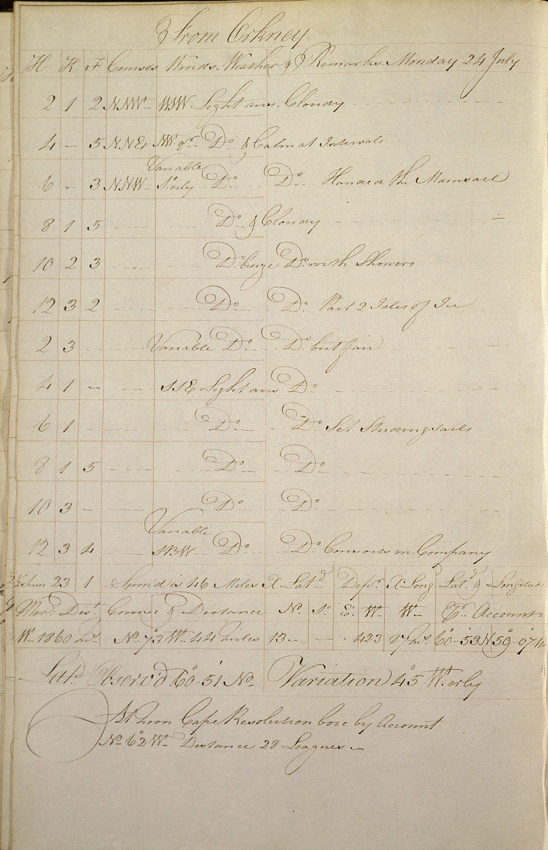
Figure 1. Typical page from a Hudson’s Bay Company logbook.
This page is from the logbook of the Queen Charlotte (24th July 1797).

Metadata: Explanation of Data Fields

The entries below are outlined as per the field headings of the ARCdoc Dataset 1 spreadsheet(s). An explanation is offered for each field in general terms, and where relevant, in dataset specific terms.

NOTE:
Each work sheet represents one year and contains two voyages. One outgoing voyage from the UK to Hudson Bay, normally leaving at the end of June, beginning of July, and one return journey leaving Hudson Bay in September and returning to the UK in October.

ID
Unique Identifier code for each entry (e.g. 1, 2, 3, etc.).

Day number
Count of days in the year of the voyage from 1 to 365 (e.g. 1, 2, 3, etc.).

Day
Day of the month of the year of the voyage (e.g. 1, 2, 3, etc.).

Month
Month of the year of the voyage (e.g. January, February, etc.).

Year
Year of the voyage (e.g. 1825, 1826, etc.).

Project name
Name of the research project (e.g. ARCdoc)

Funder
Name of the project funding body (e.g. Leverhulme).

Dates of project
Project duration dates (e.g. 2011-2014).

Transcriber
Name of the log book transcriber (e.g. Catharine Ward).

Citation
Citation is the field where the formal attribution is shown for users of the ARCdoc Datasets to cite; it credits the researchers and editors of a Dataset together with its database compilers. This citation must be quoted whenever records are referenced or employed for any purpose.

Please quote the relevant citation when using extracts or details from this Dataset:

Ward, Catharine (2014). ARCdoc Hudson’s Bay Voyages, in Nicholls, John (comp.) ARCdoc Data Pages, Hull: (http://hydra.hull.ac.uk/resources/hull:8572).

Source
Source of the research materials (e.g. Hudson Bay Company log Books).

HBCA catalogue ref. reel
Location reference of the Hudson Bay Company Archive material (where available) (e.g. LZ 123).

Image number range
Range of log sheet images accessed (e.g. LZ1-LZ200).

Date range
Range of dates of the research period (e.g. 1825).

Civil or Nautical
Purpose of voyage (e.g. Nautical).

Julian or Gregorian
Calendar type (e.g. Julian).

Instrument makers
Name of instrument makers where available (e.g. Smith and Co).

Vessel
Name of the vessel undertaking the voyage (e.g. Brunswick).

Officer
Name of the officer on board ship who kept the observations (e.g. Captain Smith).

Voyage
Start and destination ports for the voyage (e.g. Hull to Riga).

Meridian Range
Range of landmarks used by the ship to calculate it's longitude.

Latitude degrees
Degrees of latitude (e.g. 57). Where specific information is available this may be recorded as text (e.g. “Stranded Isle of Sefsoe, Callagate”).

Latitude minutes
Minutes of latitude (e.g. 5).

Longitude degrees
Degrees of longitude (e.g. 4).

Longitude minutes
Minutes of latitude (e.g. 17).

West/East
Indicates East or West of the Meridian (e.g. West)

Meridian
Specific landmark that is used by the ship to calculate it's longitude.

Noon wind direction
Wind direction reading recorded nearest to noon (e.g. SE, Calm, etc).

Converted wind direction
True wind direction - corrected for magnetic variation and split into the 4 cardinal marks: N,S,E, W.

Noon Wind Force
Wind strength recorded nearest to noon (e.g. Fresh Breezes, Strong Gales, etc).

Noon Beaufort Force
Noon wind (from “Noon wind” column) converted into Beaufort numerical scale using CLIWOC meteorological dictionary (e.g. 4).

Daily max gust
Reading of the maximum gust recorded over 24 hours (e.g. Strong gales).

Daily Beaufort Force
Daily maximum gust (from “Daily max gust column) converted into Beaufort numerical scale using CLIWOC meteorological dictionary (e.g. 3).

Noon Weather
Description of general weather condition observed (e.g. cloudy)

Daily distance
Distance in nautical miles traversed during the day (e.g. 25)

Rain
Simple indicator of whether rain was recorded over 24 hours: “1” = rain, “0” = no rain.

Snow
Simple indicator of whether snow was recorded over 24 hours: “1” = snow, “0” = no snow.

Fog
Simple indicator of whether fog was recorded over 24 hours: “1” = fog, “0” = no fog.

Sea state
Phrase indicating the state of the sea over 24 hours (e.g. Rough, Calm, etc.)

Ice
Times when ice was recorded (e.g. edge of packed ice, cross ice, streams).

Magnetic variation
Magnetic variation given in degrees and estimated by the recording officer

Wind force 0
Daily tally of wind force reading of 0.

Wind force 1-3
Daily tally of wind force reading of 1-3.

Wind force 4
Daily tally of wind force reading of 4.

Wind force 5
Daily tally of wind force reading of 5.

Wind force 6
Daily tally of wind force reading of 6.

Wind force 7
Daily tally of wind force reading of 7.

Wind force 8
Daily tally of wind force reading of 8.

Wind force 9
Daily tally of wind force reading of 9.

Wind force 10
Daily tally of wind force reading of 10.

Wind force 11
Daily tally of wind force reading of 11.

Total days missing or not conv.
Missing or unavailable wind force readings.

Total
Total tally of wind force readings.

Wind directions N
Count of readings indicating N.

Wind directions E
Count of readings indicating E.

Wind directions S
Count of readings indicating S.

Wind directions W
Count of readings indicating W.

Days missing or not conv.
Missing or unavailable wind direction readings.

Gale frequency gale force 8+
Frequency of Beaufort scale readings registering as 8 , 9 or 10.

Totals
Frequency of gales registered as a cumulative count of gales above force 9.

Vessels spoken with
Other vessels communicated with (e.g. Margaret, Walker, etc.)

Ships in company
List of other vessels accompanying (e.g. Margaret, Walker, etc.)

Notes
Recorded relevant or pertinent remarks made (e.g. “Land 50 miles distant”).

Outcomes

The outcomes are a series of monthly summary statistics for each month of the voyages. As noted above, these are confined to the summer season as the vessels could not sail in winter, but provide nonetheless a valuable series of first-hand observations. These are expressed as a series of indices quantifying the frequency of winds from each of the four quadrants (N, S, E & W), gales, fog, snow and rain. The mean wind force can also be calculated for each month. The whaling logbooks provide a unique additional set of daily and monthly-aggregated data on sea ice cover and character.

In addition to the detailed first and second generation spreadsheets, which contain the daily data, a summary of the indices over the period covered by these logbooks is also included on this site.

Ward, C. and Wheeler, D. (2012) Hudson’s Bay Company ship’s logbooks: a source of far North Atlantic weather data. Polar Record, 48, 165 – 176.

Supplementary Information

Enquiries regarding the information contained in this document and the accompanying dataset should be directed to John Nicholls (j.nicholls@hull.ac.uk).

ARCdoc Data Pages

(www.hull.ac.uk/mhsc/ARCDOC)

