Options for managing alkaline steel slag leachate: A Life Cycle Assessment
Helena I. Gomes1^{, 2},*, William M. Mayes¹, Helen A. Baxter³, Adam P. Jarvis⁴, Ian T Burke⁵, Douglas I. Stewart⁶, Mike Rogerson¹
¹ School of Environmental Sciences, University of Hull, Cottingham Road, Hull, HU6 7RX, UK
² Food, Water, Waste Research Group, Faculty of Engineering, University of Nottingham, University Park, Nottingham, NG7 2RD, UK
³National Centre for Resilience, School of Interdisciplinary Studies, University of Glasgow, Crichton Campus, Dumfries, DG14ZL, UK
⁴ School of Engineering, Newcastle University, Newcastle upon Tyne, NE1 7RU, UK
⁵School of Earth and Environment, University of Leeds, Leeds, LS2 9JT, UK.
⁶School of Civil Engineering, University of Leeds, Leeds, LS2 9JT, UK.
* Corresponding author. Tel. +44 115 846 7244. E-mail address: helena.gomes@nottingham.ac.uk (Helena I. Gomes)
Prepared for submission to Journal of Cleaner Production

Highlights
- Comparison of 5 treatment options for steel slag leachate (active and passive)
- CaCl₂ dosing was the treatment with higher environmental footprint
- Passive treatment had better environmental performance than active options
- Optimisation of metal removal and renewable energies could improve performance

Abstract
Management of steel slag (a major by-product of the steel industry) includes the treatment of highly alkaline leachate (pH > 11.5) from rainwater infiltration of slag deposits to prevent adverse impact upon surface or ground waters. This study aims to compare different treatment options for steel slag leachate through a life cycle assessment (LCA). Five options were compared: active treatment by acid dosing (A-H₂SO₄), active treatment by carbon dioxide dosing (A-CO₂), active treatment by calcium chloride dosing (A-CaCl₂), passive treatment by cascade and reedbeds with pumping (P-P), and passive treatment by cascade and reedbeds in a gravity-driven configuration (P-G). The functional unit was 1 m³ of treated leachate with pH < 9, considering 24 h and 365 days of operating, maintenance operations every year, and service life of 20 years. Inventory data were obtained from project designers, commercial suppliers, laboratory data and field tests. The environmental impacts were calculated in OpenLCA using the ELCD database and ILCD 2011 method, covering twelve impact categories. The A-CaCl₂ option scored worse than all other treatments for all considered environmental impact categories. Regarding human toxicity, A-CaCl₂ impact was 1260 times higher than the lowest impact option (A-CO₂) for carcinogenics and 53 times higher for non-carcinogenics (A-H₂SO₄). For climate change, the lowest impact was calculated for P-G < P-P < A-H₂SO₄ < A-CO₂ < A-CaCl₂, while for particulate matter/respiratory inorganics, the options ranked as follows P-G < P-P < A-CO₂ < A-H₂SO₄ < A-CaCl₂. The major contributor to these impact categories was the Solvay process to produce CaCl₂. Higher uncertainty was associated with the categories particulate matter formation, climate change and human toxicity, as they are driven by indirect emissions from electricity and chemicals production. Both passive treatment options had better environmental performance than the active treatment options. Potential design measures to enhance environmental performance of the treatments regarding metal removal and recovery are discussed and could inform operational management at active and legacy steel slag disposal sites.

Keywords
openLCA, environmental impacts, active treatments, acid dosing, reedbeds, passive treatments

1. Introduction
Steel slags are a high volume by-product of steel production with annual global production of about 170−250 million metric tonnes/year (Ober, 2016). Long-established routes for re-use and recycling of steel slag exist, predominantly as fill material or road ballast in construction applications (Motz and Geiseler, 2001). In Europe, between 70-80% of steel slag is currently reused, with the remainder being stockpiled or landfilled (Euroslag, 2017).
During slag disposal, slag conditioning (weathering prior to reuse to reduce lime content), and some afteruse situations (Banks et al., 2006), there can be environmental issues associated with highly alkaline leachates that are generated when water permeates steel slag deposits (Mayes et al., 2008; Roadcap et al., 2005). Such leachates are generated by the dissolution of oxides of calcium and magnesium, alongside hydrolysis of calcium aluminosilicate minerals within the slag (Gomes et al., 2016). The dissolution products of these minerals can generate pH values up to 12.4; well outside the pH range that will be acceptable for any receiving waters (Mayes et al., 2008). At elevated pH, there are also potential issues with high concentrations of some metals and metalloids; notably, those that form oxyanions mobile under alkaline conditions [e.g. Cr, Mo, V: (Chaurand et al., 2007; Hobson et al., 2017; Matern et al., 2013)]. The high pH and calcium loadings of the leachate can also lead to high rates of calcium carbonate precipitation, when there is contact with atmospheric CO₂, which can smother benthic communities in receiving waters (Hull et al., 2014; Koryak et al., 2002).
Given these potential chemical and physical pollution issues, pH adjustment of highly alkaline waters is typically required by regulatory authorities at steel slag disposal sites either during operation or post-closure, to ensure discharge waters meet ambient surface water quality standards [typically less than pH 8.5 or 9.0 (USEPA, 2017)]. The neutralisation of the leachate also alleviates most of the associated environmental issues associated with the mobility of potential ecotoxic metal(loid)s at high pH (Burke et al., 2013). Other legacy discharges, such as drainage from abandoned coal and metal mines, have long-established technologies for, and mature engineering guidance on treatment (e.g. PIRAMID Consortium, 2003; Younger et al., 2002). However, the range of options for treating highly alkaline steel slag leachate has not been systematically appraised (Gomes et al., 2016). Treatment options for alkaline slag leachates include direct neutralisation with refined inorganic acids (usually H₂SO₄), and direct carbonation through aeration with high-grade CO₂ or air (Hall, 2008). Acid dosing has historically been adopted for alkaline steel slag leachates both in-situ and ex-situ (Mayes et al., 2008), and while very effective at pH control; it suffers from potential health and safety issues associated with acid handling. Direct CO₂ dosing has been successfully applied for high flow (> 50 L s⁻¹), short-term treatment of alkaline wastewaters associated with construction and groundworks (Hall, 2008). Such in-situ dosing units rely on dissolution of CO₂ at pressure, which precedes reaction with the alkaline water in a flocculator and drives the pH buffering. Subsequently, secondary carbonate deposits and fines are captured through settlement (Hall, 2008).
Alternatively, excess alkalinity can be removed from steel slag leachates by the addition of a Ca salt (such as CaCl₂) because these slags contain sodium alkalinity from Na₂CO₃ used in the process. These leachates are calcium-limited, so addition of Ca⁽²⁺⁾_{(aq)} promotes CaCO₃ precipitation (Blue et al., 2017).
More recently passive treatment approaches encouraging gravity-driven cascades and wetlands have been proposed as alternatives for buffering alkaline steel slag leachates (Banks et al., 2006; Gomes et al., 2017b; Mayes and Younger, 2006). With stepped cascade systems, flow of the leachate affected water over weirs entrains air and induces mixing, which enhances CO₂ dissolution. Whereas in wetland systems, microbial respiration in the soil and plant litter produces CO₂, which contributes alongside dissolution of atmospheric CO₂ at the free surface to the buffering of alkaline waters (Higgins et al., 2017; Mayes et al., 2009a). Passive treatment options are characterised by an initial capital outlay, and while regular maintenance of the systems is required (e.g. de-sludging, vegetation management), there is no major operating expenditure associated with energy input (e.g. to pump waters), or chemical reagents (Younger et al., 2002).
The waste hierarchy prefers leachate prevention, and can be achieved through conventional containing and capping slag deposits in a lined landfill, or through more novel approaches such as slag coating and passivation [e.g. with bitumen or alum salts (Özkök et al., 2016)]. However, at many current and former steelworks sites tipping of material dates from a time before strict environmental regulation was imposed (Mayes et al., 2008). At such sites, slag disposal is typically in unlined landfills while the composition of historic production slags was more variable and did not lend itself to widespread reuse (Motz and Geiseler, 2001). As such, leachate generation represents an enduring problem and poses a multi-decadal environmental pollution legacy at some locations (Riley and Mayes, 2015; Roadcap et al., 2005). Evaluation of remediation options for such abandoned steelmaking sites and those in the closing stages of their operational life cycle is particularly timely given the number of older steelmaking sites approaching closure in Europe (Masrani, 2016; Neuhoff et al., 2014).
Life Cycle Assessment (LCA) provides a systematic framework for appraising the environmental impacts of the various available steel slag leachate treatment options. The full life cycle approach espoused by LCA from raw material extraction, processing, manufacturing, maintenance to ultimate disposal requires information on all materials and processes used in any development to assess the long-term, cumulative impacts of an activity on the environment. LCA (Hengen et al., 2014), multi-criteria sustainability assessments (Winfrey et al., 2015) have been applied in analogous situations, including mine water treatment studies at abandoned mining sites, and provided a useful tool, alongside direct Cost-Benefit Analysis (CBA), to help inform sound environmental management. Other successful applications of LCA include assessments of the impact on groundwater of municipal solid waste incineration slags disposal on landfills, focusing on Cd²⁺ and Cu²⁺ impacts in particular (Hellweg et al., 2005). Recent works also target resource recovery from municipal solid waste incineration bottom ash (Allegrini et al., 2015), but no study to date has focused on treatment of alkaline drainage produced by steel slag. This study aims to compare the full life cycle environmental impacts of a range of implemented and potential remedial strategies for managing the legacy of highly alkaline leachates at steel slag disposal sites.

2. Methods
2.1. Case study
The hypothetical study presented provides a comparative assessment of passive and active treatment options for alkaline steel slag leachate. It is based on data from research on mesocosm scale on passive treatments of steel slag leachate (Gomes et al., 2017b), laboratory-scale batch tests for active treatment dosing (Fig. S1, Supplementary Information), information from stakeholders on operational management, as well as ongoing monitoring of constructed reedbeds at pilot scale (Table 1).

Table 1. Composition of the synthetic steel slag leachate considered and comparison with the range of values found in in the UK (Hull et al., 2014; Mayes et al., 2008) and the values after dosing with H₂SO₄, CaCl₂ and CO₂ and measured in the constructed reedbeds.
Determinand | Synthetic slag leachate (average values, n=80) | Range of reported UK leachate values |  | After H₂SO₄ dosing¹ (n=3) |  | After CaCl₂ dosing¹  (n=3) |  | After CO₂ dosing¹ (n=3) |  | After passive treatment with reedbeds² (n=141)
pH | 11.2±0.1 | 10.3-11.9 |  | < 9 |  | < 9 |  | < 9 |  | < 9
Major elements (mg L⁻¹)
Ca | 93±24 | 11-239 |  | 37±2 |  | 1592±225 |  | 81±0.2 |  | 2.4±1.7
Mg | 0.2±0.2 | 1-12 |  | 0.005±0.001 |  | 1.2±0.05 |  | 2±0.01 |  | 1.1±1.0
K | 143±3 | 18-293 |  | 173±1 |  | 143±35 |  | 23±0.3 |  | 109±12
Na | >1000 | 24-83 |  | >1000 |  | >1000 |  | >1000 |  | > 1000
Al | 1.4±0.4 | 0.013-0.5 |  | 0.16±0.1 |  | 0.05±0.02 |  | 0.10±0.002 |  | 1.2±0.5
Si | 3.6±2.2 | 0.203-7.7 |  | 12±2 |  | 3.9±0.3 |  | 11±0.04 |  | 9.9±1.1
Sr | 0.1±0.1 | 0.2-4 |  | 2.11±0.01 |  | 1.03±0.004 |  | 0.05±0.001 |  | 0.2±0.01
Trace elements (µg L⁻¹)
As | <15 | na |  | < 15 |  | < 15 |  | < 15 |  | 7±11
Ba | 25±21 | 4.6-42.5 |  | 48±5 |  | 61±0.4 |  | 42±0.3 |  | 5±2
Cd | <0.5 | <0.1-0.3 |  | <0.5 |  | <0.5 |  | <0.5 |  | <0.5
Cr | <1 | <5-22 |  | <1 |  | <1 |  | <1 |  | <1
Cu | <0.3 | <5-70 |  | <0.3 |  | <0.3 |  | <0.3 |  | 37±39
Fe | <0.6 | 54-920 |  | <0.6 |  | <0.6 |  | <0.6 |  | 76±130
Ga | <2 | na |  | <2 |  | <2 |  | <2 |  | 22±25
Li | 5±2 | 4.4-822 |  | 4±2 |  | 170±2 |  | 15±0.1 |  | 182±23
Mn | <0.1 | 5.4-160 |  | <0.1 |  | <0.1 |  | <0.1 |  | <0.1
Mo | <3 | 2.8-45 |  | <3 |  | <3 |  | <3 |  | <3
Ni | <2 | 0.3-70 |  | <2 |  | <2 |  | <2 |  | <2
Pb | <9 | <5-70 |  | <9 |  | <9 |  | <9 |  | <9
V | 456±64 | 1.6-120 |  | 230±6 |  | 92±5 |  | 402±0.4 |  | 67±34
Zn | <2 | 2-40 | <2 |  | <2 |  | <2 |  | <2
n – number of samples; na – not available

¹ Results from laboratory experiments with synthetic steel slag leachate produced as described in Gomes et al. (2017)

² Results from pilot reedbeds at British Steel, Scunthorpe

Three active and two passive treatment options were considered (Table 2, Fig. 1 and 2). These all assume the treatment scheme is designed to minimise pumping and to take advantage of the terrain typically expected at steel disposal sites. All the treatments were dimensioned for a 3 L s⁻¹ flow that must meet pH < 9 criterion before discharge, in line with prescribed regulatory limits. This flow rate reflects an upper estimate of flow rates typical at steel disposal sites in the UK (Mayes et al., 2008). The active treatment A-H₂SO₄ comprises of pumps (two parallel pumps, 3 kW, 3 m head), a 500 L mix tank made of high-density polyethylene (HDPE) with an agitator (potency 0.25 kW), and a residence time of 3 min. The sulphuric acid dosing system has a dosing pump (0.18 kW) and a 14.3 m³ double-walled XLPE (high-density cross-linked polyethylene) tank with secondary containment basin. The dosage of 96% sulphuric acid is 3 L h⁻¹ (determined by laboratory experiments, Fig. S1 – Supplementary Information), and the annual reagent consumption is 26 m³ per year. After the acid dosing, an anionic flocculant based on acrylamide is added at a rate of 0.1 mg L⁻¹ using an automatic liquid polymer preparator with a 0.25 kW dosing pump and a 0.55 kW mixer. For solids removal, the influent will go to a stainless steel Lamella clarifier with a 20 m² effective settlement area, and a 50 m³ polishing pond (10 m × 5 m × 1 m, 1.5mm HDPE membrane with protective geotextile) for pH adjustment before discharging to the receiving environment. Residence time is estimated to be 5 hours. The thickened sludge from the clarifier is filtered and pressed (filter area 1.4 m², 3 kW).
The other active treatments have similar configurations (Fig. 1), but the chemical and dosing system are different. For the A-CO₂ option, two industrial cylinders VK/LK with 34 kg of 99.8%CO₂ dose the gas at 0.4 g L⁻¹ (Siltbuster, 2017). An integrated probe and pH controller monitors the pH levels of the water, automatically controlling the CO₂ dose rates. The treatment also includes two mixers (2.2 kW each), a heater (1.0 kW), a sludge pump (0.75 kW) and a feed pump (2.2 kW). No flocculant addition is needed for this option. For the A-CaCl₂, a dosing rate of 1.011 kg per m³ of leachate was determined in laboratory experiments (Fig. S1, Supplementary information). The CaCl₂ is stored in a 30 m³ silo, and the treatment is similar to the A-H₂SO₄, except for the CaCl₂ storage and dosing.
The passive treatment (Figure 2) consists of a stepped aerated cascade 10 m high and 3 m wide, with 0.5 m steps, followed by a concrete settlement basin (20 m³) and two surface flow reedbeds. Each reedbed has a retention time of 24 h (300 m³) and is lined with 1.5 mm HDPE membrane with protective geotextile. The beds have a 20 cm layer of gravel and 50 cm layer of compost. Phragmites australis (common reed) plants fill both beds. The difference between the two options P-P and P-G is in the first step of the treatment; with P-G it is assumed that site topography allows the system to be gravity fed with leachate, so it does not require pumping.

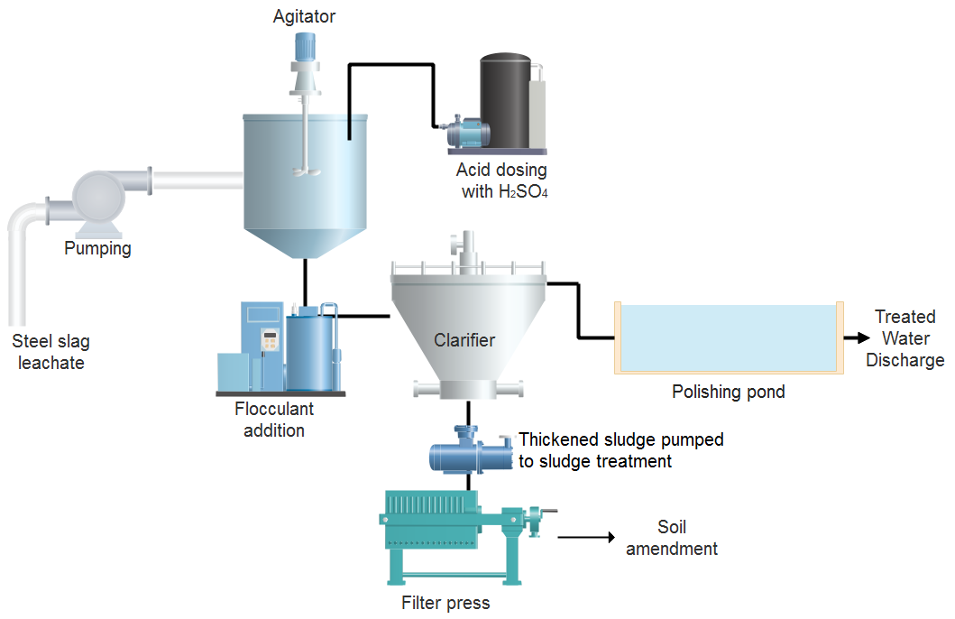
A-H₂SO₄
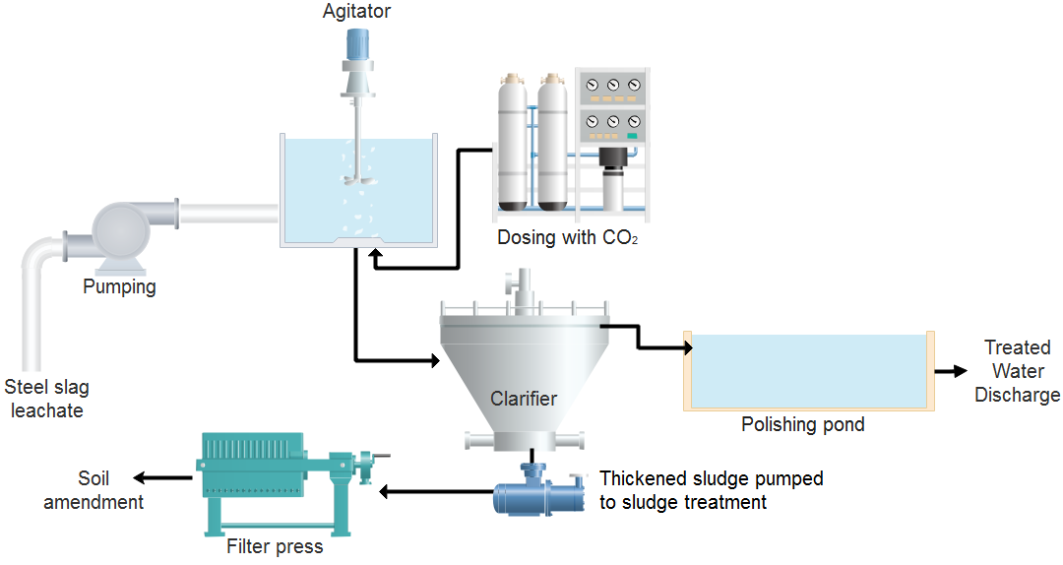
A-CaCl₂
A-CO₂
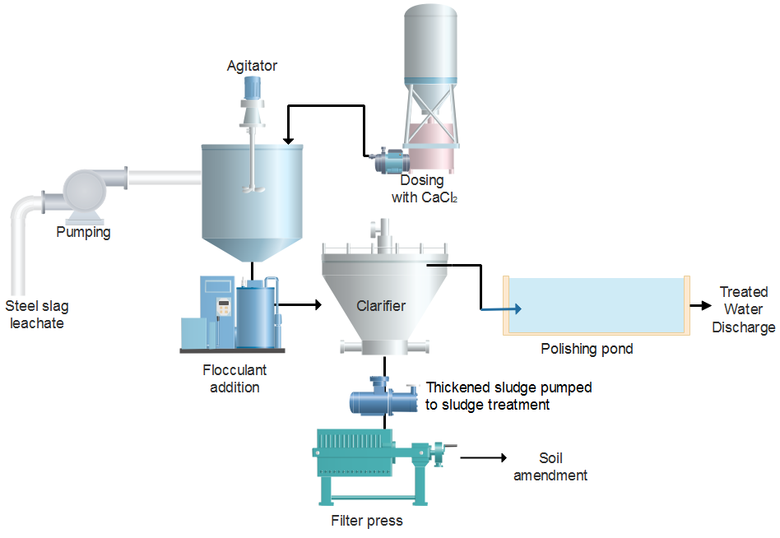
Figure 1. Schematic diagram of steel slag leachate treatment for the active treatment options. Figures not drawn to scale.
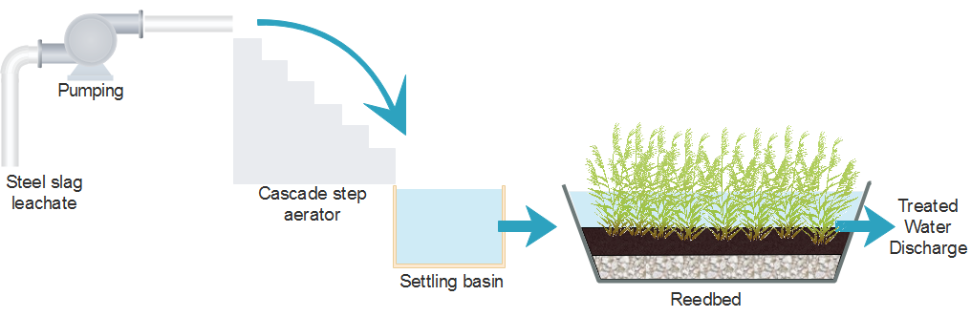
P-P
Figure 2. Schematic diagram of steel slag leachate treatment for the passive treatment option P-P. In the option P-G there is no pumping, and the water is gravity driven to the cascade step aerator. Figure not drawn to scale.

2.2. Goal and scope definition
This LCA aims to evaluate the environmental impacts associated with the construction, operation and maintenance of five different treatment options for steel slag leachate (Table 2), using a consequential model, as recommended for flows into the environment (Ekvall et al., 2016). All options aim to lower the pH of the alkaline leachate to reach the regulatory limits for discharge and aquatic life (<9), simultaneously removing some metals through precipitation.

Table 2. Treatment options abbreviations and process descriptions.
Abbreviation | Description
A-H₂SO₄ | Active treatment with acid dosing (H₂SO₄)
A-CO₂ | Active treatment with carbon dioxide dosing (CO₂)
A-CaCl₂ | Active treatment with calcium chloride CaCl₂ dosing
P-P | Passive treatment with cascade and reedbeds with pumping
P-G | Passive treatment with cascade and reedbeds gravity driven

The life cycle assessment was conducted with the OpenLCA v1.7 software (Green Delta, Germany) and the ELCD (European reference Life Cycle Database) v3.2, following the recommended International Reference Life Cycle Data System (ILCD) methodology developed by the European Joint Research Council (European Commission et al., 2010; European Commission et al., 2011; Hauschild et al., 2013; Owsianiak et al., 2014).
The functional unit for this study is 1 m³ of treated leachate with pH < 9, considering both the quantity and quality of the treated leachate, assuming 24 h and 365 days of operating, maintenance operations every year, and a service life of 20 years (conservative estimate typical for treatment plants) (Cornejo et al., 2016; Machado et al., 2007; Rahman et al., 2016). This functional unit is relevant, as the main concern for the leachate treatment is to neutralise acidity and secure that the pH after treatment is below the regulatory levels for discharge of treated effluent and ambient aquatic life limits (pH=9). Trace metals of most environmental concern associated with steel slag leachate are those potentially soluble at high pH, because they form oxyanions (e.g. As, Cr, Mo, Se and V), which can be very mobile as they sorb weakly to soils and sediments (Cornelis et al., 2008; Mayes et al., 2011). Lowering pH during the leachate treatment will allow removal of metals through precipitation. The generation of steel slag leachate in legacy sites is known to persist for more than 30 years, making the timescale of our analysis reasonable (Mayes et al., 2008; Riley and Mayes, 2015). The geographic coverage of the study is Great Britain, but it can be representative for the rest of Europe, making adjustments for the energy mix and the transportation modes.
The system boundaries are presented in Fig. 3, and comprise all essential components and processes used in each of the treatment options to ensure a realistic and transparent comparative analysis between treatments. These components and processes encompass raw materials (including extraction and processing for mined materials), transportation, construction (including excavation and installation of the equipment), and process energy required for pumping and treatment. Impacts associated with human labour associated with the installation and continued running of the treatments have not been included, neither has equipment for building and transport. The decommissioning of the treatment plants after the 20 year design life (Fig. 1) was also excluded, as the impacts associated are considered negligible compared with the construction and operation phases (Bonton et al., 2012; Vince et al., 2008), and is also uncertain depending on material recycling measurements (Jeong et al., 2018).

2.3 Life Cycle Inventory

2.3.1 Construction phase
The materials for the construction of each treatment option were obtained from commercial suppliers. The materials quantities (e.g. volume of concrete and steel) were normalized to a m³ of treated leachate by dividing with total volume of water treated in its lifetime of 20 years. Plastics (XLPE, HDPE, PVC and PP) are modelled using the raw materials from the ELCD database and the energy needed for moulding (Elduque et al., 2015), assuming an articulated lorry transport 40 t total weight, 27 t max payload of 1.5E-6 t.km (standard distance). The excavation uses a 100 kW excavator (ELCD 3.2 database). The concrete used for construction was modelled with Portland cement, sand, aggregate, water and energy (Sjunnesson, 2005). Materials used in the tubing were not included in the analysis, as they would be similar for all options. Transportation of the plants and compost used in P-P and P-G are included, but no other burdens were attributed to them. This zero burden assumption for the compost, and the use of locally-sourced populations of reeds is recommended for use in passive treatment systems (PIRAMID, 2003). Table S1 (Supplementary Information) gives details of the inventory and summarise the sources of information used in this study.
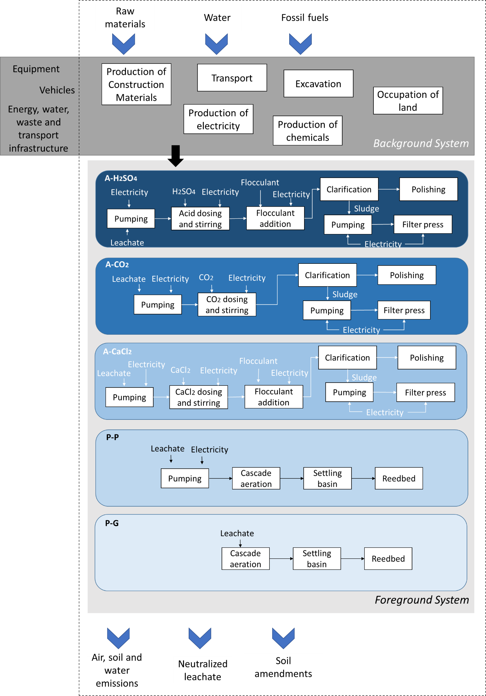Figure 3. System boundaries for the LCA (dotted line), showing background and foreground systems, processes and flows (emissions and natural resources) considered in the study.

2.3.2 Operation phase
The detailed description of the treatment processes and equipment can be found in Section 2.2. The electrical consumption of active systems is calculated from unit power, efficiency and operating time. All equipment needs low voltage electricity (between 220 V and 400 V), using the Electricity Mix, consumption mix, at consumer, AC, 230-240V - GB. The consumption of chemicals is based on laboratory tests to lower the pH below 9 and the treated flow volume during the design lifetime (Fig. S1, Supplementary Information). The sludge produced in all options is used as a soil amendment (as a lime substitute), and the emissions to agricultural soil were estimated based on the mass balance calculation applied to the leachate quality samples (Table S2, Supplementary Information). Elements with concentrations below the limit of detection were not included in the LCI model. Furthermore, for the passive treatment options, we used data from wetland field sites to assess sediment quality and accumulation rates (Mayes et al., 2009b; Mayes and Younger, 2006; Mayes et al., 2008). Field data suggests consistent sludge accumulation rates of ~0.9 g/m²/day (range: 0.3-1.8 g/m²/day) in monitored wetlands receiving alkaline steel slag leachate (Mayes et al., 2006). Composition of sludge is taken from Mayes et al. (2008; 2009) which generally shows the sludge to be dominated by secondary carbonate deposits with relatively low trace element concentrations.
The chemicals needed for the active treatment (H₂SO₄, CO₂, CaCl₂ and acrylic acid for the flocculant) are not included in the ELCD database and were modelled using the Ecoinvent information available for their fabrication (Althaus et al., 2007).
The transport distance during operation is 50 km, with the transport performed by smaller vehicles (small lorry transport, Euro 0, 1, 2, 3, 4 mix, 7,5 t total weight, 3,3 t max payload - RER) and by a diesel passenger vehicle (fleet average 2010) (Spielmann et al., 2007).
Land occupation (Occupation, industrial area, built up, m².a) was considered for all treatment options (Table S1, Supplementary Information), according to the dimensions of the unit operations described in Section 2.2.
The outflow composition considered to estimate the pollutant emissions into water for the LCI model was measured in the lab tests and pilot reedbeds (Table 1). The elements with concentrations below the limit of detection were not included in the LCI model.

2.3.3 Maintenance phase
The maintenance in the active treatment options comprises predictive electromechanical maintenance (to control the condition of equipment operations, to prevent breakdowns, and carry out a rapid repair following a failure), as well as metrological maintenance (regular calibration and adjustments to continuous measurement equipment and facilities' instrumentation). It is modelled as a visit to the treatment plant every three months and includes the transportation in a diesel passenger vehicle (fleet average 2010). The maintenance of the passive treatment systems includes vegetation management every two years (transportation in a diesel passenger vehicle) and the sludge removal from the concrete settlement basin after the cascade every five years (excavation and transport), which is consistent with operational experience. The excavation uses a 100 kW excavator (ELCD 3.2 database).
2.4 Life Cycle Impact Assessment
The impact assessment was modelled using ILCD 2011 impact assessment method. Midpoint and endpoint categories were selected to quantify the types of impact that are associated with and relevant to the case study, focusing on water quality, human health and global environmental problems (Baxter, 2015; Corominas et al., 2013; Niero et al., 2014). The midpoint metrics were climate change (kg CO₂ eq), respiratory/particulate matter (kg PM2.5 eq.), human health – human toxicity both carcinogenic and non-carcinogenic [Comparative Toxic Unit for human (CTUh)], freshwater ecotoxicity [Comparative Toxic Unit ecosystems (CTUe)], land use (kg C deficit) and eutrophication [freshwater (kg P eq), marine (kg N eq) and terrestrial (molc N eq)]. The categories excluded were acidification; ionizing radiation; mineral, fossil and renewable resource depletion; ozone depletion; photochemical ozone formation; and water resource depletion due to lack of reliable life cycle data. The selection of impact categories is consistent with the goal and scope of the study and reflects a comprehensive set of environmental issues related to the treatment of alkaline leachate from steel slag (Mayes et al., 2009a; Mayes et al., 2009b). Hengen et al. (2014) used a ‘Hierarchist’ perspective to address key environmental impact metrics associated with their case study on acid mine drainage and showed that climate change, human toxicity, particulate matter formation, and fossil depletion contributed more than 10% to the total endpoint impact categories.
The ILCD endpoint categories considered are: damage to human health (DALY - Disability Adjusted Life Years); damage to ecosystems (predicted loss of species on different ecosystems as a result of the activities undertaken); and loss of materials/minerals or non-renewable resources (quantified in US dollars, as the sum of the total resources lost and a relative comparative unit to avoid use of absolute values).

3. Results

3.1 Midpoint analysis

3.1.1. Human toxicity
Figure 4 and Table 3 present human toxicity potentials (carcinogenics and non-carcinogenics impact categories) for each treatment option, expressed in comparative toxicity units (CTUh). The option A-CaCl₂ has the highest (3.92E-07 CTUh) carcinogenic impacts, due to the Solvay process for the manufacture of CaCl₂ (2.87E-7 CTUh, which is related to chromium emissions). Similarly, for non-carcinogenics and A-CaCl₂, the production of chemicals is responsible for 3.28E-7 CTUh (emissions of mercury, lead, and cadmium), energy and heat by 2.19E-7 CTUh (metal emissions to air, water, and soil), while the leachate treatment is responsible for 2.80E-8 CTUh (vanadium emissions to soil), 1.78E-8 CTUh (vanadium emissions to water), 5.99E-9 CTUh (barium emissions to water) and 1.47E-9 CTUh (barium emissions to soil). For non-carcinogenics, the treatment options that have lowest values for human toxicity (Figure 4, Table 3) are A-CO₂ and A-H₂SO₄. The passive treatments are 10 times higher, due to the arsenic (1.91E-7 CTUh) and vanadium emissions to water (1.30E-8 CTUh), together with vanadium (7.00E-8 CTUh) and barium (2.46E-8 CTUh) emissions to agricultural soil. Regarding human toxicity carcinogenics, in the passive treatment options, arsenic water emissions are responsible for 2.58E-9 CTUh.

3.1.2 Climate change
The impact on climate change is also much higher for A-CaCl₂ (Figure 4, Table 3) with the major contributors being the energy and heat consumption for the Solvay process (89 kg CO₂ eq). The active treatments A-H₂SO₄ and A-CO₂ show similar values, higher than passive treatments due to the energy consumption in the operation phase and the transport during the maintenance phase. The most environmentally friendly treatment option regarding climate change is P-G, where the main contributors are the construction materials (0.009 kg CO₂ eq).

3.1.3 Particulate matter
Out of the treatment options analysed, A-CaCl₂ is the highest contributor to the emissions of particulate matter < 2.5 µm (PM2.5), once more due to the Solvay process for the production of CaCl₂ (0.023 kg PM2.5 eq.) and the use of NaCl for PVC production (0.03 kg PM2.5 eq.). Particulate matter emissions are lowest with the passive treatments and the main contributors are construction materials (1.48E-06 kg PM2.5 eq.) and transport (6.69E-07 kg PM2.5 eq.).

3.1.4 Freshwater ecotoxicity
As the treatment scenarios compared in this study aim to reduce the metals emissions from steel slag leachate, this category is particularly relevant. Comparing the active treatments, dosing with CaCl₂ (A-CaCl₂) has most impact, due to the vanadium emissions to surface water (10.4 CTUe) and agricultural soils (11.7 CTUe). For A-H₂SO₄, vanadium is also the major contributor with 26.0 CTUe (water emissions) and 1.2 CTUe (agricultural soils emissions), In the treatment option A-CO₂, vanadium water emissions are the major responsible (45.4 CTUe). The two passive treatment scenarios have the same impact, slightly higher than A-H₂SO₄ due the vanadium emissions to water (29.2 CTUe) and agricultural soil (29.2 CTUe), as well as Cu emissions to water (2.0 CTUe).
3.1.5 Land use
Passive treatment options show the best performance in this impact category. The difference between the two passive treatment options is due to the energy consumption for pumping in P-P. The energy consumption was also the major determinant for this impact category. In the active treatments, energy consumption was responsible by 2 kg C deficit for A-CaCl₂, 0.3 kg C deficit for A-CO₂, and 0.2 kg C deficit for A-H₂SO₄.
3.1.6 Eutrophication (freshwater, marine, terrestrial)
Regarding freshwater eutrophication, A-H₂SO₄ was the treatment option with lower impacts, followed by A-CO₂ in which the phosphorus emissions to soil contributed with 0.008 kg P eq. Phosphorus emissions to agricultural soils of the passive treatment options are also the major contributors (0.001 kg P eq). The worst performance of A-CaCl₂ is due to the emissions to water associated with the Solvay process (0.009 kg P eq). The emissions to water for all treatment options are below the 1% cuttoff of impact associated with eutrophication. For both marine and terrestrial eutrophication, the treatment options ranked as follows: P-G < P-P < A-H₂SO₄ < A-CO₂ < A-CaCl₂. Emissions of ammonia to air from the Solvay process associated with A-CaCl₂ are responsible for 4.65 molc N eq, contributing to terrestrial eutrophication, while emissions to air of nitrogen dioxide contribute with 0.04 kg N eq for marine eutrophication. For A-H₂SO₄, the major contributor to the eutrophication impact categories is energy consumption, while in A-CO₂, besides energy consumption, phosphorus emissions to agricultural soils contribute with 0.008 kg P eq.

Table 3. Summary of midpoint impact category results.

Impact category | Unit |  | A-H₂SO₄ |  | A-CO₂ | A-CaCl₂ | P-P | P-G
Human toxicity, cancer effects | CTUh |  | 3.56E-10 |  | 3.11E-10 | 3.92E-7 | 2.89E-9 | 2.88E-9
Human toxicity, non-cancer effects | CTUh |  | 5.33E-8 |  | 8.35E-8 | 2.81E-6 | 2.99E-7 | 2.99E-7
Climate change | kg CO₂ eq |  | 6.08E-2 |  | 7.16E-2 | 1.34E+2 | 1.77E-2 | 1.44E-2
Particulate matter | kg PM2.5 eq |  | 2.07E-5 |  | 1.44E-5 | 6.07E-2 | 3.82E-6 | 3.19E-6
Freshwater ecotoxicity | CTUe |  | 2.72E+1 |  | 4.55E+1 | 5.03E+1 | 3.94E+1 | 3.94E+1
Land use | kg C deficit |  | 3.71E-2 |  | 4.29E-2 | 2.02E+0 | 1.65E-3 | 1.76E-5
Freshwater eutrophication | kg P eq |  | 1.06E-8 |  | 8.40E-3 | 1.13E-2 | 1.00E-3 | 1.00E-3
Marine eutrophication | kg N eq |  | 5.62E-5 |  | 6.24E-5 | 9.01E-2 | 1.84E-5 | 1.56E-5
Terrestrial eutrophication | molc N eq |  | 6.15E-4 |  | 6.82E-4 | 5.29E+0 | 2.01E-4 | 1.71E-4

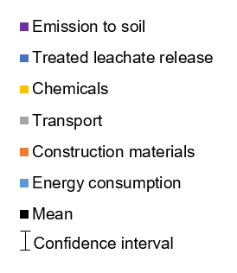
Figure 4. Midpoint results for the active and passive treatment options and relative contributions of the processes considered: a) human toxicity (carcinogenic and non-carcinogenic – CTUh), b) climate change (kg CO₂ eq.), c) particulate matter formation (kg PM2.5 eq.) and d) freshwater ecotoxicity [Comparative Toxic Unit ecosystems (CTUe)], mean coming from Monte Carlo simulation (black square), and 95% confidence interval (error bars). The error bars indicate that in 95% of the cases the characterised LCIA would fall within the range. Confidence intervals and categories may be smaller than symbols. The contributions were aggregated in the categories Energy consumption (includes the electricity mix, natural gas, diesel mix), Construction materials (needed for the leachate treatment), Transport, Chemicals, Treated leachate release and Emission to soil, when applicable. The plots are presented in a logarithmic scale.

Figure 5. Midpoint results for the active and passive treatment options and relative contributions of the processes considered: a) land use (kg C deficit), b) freshwater eutrophication (kg P eq), c) marine eutrophication (kg N eq), and d) terrestrial eutrophication (molc N eq), mean coming from Monte Carlo simulation (black square), and 95% confidence interval (error bars). The error bars indicate that in 95% of the cases the characterised LCIA would fall within the range. Confidence intervals may be smaller than symbols. The contributions were aggregated in the categories Energy consumption (includes the electricity mix, natural gas, diesel mix), Construction materials (needed for the leachate treatment), Transport, Chemicals, Treated leachate release, and Emission to soil, when applicable. The plots are presented in a logarithmic scale.

3.2 Endpoint analysis
Table 4 summarises the results of the endpoint impact category considered. The active treatment with CaCl₂ dosing has the highest impact in all categories (damage to human health, damage to ecosystems and loss of materials/minerals on non-renewable resources). The fossil fuel intensive Solvay process and the manufacture of PVC are the main responsible for all impact categories. Regarding damage to human health, measured in DALY (Disability Adjusted Life Years), the two other active treatment have similar values and the major contributors are the energy consumption (electricity mix; 8.10E-9 DALY and 1.04E-8 DALY for A-H₂SO₄ and A-CO₂, respectively) in the operation phase and the metal emissions to surface water (1.56E-9 and 2.10E-8 DALY for A-H₂SO₄ and A-CO₂, respectively). The passive treatment options have lower impact on damage to human health, and the primary contributor are the vanadium emissions to water and agricultural soils.
Concerning damage to the ecosystems, the active treatments rank as A-CaCl₂ > A-CO₂ > A-H₂SO₄ due to the consumption of fossil fuels in the production of materials and electricity. The difference between the passive treatments is also due to the energy consumption (7.13E-12 species*year in P-P). In these options, the major contributors are the HDPE (4.29E-11 species*year) and the phosphorus emissions to surface waters (3.11E-11 species*year).
P-G is the treatment option with the lowest resource depletion (Table 4), followed by P-P, A-CO₂, A-H₂SO₄ and A-CaCl₂. In this category, the use of fossil fuels for the fabrication of plastics, extraction of raw materials and the electricity production are the main contributors to the environmental impact.

Table 4. Summary of endpoint impact category results.
Impact category | Unit | A-H₂SO₄ | A-CaCl₂ | A-CO₂ | P-P | P-G
Human health | Disability Adjusted Life Years (DALY) | 8.08E-09 | 7.0E-07 | 1.04E-08 | 5.87E-10 | -5.45E-12
Ecosystems | species*year | 9.82E-11 | 3.3E-08 | 1.24E-10 | 6.99E-12 | -6.48E-14
Resource depletion | $ | 1.99E-03 | 9.0E-01 | 2.49E-03 | 1.40E-04 | -1.30E-06

Figure 6 summarises the relative indicator results of each treatment options, for both midpoint and endpoint indicators. For each indicator, the maximum result is set to 100%, and the results of the other variants are displayed in relation to this result. It is clear that the active treatment A-CaCl₂ was the one with highest values for all impact categories, except freshwater toxicity. This result is due to the high dose of CaCl₂ needed to neutralise the steel slag leachate (Fig. S1, Supplementary information) and subsequent impact associated with the energy-intensive Solvay process. The use of PVC in the materials needed for this option also is the major contributor to the impact categories considered.

Figure 6. Relative results for the a) midpoint and b) endpoint analysis for the active and passive treatment options.

3.3 Uncertainty analysis
Only parametric uncertainty in both background and foreground processes (variation and stochastic errors of the input) was considered in this study, excluding model uncertainty and other types of uncertainty (e.g. derived from setting system boundaries, time horizon and other choices). Parametric uncertainty was represented by a lognormal probability distribution using the semi-quantitative Pedigree Matrix approach that relates quality indicators to uncertainty ranges (Pintilie et al., 2016). Five independent characteristics: reliability, completeness, temporal correlation, geographical correlation, and further technological correlation were quantified for each vector included in the inventory for background and foreground processes. For the outputs of each treatment option, namely water and soil emissions, a triangular distribution was assumed using the range of values reported in the UK (Table 1 and Table S2). Temporal, geographical and technological correlation of foreground processes were not considered in the analysis. For the shared background processes; e.g., production of chemicals, electricity, transport; the unit process data were identically randomised for each Monte Carlo simulation (Nhu et al., 2016). To perform uncertainty analysis, Monte Carlo simulation was carried out (Hertwich et al., 2000; Huijbregts et al., 2003), using 10000 iterations and 95% confidence interval.
Monte-Carlo analyses results are shown in terms of 5th and 95th percentiles of the category midpoints for each treatment option (Figure 4). The results reveal that the impact values calculated are within the 95% confidence interval calculated in the Monte Carlo simulation (Figure 4). The impacts associated with energy consumption (particulate matter formation, climate change and human toxicity) have the highest uncertainty, as they are driven by indirect emissions from electricity and chemicals production, collected from limited available literature and, in this case, the information about the Solvay process was added from a different database. Also, uncertainty in emissions from background unit processes has a more pronounced effect when toxicity impacts are characterised (Rahman et al., 2016). Freshwater ecotoxicity shows the lowest deviation from the mean and the narrowest confidence intervals. This is directly associated with the statistical distribution of this emission using the range of values found in the UK (Table 1).

4. Discussion
Although this is the first study focusing on assessing options for alkaline leachate treatment, the results are comparable with other studies using constructed wetlands (Garfí et al., 2017; Hengen et al., 2014). The results show that passive treatments have a consistently lower environmental footprint for the treatment of alkaline steel slag leachates than active treatment, which is similar to the findings for acid mine drainage treatment comparisons (Baxter, 2015; Hengen et al., 2014). These patterns are largely driven by the more modest requirements for materials in the construction of the passive schemes, even though the required land area is greater (which is often a key issue in traditional Cost Benefit approaches: PIRAMID Consortium, 2003). Interestingly, even with the requirement for pumping of water in one of the passive options (P-P), the impacts are less than active treatment in most categories. Given that many steel working sites in Europe are located in relatively flat and coastal areas (Mayes et al., 2008), getting sufficient hydraulic head to drive aeration cascades will typically require pumping.
This study is unable to encompass the entire life cycle of the leachate treatment, as there are limitations related to the influent and effluent composition in each treatment option. For the active treatment options, both the amounts of chemicals needed for dosing and the emissions to water after treatment were determined with laboratory scale tests using a synthetic steel slag, while for the passive treatments there were data available at a pilot scale, with a higher number of samples (Table 1, n=3 vs n=141). However, in all treatment options, the inflow quality of the leachate was considered as well as the treatment efficiencies, and both synthetic and industrial leachates had similar composition reflecting UK slag disposal situations (Mayes et al., 2008). Also, more detailed information was available from previous studies on the composition of the sludges from passive treatments, while for active ones, the emissions for agricultural soil were calculated after a mass balance of three samples.
The ELCD database did not include data on the chemicals (H₂SO₄, CO₂, CaCl₂ and the flocculant acrylic acid) used for the active treatment of the leachate. To complement the ELCD data, those chemicals were modelled using available Ecoinvent data (Althaus et al., 2007). Use of different databases should be transparent and justified LCA (Steubing et al., 2016), it allows crucial data to be included in the model, as was done here. Given the dominant signal of CaCl₂ produced via the Solvay process in many of the categories, it would be informative if a broader selection of input data were available for some of these chemicals to test model sensitivity. The uncertainty analysis presented does however show that the values are within the 95% confidence interval of the Monte Carlo simulation and that the highest uncertainty is associated human-health toxicity impact categories, as is typical in LCA (Rahman et al., 2016).
Despite these potential limitations, the LCA process is informative in highlighting how the different treatment options could be improved to minimise their environmental impact. For example, both the active options (A-H₂SO₄ and A-CO₂) could have an even better performance if the treatment efficiently removed barium, which would lower the freshwater ecotoxicity value, with which the bulk of this residual impact is associated. As Ba can be removed by precipitating as carbonate (Parks and Edwards, 2006), ways to increase bicarbonate (HCO₃⁻_{(aq)}) concentration in water could enhance barium removal. The use of cascades (Gomes et al., 2017b) and other aeration methods could lower Ba emissions [which is incorporated in precipitated carbonates (Rogerson et al., 2008)] and thus the freshwater ecotoxicity of the discharged effluent.
Active treatment via CO₂ dosing (A-CO₂) performed better in midpoint and endpoint analyses than CaCl₂ (A-CaCl₂) dosing and performed similarly to H₂SO₄ dosing (A-H₂SO₄) in most categories (Tables 3, 4). Given acid dosing is often the prevalent remedial strategy particularly for operational or short-lived alkaline discharges (e.g. Mayes et al., 2008; Mayes et al., 2011), it is quite revealing that there is a similarly impactful active treatment alternative that is only sparingly deployed currently (Hall, 2008; Roadcap et al., 2005). The major environmental impact associated with the active treatment A-CO₂ is that of freshwater ecotoxicity, and this could be minimised if the treatment incorporated associated processes to remove vanadium from the leachate, such as ion exchange resins (Gomes et al., 2017a). The high residual vanadium concentrations are consistent with the control on vanadium solubility by calcium vanadate species at high pH (Cornelis et al., 2008; Hobson et al., 2017) and where Ca is rapidly removed from solution in precipitated carbonates, residual vanadium levels can remain elevated in the water column. The use of ion exchange resins also has the advantage that vanadium could be recovered and reused, adding value to the treatment and possibly offsetting some of the treatment costs. If, instead of commercial liquid CO₂, this treatment was implemented using the gas effluent of the steelworks (Zhang et al., 2013), then GHG emissions would be lower and consequently the impact on climate change, as well as all the impacts associated with commercial CO₂ manufacture after monoethanolamine (Althaus et al., 2007). Similarly, in the passive treatments, we did not account for the atmospheric CO₂ sequestration that occurs when calcium in the leachate precipitates as carbonates which could add considerable environmental benefits if fully-accounted in the process (Renforth et al., 2009). Furthermore, the passive treatments do not account for the potential benefits of creation of reedbed habitat, which is considered a priority habitat in the European Union (Habitats Directive, European Commission, 1992), with studies of analogous systems highlighting biodiversity benefits of treatment wetlands (e.g. Batty et al., 2005; European Commission, 1992).
In all the modelled options, the energy mix used in the operation phase was the same and assumed constant for the 20 years of service life of the treatment plants. However, it is predictable that electricity generation in the UK will be decarbonised in 2030 and nearly carbon neutral in 2050 (Sithole et al., 2016), which would improve the environmental footprint of all options, except for P-G. Considering the midpoint categories, lower impact values would be obtained for climate change, human toxicity and particulate matter. In the endpoint categories, resource depletion would be the most reduced. All options would also benefit from the minimisation of transport distances. Additional design optimisation measures are sourcing local materials, use of materials with a low degree of processing, and minimising pumping energy (Hengen et al., 2014), which could all be incorporated in site-specific operational management.

5. Conclusions
This study compared five different options for the treatment of alkaline drainage resulting from steel slag management practices. The results show that gravity-fed passive treatment results in lower environmental impacts for the neutralisation and treatment of steel slag leachate. Whenever possible, considering required area, land availability and hydrochemistry of the leachate, these systems should be adopted. Even if pumping is required, the environmental footprint is lower than the active treatments studied. However, all treatments could have lower environmental impacts if higher metal removal and subsequent recovery was achieved, and also if the energy mix used during the operation phase incorporated a higher percentage of renewable energies. The LCA methodology demonstrated how it could be a valuable tool for design engineering and optimisation of alkaline leachate treatment processes.

Acknowledgements
This project was funded by the UK Natural Environment Research Council, Economic and Social Research Council and the Department for Environment, Food and Rural Affairs under the Resource Recovery from Waste theme via grant NE/L014211/1. Bob Knight and Mike Thompson performed the ICP analysis of the aqueous samples. We thank three anonymous reviewers for their comments which have improved the manuscript.

References
Allegrini, E., Vadenbo, C., Boldrin, A., Astrup, T.F., 2015. Life cycle assessment of resource recovery from municipal solid waste incineration bottom ash. J Environ Manage151, 132-143.
Althaus, H.-J., Chudacoff, M., Hischier, R., Jungbluth, N., Osses, M., Primas, A., 2007. Life Cycle Inventories of Chemicals. Final report ecoinvent data v2.0 No. 8. Swiss Centre for Life Cycle Inventories, Dübendorf, CH.
Banks, M.K., Schwab, A.P., Alleman, J.E., Hunter, J.G., Hickey, J.C., 2006. Constructed wetlands for the remediation of blast furnace slag leachates. Publication FHWA/IN/JTRP-2006/03. Joint Transportation Research Program, Indiana Department of Transportation and Purdue University, West Lafayette, Indiana. http://dx.doi.org/10.5703/1288284313362.
Batty, L.C., Atkin, L., Manning, D.A.C., 2005. Assessment of the ecological potential of mine-water treatment wetlands using a baseline survey of macroinvertebrate communities. Environ Pollut138(3), 412-419.
Baxter, H.A., 2015. Framework for Remediation of Rivers Impacted by Legacy Metal Mine Pollution, Thesis submitted for the Degree of PhD in the University of Hull. December 2015.
Blue, C.R., Giuffre, A., Mergelsberg, S., Han, N., De Yoreo, J.J., Dove, P.M., 2017. Chemical and physical controls on the transformation of amorphous calcium carbonate into crystalline CaCO₃ polymorphs. Geochim Cosmochim Acta 196, 179-196.
Bonton, A., Bouchard, C., Barbeau, B., Jedrzejak, S., 2012. Comparative life cycle assessment of water treatment plants. Desalination 284, 42-54.
Burke, I.T., Peacock, C.L., Lockwood, C.L., Stewart, D.I., Mortimer, R.J.G., Ward, M.B., Renforth, P., Gruiz, K., Mayes, W.M., 2013. Behavior of aluminum, arsenic, and vanadium during the neutralization of red mud leachate by HCl, gypsum, or seawater. EnvironSci Technol 47(12), 6527-6535.
Chaurand, P., Rose, J., Briois, V., Olivi, L., Hazemann, J.-L., Proux, O., Domas, J., Bottero, J.-Y., 2007. Environmental impacts of steel slag reused in road construction: A crystallographic and molecular (XANES) approach. J Hazard Mater139(3), 537-542.
Cornejo, P.K., Zhang, Q., Mihelcic, J.R., 2016. How does scale of implementation impact the environmental sustainability of wastewater treatment integrated with resource recovery? Environ Sci Technol 50(13), 6680-6689.
Cornelis, G., Johnson, C.A., Gerven, T.V., Vandecasteele, C., 2008. Leaching mechanisms of oxyanionic metalloid and metal species in alkaline solid wastes: A review. App Geochem 23(5), 955-976.
Corominas, L., Foley, J., Guest, J.S., Hospido, A., Larsen, H.F., Morera, S., Shaw, A., 2013. Life cycle assessment applied to wastewater treatment: State of the art. Water Res 47(15), 5480-5492.
Ekvall, T., Azapagic, A., Finnveden, G., Rydberg, T., Weidema, B.P., Zamagni, A., 2016. Attributional and consequential LCA in the ILCD handbook. Int J LCA, 1-4.
Elduque, A., Javierre, C., Elduque, D., Fernández, Á., 2015. LCI Databases Sensitivity analysis of the environmental impact of the injection molding process. Sustainability 7(4), 3792.
European Commission, 1992. Council Directive 92/43/EEC of 21 May 1992 on the conservation of natural habitats and of wild fauna and flora Official Journal L 206 , 22/07/1992 P. 0007 - 0050.
Euroslag, 2017. Statistical data. Available at http://www.euroslag.com/researchlibrarydownloads/downloads/ [last accessed 01/08/17].
Garfí, M., Flores, L., Ferrer, I., 2017. Life Cycle Assessment of wastewater treatment systems for small communities: Activated sludge, constructed wetlands and high rate algal ponds. J Cleanr Prod 161, 211-219.
Gomes, H.I., Jones, A., Rogerson, M., Greenway, G.M., Lisbona, D.F., Burke, I.T., Mayes, W.M., 2017a. Removal and recovery of vanadium from alkaline steel slag leachates with anion exchange resins. J Environ Manage 187, 384-392.
Gomes, H.I., Mayes, W.M., Rogerson, M., Stewart, D.I., Burke, I.T., 2016. Alkaline residues and the environment: a review of impacts, management practices and opportunities. J CleanProd 112, 3571-3582.
Gomes, H.I., Rogerson, M., Burke, I.T., Stewart, D.I., Mayes, W.M., 2017b. Hydraulic and biotic impacts on neutralisation of high-pH waters. Sci Total Environ 601-602, 1271-1279.
Hall, N., 2008. Treating water: Decontaminating water with CO₂ dosing systems. Filtr Sep 45(7), 40-41.
Hellweg, S., Hofstetter, T.B., Hungerbühler, K., 2005. Time-dependent life-cycle assessment of slag landfills with the help of scenario analysis: the example of Cd and Cu. J CleanProd 13(3), 301-320.
Hengen, T.J., Squillace, M.K., O'Sullivan, A.D., Stone, J.J., 2014. Life cycle assessment analysis of active and passive acid mine drainage treatment technologies. Res Conserv Recy86, 160-167.
Higgins, D., Curtin, T., Courtney, R., 2017. Effectiveness of a constructed wetland for treating alkaline bauxite residue leachate: a 1-year field study. Environ Sci PollutRes, 1-9.
Hobson, A.J., Stewart, D.I., Bray, A.W., Mortimer, R.J.G., Mayes, W.M., Rogerson, M., Burke, I.T., 2017. Mechanism of vanadium leaching during surface weathering of basic oxygen furnace steel slag blocks: A microfocus X-ray absorption spectroscopy and electron microscopy study. Environ Sci Technol 51(14), 7823-7830.
Hull, S.L., Oty, U.V., Mayes, W.M., 2014. Rapid recovery of benthic invertebrates downstream of hyperalkaline steel slag discharges. Hydrobiologia 736(1), 83-97.
Jeong, H., Broesicke, O.A., Drew, B., Crittenden, J.C., 2018. Life cycle assessment of small-scale greywater reclamation systems combined with conventional centralized water systems for the City of Atlanta, Georgia. J CleanProd174, 333-342.
Koryak, M., Stafford, L.J., Reilly, R.J., Magnuson, M.P., 2002. Impacts of steel mill slag leachate on the water quality of a small Pennsylvania stream. J Freshwater Ecol 17(3), 461-465.
Machado, A.P., Urbano, L., Brito, A., Janknecht, P., Salas, J., Nogueira, R., 2007. Life cycle assessment of wastewater treatment options for small and decentralized communities. Water Sci Technol 56(3), 15-22.
Masrani, S., 2016. Britain's steel industry: decline isn't just down to Tata, The Conversation, 30.3.2016.
Matern, K., Rennert, T., Mansfeldt, T., 2013. Molybdate adsorption from steel slag eluates by subsoils. Chemosphere 93(9), 2108-2115.
Mayes, W.M., Aumonier, J., Jarvis, A.P., 2009a. Preliminary evaluation of a constructed wetland for treating extremely alkaline (pH 12) steel slag drainage. Water Sci Technol 59(11), 2253-2263.
Mayes, W.M., Batty, L.C., Younger, P.L., Jarvis, A.P., Kõiv, M., Vohla, C., Mander, U., 2009b. Wetland treatment at extremes of pH: A review. Scie Total Environ407(13), 3944-3957.
Mayes, W.M., Jarvis, A.P., Burke, I.T., Walton, M., Feigl, V., Klebercz, O., Gruiz, K., 2011. Dispersal and atenuation of trace contaminants downstream of the Ajka bauxite residue (red mud) depository failure, Hungary. Environ Sci Technol 45(12), 5147-5155.
Mayes, W.M., Younger, P.L., 2006. Buffering of alkaline steel slag leachate across a natural wetland. Environ Sci Technol 40(4), 1237-1243.
Mayes, W.M., Younger, P.L., Aumônier, J., 2008. Hydrogeochemistry of alkaline steel slag leachates in the UK. Water Air Soil Pollut 195(1-4), 35-50.
Motz, H., Geiseler, J., 2001. Products of steel slags an opportunity to save natural resources. Waste Manage21(3), 285-293.
Neuhoff, K., Acworth, W., Ancygier, A., Branger, F., Christmas, I., Haussner, M., Ismer, R., van Rooij, A., Sartor, O., Sato, M., Schopp, A., 2014. Carbon control and competitiveness post 2020: The steel report. London: Climate Strategies.
Nhu, T.T., Schaubroeck, T., Henriksson, P.J.G., Bosma, R., Sorgeloos, P., Dewulf, J., 2016. Environmental impact of non-certified versus certified (ASC) intensive Pangasius aquaculture in Vietnam, a comparison based on a statistically supported LCA. Environ Pollut 219, 156-165.
Niero, M., Pizzol, M., Bruun, H.G., Thomsen, M., 2014. Comparative life cycle assessment of wastewater treatment in Denmark including sensitivity and uncertainty analysis. J Clean Prod 68, 25-35.
Ober, J.A., 2016. Mineral Commodity Summaries 2016; US Geological Survey.
Özkök, E., Davis, A.P., Aydilek, A.H., 2016. Treatment methods for mitigation of high alkalinity in leachates of aged steel slag. J EnvironEng 142(2), 04015063.
Parks, J.L., Edwards, M., 2006. Precipitative removal of As, Ba, B, Cr, Sr, and V using sodium carbonate. J Environ Eng132(5), 489-496.
PIRAMID Consortium, 2003. Consortium Engineering guidelines for the passive remediation of acidic and/or metalliferous mine drainage and similar wastewaters. European Commission 5th Framework RTD Project no. EVK1-CT-1999-000021 "Passive in-situremediation of acidic mine / industrial drainage" (PIRAMID). University of Newcastle Upon Tyne, Newcastle Upon Tyne UK. 166pp.
Rahman, S.M., Eckelman, M.J., Onnis-Hayden, A., Gu, A.Z., 2016. Life-Cycle Assessment of advanced nutrient removal technologies for wastewater treatment. Environ Sci Technol 50(6), 3020-3030.
Riley, A.L., Mayes, W.M., 2015. Long-term evolution of highly alkaline steel slag drainage waters. Environ Monitor Assess 187(7), 1-16.
Roadcap, G.S., Kelly, W.R., Bethke, C.M., 2005. Geochemistry of extremely alkaline (pH > 12) ground water in slag-fill aquifers. Ground Water 43(6), 806-816.
Rogerson, M., Pedley, H.M., Wadhawan, J.D., Middleton, R., 2008. New insights into biological influence on the geochemistry of freshwater carbonate deposits. Geochim Cosmochim Acta 72(20), 4976-4987.
Siltbuster, 2017. Solutions for the concrete industry. http://www.siltbuster.com [last accessed 18/09/17].
Sithole, H., Cockerill, T.T., Hughes, K.J., Ingham, D.B., Ma, L., Porter, R.T.J., Pourkashanian, M., 2016. Developing an optimal electricity generation mix for the UK 2050 future. Energy 100, 363-373.
Sjunnesson, J., 2005. Life Cycle Assessment of Concrete. Department of Technology and Society. Environmental and Energy Systems Studies. Lund University.
USEPA, 2017. National Recommended Water Quality Criteria – Aquatic Life Criteria Table. Available at: https://www.epa.gov/wqc/national-recommended-water-quality-criteria-aquatic-life-criteria-table [last accessed 1/8/17].
Vince, F., Aoustin, E., Bréant, P., Marechal, F., 2008. LCA tool for the environmental evaluation of potable water production. Desalination 220(1), 37-56.
Winfrey, B.K., Nairn, R.W., Tilley, D.R., Strosnider, W.H.J., 2015. Emergy and carbon footprint analysis of the construction of passive and active treatment systems for net alkaline mine drainage. Mine Water Environ34(1), 31-41.
Younger, P., Banwart, S.A., Hedin, R.S., 2002. Mine Water. Hydrology, Pollution, Remediation. Springer Netherlands.
Zhang, H., Dong, L., Li, H., Fujita, T., Ohnishi, S., Tang, Q., 2013. Analysis of low-carbon industrial symbiosis technology for carbon mitigation in a Chinese iron/steel industrial park: A case study with carbon flow analysis. Energy Policy 61, 1400-1411.

